

Syrian Private University
Faculty Of Artifical Intelligence Engineering

BIAVORA BI AGENTING PLATFORM

Prepared by

Massa Mohammad Jamal Nasri
Ayman Naeem Alkotyfan

Supervisors
Dr. Mouhib Alnoukari
Eng.Anas Abdualziz

Academic Year: 2025–2026

الجامعة السورية الخاصة
كلية هندسة الذكاء الصنعي
BIAVORA
منصة ذكاء الأعمال الوكيلية

اعداد

ماسة محمد جمال نصري
أيمن نعيم القطيفان

اشراف
الدكتور مهيب النقري
المهندس أنس عبد العزيز

السنة الدراسية 2025-2026

Supervisor certification
I certify that the preparation of this project entitled BI Agentic Platform, prepared by Ayman Al-kotyfan and Massa Nasri, was carried out under my supervision in the Department of Software Engineering and Artificial Intelligence as part of the requirements for obtaining a Bachelor's degree at the College of Artificial Intelligence Engineering.

Name | Role / position | Signature | Date
Dr. Mouhib Alnoulari |  | ____________
Eng. Anas Abdulaziz |  | ____________

Abstact

BIAVORA: BI Agentic Platform is an advanced Business Intelligence platform designed to simplify access to organizational data and transform it into reliable, actionable information for decision-making. The platform enables users to interact with their data using natural language without requiring advanced knowledge of SQL or traditional Business Intelligence tools. Business questions and analytical objectives are transformed into governed analytical workflows, and the resulting insights are presented through reports, visualizations, and explainable executive outputs.
The platform is built on a distributed microservices-based architecture with clearly separated responsibilities across data integration, processing, analytics, and artificial intelligence components. It supports multiple heterogeneous data sources and file-based inputs through a distributed Extract, Transform, and Load pipeline. In addition, BIAVORA incorporates Change Data Capture (CDC) for PostgreSQL using technologies such as Debezium, Kafka Connect, and Apache Kafka, enabling the platform to move beyond static data snapshots toward continuous synchronization of database changes. Analytical data is stored in a high-performance analytical database such as ClickHouse for efficient querying and processing.
To provide a consistent understanding of business data, BIAVORA introduces a governed Semantic Layer & Metrics component responsible for centrally defining business entities, dimensions, measures, relationships, and metrics. A Semantic Modeling Agent assists users in proposing semantic models, data mappings, descriptions, and business aliases while keeping validation, approval, and publication under human control.
Agentic analytics represent a central capability of the platform. A governed Analyst Agent performs multi-step analytical reasoning using a controlled set of authorized tools, while the Query Service remains the sole authority for analytical query execution. This architecture enables descriptive, comparative, and diagnostic analysis, as well as predictive analytics and bounded What-if Analysis, while preserving strict authorization, resource, and execution boundaries.
BIAVORA also emphasizes the reliability and explainability of AI-generated results through its Trust & Explainability mechanisms. Analytical outputs are linked to the metrics, data versions, queries, and evidence used to produce them. Limited data-reliability capabilities evaluate factors such as freshness, ingestion state, missing fields, and data-quality indicators. The platform explicitly distinguishes observed facts, contributions, correlations, likely drivers, and causal conclusions in order to reduce unsupported interpretations generated by artificial intelligence models.

The platform supports governed interaction with external systems using the Model Context Protocol (MCP) through policy-controlled and, when required, human-approved actions. BIAVORA also introduces AI Presentation & Executive Report Generation, where the platform first performs the governed analysis, derives trusted metrics and evidence, generates charts, and constructs an analytical narrative. A provider-independent presentation layer can then use implementations such as GammaProvider and SlidesGPTProvider to generate executive presentations without granting external providers direct access to customer databases.
The platform further provides interactive dashboards and visualizations, workspace and user management, role-based authorization, subscription and entitlement controls, and resource-aware usage metering for analytical executions, AI-model usage, forecasting, external actions, and presentation generation. The system is evaluated through functional, analytical, and security testing covering data-pipeline correctness, tenant isolation, query correctness, AI quality, factual consistency, failure recovery, and system performance.
By combining data engineering, Business Intelligence, semantic modeling, governed agentic analytics, predictive and scenario-based analysis, trust and explainability, controlled external actions, and automated executive reporting, BIAVORA aims to provide a scalable and production-oriented Business Intelligence platform capable of transforming heterogeneous operational data into trusted, explainable, and decision-ready analytical outcomes.

الملخص
تُعد هذه المنصة نظامًا متقدمًا لذكاء الأعمال الوكيلي، وتحمل اسم BIAVORA، تهدف إلى تبسيط عملية الوصول إلى البيانات وتحليلها وتحويلها إلى معلومات موثوقة وقابلة للاستخدام في دعم اتخاذ القرار. تتيح المنصة للمستخدمين التفاعل مع بياناتهم باستخدام اللغة الطبيعية، دون الحاجة إلى امتلاك معرفة متقدمة بلغة SQL أو أدوات ذكاء الأعمال التقليدية، حيث تقوم بتحويل الأسئلة والأهداف التجارية إلى عمليات تحليل منظمة، ثم تعرض النتائج من خلال تقارير ورسوم بيانية ومخرجات تنفيذية قابلة للتفسير.‬

تعتمد المنصة على معمارية موزعة قائمة على الخدمات المصغرة، مع فصل واضح للمسؤوليات بين مكونات التكامل، والمعالجة، والتحليل، والذكاء الاصطناعي. وتدعم الاتصال بمصادر بيانات متعددة، إلى جانب ملفات البيانات المختلفة، مع الاعتماد على خط معالجة بيانات موزع لتنفيذ عمليات الاستخراج والتحويل والتحميل. كما تتضمن المنصة آلية Change Data Capture (CDC) لقواعد بيانات PostgreSQL باستخدام تقنيات مثل Debezium وKafka Connect وApache Kafka، بهدف الانتقال من الاعتماد على اللقطات الثابتة للبيانات إلى المزامنة المستمرة للتغييرات، مع تخزين البيانات التحليلية ضمن قاعدة بيانات عالية الأداء مثل ClickHouse.‬

ولضمان فهم موحد للبيانات، تتضمن BIAVORA طبقة دلالية Semantic Layer & Metrics مسؤولة عن تعريف المقاييس والأبعاد والكيانات والعلاقات والمفاهيم التجارية بصورة مركزية ومنظمة. كما تتضمن Semantic Modeling Agent يساعد على اقتراح النماذج الدلالية وتوصيف البيانات وربطها بالمفاهيم التجارية، مع إبقاء عملية الاعتماد والنشر تحت إشراف المستخدم.‬

تمثل القدرات الوكيلية أحد المكونات الأساسية في المنصة، حيث يتولى Analyst Agent تنفيذ عملية تحليل متعددة الخطوات باستخدام مجموعة من الأدوات المقيدة والمصرح بها، مع بقاء Query Service الجهة الوحيدة المخولة بتنفيذ الاستعلامات التحليلية على البيانات. ويتيح ذلك إجراء التحليل الوصفي والمقارن والتشخيصي، إضافة إلى التحليل التنبؤي وسيناريوهات What-if Analysis، مع الحفاظ على حدود واضحة للصلاحيات والموارد المستخدمة.‬

تركز المنصة كذلك على موثوقية النتائج وقابليتها للتفسير من خلال مكونات Trust & Explainability التي تربط النتائج بالمقاييس ومصادر البيانات والاستعلامات والأدلة المستخدمة في توليدها. كما توفر آليات محدودة للتحقق من جودة البيانات وحداثتها وحالة تدفقها، وتفصل بشكل صريح بين الحقائق المرصودة، والمساهمات، والارتباطات، والمؤشرات المحتملة، والاستنتاجات السببية، بهدف الحد من الاستنتاجات غير المدعومة التي قد تنتج عن نماذج الذكاء الاصطناعي.‬

وتدعم BIAVORA تنفيذ إجراءات خارجية منظمة باستخدام Model Context Protocol (MCP) ضمن نموذج يعتمد على السياسات والصلاحيات والموافقة البشرية عند الحاجة. كما تقدم المنصة إمكانية إنشاء عروض تقديمية وتقارير تنفيذية مدعومة بالذكاء الاصطناعي، حيث تقوم BIAVORA أولًا بإجراء التحليل واستخراج المقاييس والأدلة والرسوم البيانية وبناء السرد التحليلي، ثم تستخدم طبقة مستقلة من مزودي العروض التقديمية، مثل GammaProvider وSlidesGPTProvider، لتوليد المخرجات النهائية دون منح هذه الخدمات وصولًا مباشرًا إلى قواعد بيانات المستخدم.‬

وتتضمن المنصة أيضًا لوحات معلومات وتصورات بيانية تفاعلية، وإدارة المستخدمين ومساحات العمل والصلاحيات والاشتراكات، بالإضافة إلى آليات لقياس استهلاك الموارد مثل عمليات التحليل واستخدام نماذج الذكاء الاصطناعي وتوليد العروض والتقارير. كما يتم تقييم النظام من خلال اختبارات وظيفية وأمنية وتحليلية تغطي دقة النتائج، والعزل بين المستخدمين، وصحة الاستعلامات، وموثوقية مسار البيانات، وأداء النماذج، وقدرة النظام على الاستعادة والتعامل مع الأخطاء.‬

من خلال دمج هندسة البيانات، وذكاء الأعمال، والطبقة الدلالية، والأنظمة الوكيلية، والتحليل التنبؤي، وآليات الثقة والحوكمة، والتكامل مع الأدوات الخارجية، تهدف BIAVORA إلى تقديم منصة ذكاء أعمال قابلة للتوسع وموجهة نحو الاستخدام الفعلي، تستطيع تحويل البيانات التشغيلية غير المتجانسة إلى تحليلات موثوقة ومفسرة ومخرجات تنفيذية تساعد المستخدمين على اتخاذ قرارات أفضل.‬

Table of Contents
Supervisor certification 3
Abstact 4
الملخص 6
Chapter 1 Introduction 16
1.1 Introduction Error! Bookmark not defined.
1.2 Problem Statement Error! Bookmark not defined.
. Error! Bookmark not defined.
1.3 Project Objectives Error! Bookmark not defined.
1.4 Proposed System Error! Bookmark not defined.
1.5 Report Organization Error! Bookmark not defined.
The report is structured as follows: Error! Bookmark not defined.
Chapter 1: Introduction Error! Bookmark not defined.
Chapter 2: Basic Concepts and Reference Study Error! Bookmark not defined.
Chapter 3: Project Management Error! Bookmark not defined.
Chapter 4: System Analysis Error! Bookmark not defined.
Chapter 5: System Design Error! Bookmark not defined.
Chapter 6: Artificial Intelligence Error! Bookmark not defined.
Chapter 7: Data Science Error! Bookmark not defined.
Chapter 8: Practical Implementation Error! Bookmark not defined.
Chapter 9: Report Overview Error! Bookmark not defined.
1.6 Summary Error! Bookmark not defined.
Chapter 2: Basic Concepts and Reference Study 22
2.1 Reference Study of Interactive AI Powered Business Intelligence Tools 23
2.1.1 Introduction 23
2.1.2 Fundamental Concepts 23
2.1.3 Literature Review for the system 27
II. Comparative Analysis of AI-Powered Interactive BI Platforms 34
4. Literature Review for Voice-Based Business Intelligence Systems 36
Chapter 3 Project Management 40
3.1 Introduction 41
3.2 Project Charter 41
3.3 Project Objectives 41
3.4 Approach 42
3.5 Roles and Responsibilities 43
3.6 Statement of Work (SOW) 43
3.6.1 Project Description 43
3.6.2 Project Scope 43
3.6.3 Project Goals 43
3.6.4 Deliverables 44
3.6.5 Project Requirements 44
3.6.6 Assumptions 44
3.6.7 Project Resources 44
3.6.8 Risk Management 45
3.7 Summary 45
Chapter 4: System Analysis 46
4.1 Introduction 47
4.2 Project Timeline 47
4.3 Software Requirement specification document ( SRS ) 48
4.3.1 Introduction 48
4.3.4 Overall Description 51
4.3.5.1 User and Workspace Management 54
4.3.5.2 Authentication and Account Management 55
4.3.5.3 Subscription Management 55
4.3.5.4 Voice and Text Interaction 55
4.3.5.5 AI-Based Query Processing 55
4.3.5.6 Predictive Analytics 55
4.3.5.7 Database Upload and Integration 55
4.3.5.8 ETL and Data Processing 56
4.3.5.9 Interactive Dashboard and Report Management 56
4.3.5.10 Notification System 56
4.3.5.11 System Monitoring and Logging 56
4.5 Requirements modeling 73
4.5.1 Basic UML Diagrams 73
73
• Sign Up 74
• Email verification 76
• Login 78
• Logout 80
• Forget password 81
• Edit Profile 83
• Deactivate My Profile 85
• Change password 87
• Edit Workspace Info 89
• View Workspace Members List 91
• Invite Members 92
• Assign Roles 94
• Remove Members 96
• Suspend Member 98
• Accept Invitation 100
• Ask Question 102
• View Dashboard Report 104
• View Previous Reports 105
• View Report Details 106
• Edit SQL Query and Re-execute Rep 107
• Edit Transcription and Regenerate Report 108
• Export Report as Image 109
• Delete Report 110
• Upload Database and Execute ETL Pipeline 111
• Delete Database from ClickHouse 113
• Create Page 115
• Rename Page 117
• Delete Page 119
• Move Report 120
• Resize Report 122
• Create plan 124
• Edit plan 126
• View plans 127
• Delete plan 128
• View plans for manager 129
• Subscription plan 131
• View Subscription 133
6. System architecture 134
• Class Diagram 135
• ERD Diagram 135
7. Initial Test Cases 136
Chapter 5 158
System Design 158
5.1 Introduction 158
5.2 High-Level System Design 159
5.3 Architecture Layers 160
- Client Layer 161
- API Gateway Layer 161
- Orchestration Layer 161
- Core Services Layer 162
- AI Service 162
- Query Service 162
- Visualization Service 163
- Subscription Service 163
- Support Services Layer 163
- Auth Service 163
- Workspace Service 164
- Report Service 164
- Notification Service 164
- ETL Service 165
- External Systems Layer 165
- OpenRouter API 165
- Ollama (Local LLM) 165
- Metabase 166
- Data Layer 166
- ClickHouse 166
- PostgreSQL 167
- SurrealDB 167
5.4 -Design class diagram 167
Chapter 6 180
Artificial Intelligence 180
1. Introduction 181
2. Role of AI in Voice-Based Analytical Systems 182
3. AI Processing Pipeline for Voice-Based Analytics 183
4. AI Models and Their Roles in the BI Voice Agent System 186
4.4 Preprocessing Layer: Low-Level and High-Level Processing 189
a) Low-Level Preprocessing 189
b) High-Level Preprocessing 189
c) Role in AI Pipeline Stability 190
d) Integration within the Analytical Workflow 191
4.5 Predictive Forecasting Model and Time-Series Analysis 191
a) Model Overview 191
b) Input and Output 192
c) Predictive Reasoning and Temporal Understanding 192
d) Role in Safe Predictive Analytics 192
e) Integration within the AI Pipeline 193
5. Summary 193
Chapter 7 194
Data science Module 194
1. Introduction 195
1.2 Relationship Between ETL and Voice-Based Querying 195
2. Applied ETL Workflow for Data Preparation 195
3. Data Readiness for Voice-Based Querying 198
4. Summary 198
Chapter 8 199
Practical Implementation 199
8.1 Introduction 200
8.2 Used Tools 200
8.3 AI Used Technologies and Tools 201
6.4 Summary 214
Chapter 9 215
Report Overview 215
9.1 Introduction 216
9.2 Report Structure and Purposes 216
Chapter 1: Introduction 216
Chapter 2: Basic Concepts and Reference Study 216
Chapter 3: Project Management 216
Chapter 4: System Analysis 216
Chapter 5: System Design 217
Chapter 6: Artificial Intelligence 217
Chapter 7: Data Science 217
Chapter 8: Practical Implementation 217
9.3 Summary 217
References 218

List of Tables

Table 1 : Comparative Analysis of Reference Studies 36
Table 2 : Thematic Analysis of AI Techniques in Voice-Based Business Intelligence 38
Table 3 : Roles and Responsibilities 43
Table 4 : Risk Management 45
Table 5 : Project Timeline and Sprint Planning 47
Table 6 : Use Case Specification for “Sign Up 74
Table 7 : Use Case Specification for “Email Verification" 76
Table 8 : Use Case Specification for “Login" 78
Table 9 : Use Case Specification for “Logout" 80
Table 10 : Use Case Specification for “Forget Password" 81
Table 11 : Use Case Specification for “Edit Profile" 83
Table 12 : Use Case Specification for “Deactivate My Profile" 85
Table 13 : Use Case Specification for “Change Password" 87
Table 14 : Use Case Specification for "Edit Workspace Info " 89
Table 15 : Use Case Specification for “View Workspace Member list" 91
Table 16 : Use Case Specification for “Invite Member" 92
Table 17 : Use Case Specification for “Assign Roles" 94
Table 18 : Use Case Specification for “Remove Members" 96
Table 19 : Use Case Specification for “Suspend Member" 98
Table 20 : Use Case Specification for “Accept Invitation" 100
Table 21 : Use Case Specification for “As; Quesition" 102
Table 22 : Use Case Specification for “View Dashboard report" 104
Table 23 : Use Case Specification for “View Previous Reports" 105
Table 24 : Use Case Specification for “View Report Details" 106
Table 25 : Use Case Specification for “Edit SQL Query" 107
Table 26 : Use Case Specification for “Edit Transcription" 108
Table 27 : Use Case Specification for “Export Report" 109
Table 28 : Use Case Specification for “Delete Report" 110
Table 29 : Use Case Specification for “Upload Database" 111
Table 30 : Use Case Specification for “Delete Database" 113
Table 31 : Use Case Specification for “Create Page" 115
Table 32 : Use Case Specification for “Rename Page" 117
Table 33 : Use Case Specification for “Delete Page" 119
Table 34 : Use Case Specification for “Move Report" 120
Table 35 : Use Case Specification for “Resize Report" 122
Table 36 : Use Case Specification for “Create Plan" 124
Table 37 : Use Case Specification for “Edit Plan" 126
Table 38 : Use Case Specification for “Views Plan" 127
Table 39 : Use Case Specification for “Delete plan" 128
Table 40 : Use Case Specification for “View plans for manager" 129
Table 41 : Use Case Specification for “Subscription plan" 131
Table 42 : Use Case Specification for “View Subscription" 133
Table 43 : Test cases for User Registration 138
Table 44 : Test Cases for User Login 139
Table 45 : Test Cases for Email Verification 139
Table 46 : Test Cases for Authentication and Token Management 140
Table 47 : Test Cases for User Management by Admin 141
Table 48 : Test Cases for Audit Logs and Activity Tracking 142
Table 49 : Test Cases for Accepting Workspace Invitations 143
Table 50 : Test Cases for Permission and Authorization Control 144
Table 51 : Test Cases for Role & Permission Enforcement (Advanced Scenarios) 145
Table 52 : Test Cases for Member Suspension Management 146
Table 53 : Test Cases for Data Processing (ETL Pipeline) 147
Table 54 : Test Cases for ETL Pipeline Execution (Detailed Stages) 149
Table 55 : Test Cases for ClickHouse Load & Data Integrity 150
Table 56 : Test Cases for Metadata Management & Data Lineage 150
Table 57 : Test Cases for System Performance & Scalability 152
Table 58 : Test Cases for Voice-to-SQL Processing & Intent Detection 152
Table 59 : Test Cases for Chart Generation & Visualization 153
Table 60 : Test Cases for Dashboard Creation & Management 154
Table 61 : Test Cases for Account Deletion & Data Retention Policy 157

List of Figures
Figure 1 : Use case Diagram 73
Figure 2 : Sequence Diagram for "Sign Up" 75
Figure 3 : Sequence Diagram for "Email Verification" 77
Figure 4 : Sequence Diagram for "Log in" 79
Figure 5 : Sequence Diagram for "Logout" 80
Figure 6 : Sequence Diagram for "Forget Password" 82
Figure 7 : Sequence Diagram for "Manage Profile" 84
Figure 8 : Sequence Diagram for "Deactivate My Profile" 86
Figure 9 : Sequence Diagram for "Change password" 88
Figure 10 : Sequence Diagram for " Edit Workspace Info" 90
Figure 11 : Sequence Diagram for " View Workspace members list" 91
Figure 12 : Sequence Diagram for " invite members" 93
Figure 13 : Sequence Diagram for " Assign Roles" 95
Figure 14 : Sequence Diagram for "Remove Member" 97
Figure 15 : Sequence Diagram for "Suspend Member" 99
Figure 16 : Sequence Diagram for " Accept inivation" 101
Figure 17 : Sequence Diagram for "Ask Question" 103
Figure 18 : Sequence Diagram for "View Dashboard Reports" 104
Figure 19 : Sequence Diagram for "View Previous Reports" 105
Figure 20 : Sequence Diagram for "View Reports Details" 106
Figure 21 : Sequence Diagram for "Edit SQL" 107
Figure 22: Sequence Diagram for " Edit Transcription" 108
Figure 23 : Sequence Diagram for " Export Report 109
Figure 24: Sequence Diagram for " Delete Report" 110
Figure 25 : Sequence Diagram for " Upload datanase" 112
Figure 26 : Sequence Diagram for "Delete Database" 114
Figure 27 : Sequence Diagram for "Create Page" 116
Figure 28 : Sequence Diagram for "Rename Page" 118
Figure 29 : Sequence Diagram for "Delete Page" 119
Figure 30 : Sequence Diagram for "Move Report" 121
Figure 31 : Sequence Diagram for "Resize Report" 123
Figure 32 : Sequence Diagram for "Create Plan" 125
Figure 33 : Sequence Diagram for "Edit Plan" 126
Figure 34 : Sequence Diagram for "Views plan" 127
Figure 35 : Sequence Diagram for "Delete Plan" 129
Figure 36 : Sequence Diagram for "View plans for manager" 130
Figure 37 : Sequence Diagram for "Subscription plan" 132
Figure 38 : Sequence Diagram for "View subscription" 134
Figure 39 : Class Diagram 135
Figure 40 : ERD Diagram 136
Figure 41 : System Architecture 160
Figure 42 : Class diagram for user auth 169
Figure 43 : class diagram for User managements 170
Figure 44 : class diagram for Workspace managements 172
Figure 45 : class diagram for Database Managements 174
Figure 46 : Class Diagram for AI Services 176
Figure 47 : class diagram for Voice Managements 179
Figure 48 : AI Processing Pipeline 185
Figure 49 : ETL Pipeline 197
Figure 50 : Home Page Interface 205
Figure 51 : Login interface 205
Figure 52 : sign up interface 206
Figure 53 : Email verification in gmail 206
Figure 54 : Dashboard Manager 207
Figure 55 : Workspace Settings 207
Figure 56 : Profile settings 208
Figure 57 : Detective account interface 208
Figure 58 : invitation member interface 209
Figure 59 : join workspace in gmail 209
Figure 60 : dashboard Analysis 210
Figure 61 : Member Settings 210
Figure 62 : Suspend Member interface 211
Figure 63 : change member role 211
Figure 64 : Dashboard Executive 212
Figure 65 : Upload database 212
Figure 66 : Upload Voice 213
Figure 67 : Edit SQL 213

Chapter 1 Introduction

1.1 Introduction
Data has become one of the most important assets used by organizations for planning, performance evaluation, and decision-making.

With the continuous growth in data volume, diversity, and velocity, Business Intelligence (BI) systems have evolved from tools focused primarily on dashboards and reporting into more intelligent and interactive analytical platforms.

At the same time, rapid advances in artificial intelligence, especially Large Language Models (LLMs) and Agentic Systems, have created new opportunities for users to interact with data through natural language and request complex analyses without requiring deep knowledge of databases or query languages.

However, building an integrated system that combines data connectivity, processing, continuous synchronization, unified business definitions, AI-based analysis, explainability, controlled external actions, and executive reporting remains a significant engineering and analytical challenge.

To address this challenge, this project proposes BIAVORA: BI Agentic Platform, an agentic Business Intelligence platform designed to provide an integrated environment in which users can connect heterogeneous data sources, transform operational data into analytical information, interact with the data using natural language, and obtain analyses, visualizations, reports, and decision-support outputs.

BIAVORA focuses on combining several modern technologies and concepts within one platform, including data integration, continuous data synchronization, semantic modeling, agentic analytics, predictive analysis, scenario analysis, trust and explainability, external tool integration, and automated executive reporting and presentation generation.

The platform also aims to support multiple users and workspaces while applying security, authorization, and tenant-isolation principles. Interactive dashboards, visualizations, usage management, and resource controls are also included as part of the overall system.

This chapter provides a general introduction to the project, defines the problem addressed by BIAVORA, presents the main project objectives, describes the proposed solution at a high level, and outlines the organization of the remaining report.

1.2 Problem Statement
Despite major advances in Business Intelligence tools and platforms, organizations still face several challenges when attempting to use data quickly, effectively, and reliably.
One major challenge is data fragmentation across heterogeneous sources, including databases, files, and operational applications. This requires multiple integration, cleaning, and transformation processes before the data can be used effectively for analysis.

Operational data also changes continuously, while some analytical solutions rely mainly on periodic imports or static snapshots. As a result, the analytical view may become outdated compared with the current state of the operational systems.
Another important challenge is the lack of consistent business definitions. Metrics such as revenue, profit, customer count, or growth may be calculated differently across departments, dashboards, or tools. This inconsistency can produce conflicting results and reduce trust in analytical outcomes.

Traditional BI tools may also require technical knowledge of database structures, query languages, data modeling, and report development. Consequently, non-technical users often depend on data analysts or technical teams to obtain answers to business questions.

The increasing use of artificial intelligence introduces additional challenges related to analytical reliability and explainability. AI-generated results may appear plausible while being inaccurate or insufficiently supported by evidence. Users may also find it difficult to understand how a particular result was produced or which data and assumptions were used.

Furthermore, the overall analytical workflow is often fragmented across separate tools. Data integration may be performed in one system, analysis in another, visualization in a third, and executive reporting or external actions in additional tools. This fragmentation makes governance, authorization, auditing, and result tracking more difficult.

Therefore, the main problem addressed by this project is the need for an integrated Business Intelligence platform capable of connecting and synchronizing heterogeneous data, providing consistent business semantics, performing reliable and explainable AI-assisted analysis, and transforming analytical results into clear outputs that support decision-making.

1.3 Project Objectives
The main objective of BIAVORA is to design and develop an integrated, scalable, and agentic Business Intelligence platform that simplifies access to data and transforms operational information into useful and decision-ready analytical outcomes.
The main project objectives include:

- Providing a unified platform for connecting heterogeneous data sources.
- Supporting data ingestion and processing from different databases and file formats.
- Supporting continuous synchronization of source-data changes to reduce dependency on outdated analytical snapshots.
- Creating a unified semantic layer for consistent definitions of business metrics, entities, dimensions, and relationships.
- Assisting users in creating and understanding semantic models using artificial intelligence techniques.
- Enabling users to interact with analytical data using natural language without directly writing database queries.
- Supporting multi-step analytical workflows using controlled agentic mechanisms.
- Supporting different forms of analysis, including descriptive, comparative, diagnostic, and predictive analytics.
- Supporting What-if Analysis to study the effect of changes in assumptions or business variables.
- Providing interactive dashboards, visualizations, and analytical reports.
- Improving analytical trust by connecting results with the relevant metrics, data sources, and supporting evidence.
- Helping users distinguish between observed facts, contributions, correlations, forecasts, and scenarios.
- Providing limited data-reliability capabilities such as freshness, completeness, and synchronization-status checks.
- Supporting integration with external tools and services through governed and authorized actions.
- Supporting human approval for sensitive external operations when required.
- Generating executive reports and presentations based on analytical results, charts, and evidence.
- Supporting predictive analytics and time-series forecasting when appropriate for the available data.
- Providing user, workspace, role, and permission management.
- Supporting resource and usage management for analytical operations, AI processing, and external services.
- Evaluating AI and analytical components in terms of correctness, factuality, and reliability.
- Applying security controls and tests to protect user data and prevent unauthorized access.
- Building the system using a modular and scalable architecture that supports future development and maintenance.
- Preparing the platform to evolve toward a deployable production-oriented product rather than remaining only an academic prototype.

1.4 Proposed System
BIAVORA proposes an integrated Business Intelligence system composed of several cooperating layers that transform raw operational data into useful analytical information.

The workflow begins with data sources, which may include different databases, files, and operational systems. The platform connects to these sources and manages the process of importing and preparing their data.

The data then passes through a data integration and processing layer, which performs extraction, transformation, and loading operations to clean and prepare the data for analytical use.

In addition to traditional data ingestion, the system supports Change Data Capture (CDC), allowing the platform to detect and synchronize changes from operational data sources continuously. This helps maintain fresher analytical data and reduces the delay between operational systems and analytical environments.
The prepared data is stored in an analytical environment optimized for efficient querying and data analysis.

Above the analytical data, BIAVORA provides a Semantic Layer, which defines business concepts such as entities, dimensions, metrics, measures, and relationships. This layer provides a consistent business understanding that can be shared across analytical components.

Artificial intelligence capabilities are also used to assist in understanding schemas, proposing semantic structures, and mapping technical data fields to meaningful business concepts.

When a user submits a business question using natural language, the platform analyzes the request, identifies the required analytical task, and determines the appropriate analytical steps. The platform can then execute multi-step analytical workflows using a controlled set of analytical capabilities.

BIAVORA supports several forms of analysis, including descriptive, comparative, diagnostic, predictive, and scenario-based analysis.

After the analysis is completed, the platform associates the results with relevant evidence, metrics, data sources, and analytical context in order to improve transparency and user trust.

The results can then be presented through dashboards, charts, visualizations, and analytical reports. Users can explore these outputs interactively or request additional analysis.

The platform can also integrate with external systems and services to perform selected actions under defined authorization, governance, and human-approval policies.

Another major capability of BIAVORA is the automatic generation of executive reports and presentations. Analytical findings, metrics, evidence, and charts can be organized into structured outputs that can be used by managers and decision-makers.

At a high level, the proposed workflow can be represented as:
Data Sources → Data Integration → Data Synchronization → Analytical Storage → Semantic Layer → Intelligent Analysis → Trust & Explainability → Visualization & Scenario Analysis → Controlled Actions → Executive Reports and Presentations
This design aims to provide an integrated analytical journey from raw operational data to reliable, understandable, and decision-ready business information.

1.5 Report Organization
The report is organized as follows:
Chapter 1: Introduction
Introduces the project background, problem statement, main objectives, proposed system, and overall report structure.
Chapter 2: Fundamental Concepts and State of the Art
Presents the theoretical concepts required by the project, including Business Intelligence, data engineering, ETL, data warehousing, analytical databases, Change Data Capture, large language models, agentic systems, semantic layers, predictive analytics, explainability, and external-tool integration. It also reviews related research and existing systems.
Chapter 3: Project Management
Describes the project methodology, task distribution, development phases, sprint planning, risk management, and progress monitoring.
Chapter 4: System Analysis
Presents functional and non-functional requirements, system actors, use cases, constraints, and functional analysis.
Chapter 5: System Design
Describes the overall platform architecture, major system components, services, databases, data flows, integration interfaces, and design decisions.
Chapter 6: Artificial Intelligence
Discusses the artificial-intelligence components used in the project, including natural-language processing, language models, agentic analytics, semantic modeling, forecasting, explainability, and evaluation methods.
Chapter 7: Data Science and Data Engineering
Covers data ingestion, transformation, analytical storage, continuous synchronization, data quality, and data preparation.
Chapter 8: Practical Implementation
Presents the technologies and tools used to implement the platform, component integration, testing, security validation, performance, and implementation results.
Chapter 9: Report Overview and Results
Provides an overall summary of the project, key results, achievement of project objectives, current limitations, and future development directions.

1.6 Summary
This chapter introduced BIAVORA: BI Agentic Platform and explained the motivation behind its development.
The main challenges addressed by the project were presented, including fragmented and continuously changing data, inconsistent business definitions, limited accessibility of traditional BI tools for non-technical users, AI reliability and explainability challenges, and fragmentation across analytical tools.
The chapter also presented the main objectives of BIAVORA, which focus on building a unified platform for data integration, continuous synchronization, semantic understanding, natural-language and agentic analytics, predictive and scenario analysis, explainability, governed actions, and executive reporting.
Finally, a high-level overview of the proposed system and the organization of the report were presented, providing the foundation for the theoretical concepts and reference study discussed in the following chapter.

Chapter 2: Basic Concepts and Reference Study

2.1 Reference Study of Interactive AI Powered Business Intelligence Tools

2.1.1 Introduction

This chapter provides the theoretical and conceptual foundation for understanding BI Agentic Platform by exploring the fundamental concepts and reference studies related to intelligent and interactive Business Intelligence systems. It introduces the essential terminology and core technologies used within the platform, including Business Intelligence systems, natural language interaction, Natural Language Processing (NLP), data processing pipelines, interactive dashboard management, and predictive analytics.
The chapter aims to provide a comprehensive overview of AI-powered Business Intelligence platforms and interactive systems that rely on voice or text-based communication for data analysis and insight generation. In addition, it reviews several modern reference systems and research studies to analyze the technologies currently used in the field and identify their strengths and limitations.
These reference studies help identify existing challenges in intelligent Business Intelligence environments, such as the difficulty non-technical users face when interacting with analytical systems, the limited flexibility of dashboard management, and the weak integration between predictive analytics and interactive interfaces. They also provide guidance for the design and development of the proposed system by leveraging current solutions while introducing more flexible and intelligent capabilities.
Furthermore, this chapter explains how the platform combines agentic systems, data analytics, interactive visualizations, and multi-page dashboard management within a unified environment aimed at improving user experience and supporting efficient decision-making.

2.1.2 Fundamental Concepts

To understand the architecture and functionality of BI Agentic Platform, it is essential to understand several core concepts and technologies that form the foundation of the system. The platform combines Business Intelligence, Artificial Intelligence, data engineering, natural language interaction, and interactive visualization technologies within a unified analytical environment.
- Business Intelligence (BI)
Business Intelligence refers to the technologies, methodologies, and processes used to collect, integrate, analyze, and visualize data in order to support decision-making processes. BI systems help organizations transform raw data into meaningful insights through reports, dashboards, and analytical tools. Traditional BI platforms mainly rely on predefined reports, SQL queries, and static dashboards for data exploration.
- Natural Language Querying
Business Analytics focuses on applying statistical methods, predictive models, and analytical techniques to understand historical data and predict future trends. Unlike traditional BI, which mainly describes past events, Business Analytics emphasizes forecasting, optimization, and data-driven strategic planning
- Voice-Based Interaction
Voice-Based Interaction extends natural language interfaces by enabling users to communicate with analytical systems through spoken language. These systems depend on speech recognition and speech-to-text technologies to convert voice input into textual queries while handling accents, pronunciation differences, and natural conversational patterns.
- Natural Language Querying
Natural Language Querying allows users to interact with databases and analytical systems using human language instead of formal query syntax such as SQL. This improves accessibility for non-technical users and simplifies data exploration. However, such systems must handle ambiguity, context understanding, and intent interpretation effectively.
- Natural Language to SQL (NL2SQL)
NL2SQL systems automatically transform user questions into executable SQL queries. These systems analyze user intent, identify relevant database schemas, tables, and columns, and generate structured queries while maintaining correctness, efficiency, and security.
- Large Language Models (LLMs)
Large Language Models are advanced Artificial Intelligence models trained on massive textual datasets to understand and generate human-like language. In intelligent BI systems, LLMs are used for interpreting user intent, analyzing requests, generating SQL queries, summarizing results, and supporting intelligent reasoning workflows.
- Agentic Systems
Agentic Systems refer to intelligent systems composed of multiple autonomous or semi-autonomous components that collaborate dynamically to perform tasks and make decisions. In modern AI-powered BI systems, agentic workflows help distribute reasoning, validation, query generation, and execution tasks across specialized intelligent modules.
- ETL and Data Pipelines
ETL represents the process of extracting data from multiple sources, transforming and cleaning the data, and loading it into analytical databases or data warehouses. ETL pipelines are critical for maintaining data quality, consistency, and availability in Business Intelligence systems.
- Apache Kafka
Apache Kafka is a distributed event-streaming platform used for building scalable and fault-tolerant data pipelines. It enables asynchronous communication between services and supports real-time data streaming and processing across distributed systems.
- Analytical Data Warehouses
Analytical Data Warehouses are specialized databases optimized for large-scale analytical workloads and complex aggregation queries. These systems are designed to handle read-heavy operations efficiently and support fast analytical processing for Business Intelligence applications.
- ClickHouse (Analytical Data Warehouse)

ClickHouse is a high-performance column-oriented analytical database management system designed for real-time analytical processing. It supports fast aggregations and complex analytical queries on large datasets, making it highly suitable for Business Intelligence and reporting systems.

- Metabase (Data Visualization)

Metabase is an open-source Business Intelligence and data visualization platform used to create dashboards, charts, and analytical reports. It enables users to explore data interactively without requiring advanced SQL knowledge.

- LangChain

LangChain is a framework designed for developing applications powered by Large Language Models. It enables developers to connect LLMs with external tools, APIs, databases, and memory systems while supporting multi-step reasoning workflows.

- LangGraph

LangGraph is an orchestration framework built for managing graph-based workflows between multiple AI agents and reasoning components. It enables structured execution flows, state management, and collaborative agent interactions within complex AI systems.

- LangFlow

LangFlow is a visual development environment for building and managing LLM-based workflows. It provides a graphical interface for connecting AI components, prompts, models, and processing pipelines, simplifying the development of AI-powered systems.

- Interactive Dashboard Management
Interactive Dashboard Management refers to the capabilities that allow users to dynamically organize reports and visualizations across multiple dashboard pages. These capabilities include page creation, drag-and-drop report organization, dynamic resizing and repositioning of reports, moving reports between pages, customizing chart types, and duplicating reports to display the same analytical data using different visual representations.
These features improve flexibility, user experience, and data exploration efficiency while providing an environment similar to modern professional Business Intelligence platforms.

2.1.3 Literature Review for the system
The field of Business Intelligence has undergone significant transformation in recent years due to the rapid integration of Artificial Intelligence technologies with data analytics systems. Traditional BI systems, which relied mainly on static dashboards and manual reporting, are evolving into more intelligent and interactive systems powered by autonomous agentic workflows capable of monitoring, analyzing, and generating insights proactively.
One of the most important trends in Agentic BI is the shift from reactive analytics toward proactive analytics, where modern systems can automatically detect anomalies, identify patterns, and generate insights in real time without continuous manual intervention. In addition, Natural Language Querying technologies have significantly improved accessibility for non-technical users by enabling interaction with analytical systems using human language instead of complex SQL queries.
Furthermore, modern BI platforms are increasingly integrating analytics directly into operational workflows, allowing systems not only to display insights but also to support actions and decision-making processes within business applications.
In this context, BI Agentic Platform represents part of the new generation of intelligent BI systems, combining multi-stage agentic workflows that begin with voice or text input processing, continue through intent understanding and SQL generation, and end with dynamic dashboard visualization and predictive analytics capabilities.
To better understand the position of the proposed platform within the current market, a comparative reference study is conducted on several leading AI-powered analytics platforms, focusing on their core functionalities, system actors, and architectural approaches.

[1] - Amazon Web Services (QuickSight Q)
Platform Description :
Amazon QuickSight Q leverages generative AI and natural language querying (NLQ) to allow business users to ask questions in plain English and receive instant insights, visualizations, and narratives. It is deeply integrated within the AWS ecosystem, offering scalability and security inherent to AWS services.
System Actors :
- Business Users: Non-technical individuals seeking quick answers and insights from data without needing to build dashboards or write SQL.
- Data Analysts: Can utilize QuickSight's broader capabilities for deeper exploration and dashboard creation, augmented by Q for rapid ad-hoc queries.
- Data Engineers/Architects: Responsible for data ingestion, preparation, and ensuring data governance within the AWS environment.
Core Functional Requirements :
- Natural language processing for data querying.
- Automated visualization generation.
- Generative AI capabilities for narrative insights.
- Integration with various AWS data sources (e.g., S3, Redshift).
- Scalability and robust security features.

[2] - Databricks (Genie)
Platform Description :
Databricks AI/BI Genie, part of the broader Databricks Lakehouse Platform, focuses on bringing AI intelligence directly to the data lakehouse. It aims to provide deep insights and facilitate agentic workflows, orchestrating between analytics and search functionalities.
System Actors :
- Data Scientists/Engineers: Leverage the Lakehouse platform for advanced data processing, machine learning, and AI model development.
- Business Analysts: Benefit from AI-powered insights and potentially natural language interfaces to interact with data.
- Developers: Utilize Cortex Agents for building and deploying complex AI-driven applications.
Core Functional Requirements :
- AI-driven insights directly on data lakehouse.
- Agentic workflow orchestration (e.g., Cortex Agents).
- Integration with structured and unstructured data.
- Support for advanced analytics and machine learning.
- Scalable and unified data platform capabilities.

[3] - Google Cloud (Looker Gemini)
Platform Description :
Looker Gemini integrates Google's powerful Gemini AI into the Looker platform, offering an intelligent assistant for interactive data exploration. It aims to democratize data access by enabling users to converse with their data and receive insights.
System Actors :
- Business Users: Interact with the intelligent assistant using natural language to obtain reports and insights.
- Data Analysts/Developers: Utilize Looker's robust data modeling and visualization capabilities, enhanced by AI assistance.
- Data Engineers: Manage data connections and ensure data quality within the Google Cloud ecosystem.
Core Functional Requirements :
- Natural language interaction for data querying and analysis.
- Integration with Google Cloud data sources.
- Robust data modeling and semantic layer capabilities.
- Interactive dashboards and reports.
- Scalability and enterprise-grade security.
[4] - IBM (Cognos)
Platform Description :
IBM Cognos Analytics integrates AI capabilities to enhance business intelligence, offering features like AI-powered data discovery, natural language processing, and automated insight generation. It provides a comprehensive suite for reporting, dashboards, and advanced analytics.
System Actors :
- Business Users: Leverage AI assistants for natural language querying and guided data exploration.
- Data Analysts: Create sophisticated reports and dashboards, benefiting from AI-driven recommendations.
- IT Professionals: Manage the Cognos environment, ensuring data security and governance.
Core Functional Requirements :
- AI-powered data discovery and natural language capabilities.
- Comprehensive reporting and dashboarding.
- Advanced analytics and predictive modeling.
- Data governance and security features.
- Integration with various data sources.
[5] - Microsoft (Power BI Copilot)
Platform Description :
Microsoft Power BI Copilot integrates AI capabilities, including generative AI, into the Power BI platform. It aims to empower users to create reports, visualize data, and extract insights using natural language prompts, simplifying the BI process.
System Actors :
- Business Users: Utilize Copilot to ask questions, generate reports, and gain insights without deep technical skills.
- Data Analysts: Enhance their report creation and analysis workflows with AI assistance.
- IT/Data Professionals: Manage Power BI deployments, data connections, and ensure data quality within the Microsoft ecosystem.
Core Functional Requirements :
- Natural language interaction for report generation and insights.
- Generative AI for data summaries and visualizations.
- Integration with Microsoft 365 and Azure data services.
- Interactive dashboards and data models.
- Scalability and enterprise-level governance.

[6] - Oracle (Oracle Analytics)
Platform Description :
Oracle Analytics Cloud incorporates AI and machine learning to provide augmented analytics capabilities, including natural language interaction, automated data preparation, and proactive insights. It offers a comprehensive platform for data visualization, reporting, and enterprise BI.
System Actors :
- Business Users: Employ natural language to explore data and receive AI-driven insights.
- Data Analysts: Create and publish reports, dashboards, and leverage advanced analytics features.
- Data Engineers: Integrate data sources and manage the Oracle Analytics environment.
Core Functional Requirements
- Natural language querying and conversational analytics.
- Augmented data preparation and blending.
- Predictive analytics and machine learning integration.
- Comprehensive data visualization and reporting.
- Enterprise-grade security and scalability.

[7] - Tableau (Tableau AI)
Platform Description :
Tableau AI, exemplified by “Tableau Next” and “Tableau Pulse,” signifies Tableau’s evolution towards agentic analytics. It aims to provide AI-driven insights and actions directly within workflows, enabling users to move from data to insight to action without leaving their current environment. This includes AI-augmented operational insights and proactive alerts.
System Actors :
- Business Users: Benefit from personalized KPI monitoring, proactive alerts, and natural language interfaces to interact with data.
- Data Analysts/Scientists: Utilize Tableau's powerful visualization and analysis capabilities, augmented by AI for deeper insights and efficiency.
- Developers: Can leverage APIs and extensions to integrate Tableau AI capabilities into custom applications and workflows.
Core Functional Requirements :
- AI-augmented operational insights (e.g., Tableau Pulse).
- Agentic capabilities for proactive monitoring and alerts.
- Natural language querying for data exploration.
- Seamless integration into existing workflows (e.g., Salesforce).
- Scalable and secure data connectivity.

[8] - Tellius
Platform Description :
Tellius is an agentic analytics platform purpose-built for specific industries (e.g., pharma, CPG, finance). It combines conversational analytics with agentic intelligence, allowing users to ask questions in plain English and receiving governed, consistent answers. Its AI agents monitor KPIs, detect anomalies, investigate root causes, and proactively deliver insights.

System Actors :
- Business Users: Engage in conversational analytics to get answers, proactively receive insights, and understand "why" metrics changed.
- Data Analysts: Utilize Tellius for automated root cause analysis and deeper insight generation.
- Data Stewards: Benefit from strong governance and consistency across insights.
Core Functional Requirements :
- Conversational analytics with natural language processing.
- Automated root cause analysis and anomaly detection.
- Proactive insight generation via AI agents.
- Industry-specific analytical models and workflows.
- Strong data governance and security.

[9] - ThoughtSpot
Platform Description :
ThoughtSpot offers a leading agentic analytics platform that reimagines analytics and BI. Its core strength lies in "Search-Driven Analytics," allowing users to query data using natural language, similar to a search engine. It aims to transform insights into action using AI agents and features like SpotIQ for automated insights.

System Actors :
- Business Users: Ask questions in natural language and receive immediate visual and textual answers.
- Data Analysts: Leverage ThoughtSpot's capabilities for self-service analysis and automated insight discovery.
- Data Governance Teams: Ensure data accuracy and consistency through a governed semantic layer.
Core Functional Requirements :
- Natural language search for data queries.
- AI-driven automated insights (e.g., SpotIQ).
- Interactive data exploration and visualization.
- Integration with various data sources.
- Scalability for large datasets.

[10] - Zoho (Zia)
Platform Description
Zoho Analytics with Ask Zia is an augmented analytics platform featuring an AI assistant built entirely in-house. Zia enables users to ask natural language questions ("What were our top-performing campaigns last quarter?") and receive instant visual , and text-based answers. It focuses on ease of use, making advanced analytics accessible to non-technical users.

System Actors :
- Business Users: Ask questions in plain English and receive instant reports and insights through Zia.
- Small to Medium Businesses (SMBs): Benefit from a more budget-friendly and user-friendly BI solution compared to some competitors.
- Data Analysts: Can use Zia to speed up report creation and focus on deeper analysis.
Core Functional Requirements :
- Natural language querying with the Ask Zia AI assistant.
- Automated report and dashboard generation.
- Predictive analytics, trend forecasting, and anomaly detection.
- Wide range of data visualizations.
- Integration within the Zoho ecosystem.

2.1.4 Unpacking BI Agentic Platform Pipeline
"BI Agentic Platform" presents a robust and well-defined architecture for intelligent data analysis. Let's break down each stage of your pipeline to understand its role and how it differentiates itself.

- Input Processing: Bridging Human and Data Languages
The initial stage of platform, text/voice → speech-to-text, is crucial for democratizing access to data. By accepting both text and voice inputs, your system caters to a wider range of user preferences and accessibility needs. The speech-to-text conversion ensures that verbal queries are accurately transcribed, laying the groundwork for subsequent analysis. This is a critical component for true conversational analytics, allowing users to interact with data as naturally as they would with another human.

- Data Refinement: Ensuring Quality and Relevance
The Cleaning stage is fundamental for any reliable analytical platform. Data quality is paramount, and this step ensures that inconsistencies, errors, and irrelevant information are addressed before analysis. This could involve removing duplicates, correcting formatting issues, or handling missing values, all of which contribute to the accuracy and trustworthiness of the derived insights.

- Intelligent Classification and Understanding
- Classification: Strategic Query Routing
Your Classification (analytical/non + query/forecast) module demonstrates a sophisticated understanding of user intent. By categorizing input as "analytical" or "non-analytical," the system can efficiently route requests, preventing unnecessary processing for non-data-related queries. Furthermore, differentiating between a "query" (seeking current or historical data) and a "forecast" (predicting future trends) allows for the activation of specialized analytical engines tailored to each type of request.

- Understanding: Semantic Bridge to Data
The Understanding (schema mapping + intent) phase is where your platform truly shines in its intelligence. Schema mapping is critical for translating natural language requests into structured queries that the underlying database can understand. This involves identifying relevant tables, columns, and relationships based on the user's input. Simultaneously, intent recognition allows the system to grasp the user's underlying goal, even if the phrasing is ambiguous, ensuring that the generated SQL accurately reflects what the user wants to achieve.

- Precision in Data Retrieval: SQL Generation & Validation
The SQL generation & validation (ClickHouse) component highlights your platform's technical prowess. Generating accurate and optimized SQL queries from natural language is a complex task. The validation step is equally important, ensuring that the generated query is syntactically correct and will execute efficiently against the ClickHouse database. The choice of ClickHouse suggests a focus on high- performance analytical queries and real-time data processing, a significant advantage for modern BI needs.

- Execution and Dynamic Output
The Execution phase is where the generated SQL query is run against the data store, retrieving the requested information. This is followed by the Output (Metabase visualization or TimesFM forecasting). Offering both Metabase visualization and TimesFM forecasting provides a versatile output layer. Metabase allows for diverse and interactive data visualizations, making insights accessible and understandable. The inclusion of TimesFM forecasting indicates strong capabilities in predictive analytics, enabling users to not only understand what happened but also anticipate future trends. This dynamic output mechanism, tailored to the classification of the initial query, adds significant value by providing relevant and actionable results.

II. Comparative Analysis of AI-Powered Interactive BI Platforms

Criterion | ThoughtSpot | Databricks AI/BI Genie | Microsoft Power BI | Vanna.AI | Sequel.sh | BI Voice Agent (Our Project)
Platform Type | AI-driven search-based BI platform | AI assistant inside Databricks Lakehouse | Traditional BI with AI enhancements | Open-source AI analytics framework | AI-native BI for natural querying | Voice-controlled BI assistant for speech-to-dashboard automation
Main Purpose | Natural language search and instant analytics | Natural language analytics in Databricks | Create and share dashboards and reports | Query databases via natural language | Provide instant AI-powered SQL insights | Convert voice input → SQL → dashboards automatically
Core Mechanism | NLP → SQL → Falcon engine | LLMs generate SQL with contextual understanding | Copilot Q&A + BI visualization | LLM + RAG → SQL | English → optimized SQL on live data | Whisper STT → LLM Text-to-SQL → ClickHouse → Metabase dashboards
AI Capabilities | SpotIQ, SearchIQ | Context-aware LLMs (Compound AI) | Copilot + Q&A | LLMs with RAG | Built-in LLM SQL translation | Speech recognition + LLM SQL generation + auto visualization
Primary Users | Managers & non-technical users | Analysts in Databricks | Analysts & employees | Developers & analysts | Business users & engineers | Managers, analysts, and business users who prefer voice commands
Additional Roles | Admins, devs, engineers | Domain experts, governors | Admin, Creator, Viewer | Developers, admins | Data engineers, security officers | Manager, Data Analyst, System Admin (defined in our system)
Deployment Model | Cloud / On-Prem | Databricks cloud | Cloud or Desktop | Local / Cloud | SaaS cloud or local agent | Local deployment using Docker + Kafka + ClickHouse + Flask
Data Preparation | Worksheets, Star Schema | Genie Space configuration | Power Query, Star Schema | Metadata training, schema enrichment | Auto schema detection | ETL pipeline (CSV → JSON → Kafka → ClickHouse) with cleaning & structuring
Security & Governance | SSO, Encryption | Unity Catalog | Encryption, RLS | Token identity checks | SSL, activity logs | Role-based access + workspace isolation + secure DB access
Integration Capabilities | APIs & SDKs | APIs for Teams | Power BI Embedded | Slack, Teams, Jupyter | Export & integrations | Kafka streaming, ClickHouse, Metabase, Flask APIs
User Interface | Search bar + dashboards | Conversational UI | Interactive dashboards | Chat/web UI | Chat-like workspace | Voice-based interface + dashboard viewer in Metabase
Key Features | Instant insights | Multi-agent reasoning | Microsoft ecosystem | Model-agnostic | Real-time collab | Hands-free BI reporting, full automation, real-time voice-driven analysis
Strengths | Fast & intuitive | Enterprise precision | Stable & scalable | Flexible | Collaborative | Accessibility, simplicity, minimal user effort, full automation
AI Operation Style | NLP + pattern mining | Compound AI | Copilot automation | RAG agent | Real-time LLM | Speech → NLP → SQL → Visualization pipeline
Target Audience | Large enterprises | Tech firms | Enterprises & mid-size | Developers | Startups | Businesses wanting fast voice-driven insights without technical skills
Cloud Integration | AWS/Azure/GCP | Databricks Cloud | Azure | Any cloud/local | Sequel Cloud | Docker-based local system  (future: cloud deployment)
Output Format | Dashboards | SQL + visuals | Reports, dashboards | Tables, charts | Interactive dashboards | Auto-generated dashboards + downloadable reports
Table 1 : Comparative Analysis of Reference Studies

4. Literature Review for Voice-Based Business Intelligence Systems

1. Abstract

Voice-based Business Intelligence systems combine natural language processing, large language models, and analytical data platforms to enable intuitive access to data insights without requiring technical expertise. Recent studies and commercial platforms demonstrate the effectiveness of natural language and voice-driven analytics in reducing query complexity, improving decision-making speed, and increasing data accessibility across organizational roles.
Existing solutions leverage a variety of AI techniques, including rule-based natural language interfaces, neural language models, and Large Language Models (LLMs), with performance evaluated through query accuracy, execution correctness, response latency, and user satisfaction. Analytical platforms report high effectiveness in structured environments; however, challenges remain in scalability, real-time data processing, intent disambiguation, and tight integration with ETL pipelines.
Reported systems typically achieve high query interpretation accuracy in controlled environments, but often depend on well-prepared schemas, extensive metadata, and pre-modeled datasets. These findings highlight the need for modular, scalable, and voice-first BI systems capable of handling real-time analytics and heterogeneous data sources—motivating the development of the proposed BI Voice Agent.

2. Review of Existing Systems
Several AI-powered business intelligence platforms have been proposed to support natural language and voice-based data exploration. This review analyzes five representative systems based on their architecture, system actors, and functional requirements.

2.1 ThoughtSpot – Interactive AI-Powered Business Analytics

ThoughtSpot enables search-based and voice-driven querying over enterprise datasets using natural language. It employs in-memory query acceleration and automated insight discovery through SpotIQ. While highly performant, the system relies on structured data models prepared by technical teams and operates primarily in enterprise-managed environments.

2.2 Databricks AI/BI Genie – Natural Language Analytics in Lakehouse

Databricks Genie integrates natural language querying directly within the Lakehouse architecture. Powered by LLMs, it converts business questions into SQL queries and executes them on governed data using Unity Catalog. The system offers strong governance and scalability but depends heavily on cloud infrastructure and pre-configured metadata.

2.3 Microsoft Power BI – AI-Enhanced Business Intelligence

Power BI provides natural language querying through Q&A and Copilot features, allowing users to interact with dashboards and reports using conversational language. Although widely adopted, its natural language capabilities are limited to predefined models and dashboards, and voice interaction is not fully native.

2.4 Vanna.AI – Open-Source NL2SQL Framework

Vanna.AI is an open-source framework that converts natural language questions into SQL queries using LLMs and Retrieval-Augmented Generation (RAG). It provides flexibility and transparency but requires careful schema documentation and manual model training to achieve reliable performance.

2.5 Sequel.sh – AI-Native BI Platform

Sequel.sh offers a chat-based interface that translates natural language queries into optimized SQL executed on live databases. It emphasizes simplicity and real-time analytics but operates mainly as a SaaS solution with limited customization for complex ETL workflows.

3. Thematic Analysis: Evolution of AI Techniques in Voice-Based BI

This thematic analysis examines the dominant AI approaches used in voice-based and natural language business intelligence systems, focusing on their strengths, challenges, and reported effectiveness.

Category | Key Features | Challenges | Typical Usage
Rule-Based and Search-Oriented Interfaces | Deterministic query mapping, predictable outputs | Limited flexibility, poor handling of ambiguity | Early BI systems and basic natural language interfaces
Traditional NL2SQL Systems | Structured intent parsing, schema mapping |  | High-accuracy querying in constrained domains
  Strong schema dependency, limited generalization
LLM-Based BI Systems | Contextual understanding, flexible language handling |  | Advanced natural language analytics and improved user experience
  Hallucination risk, high computational cost, governance concerns
Streaming and ETL-Integrated Analytics | Real-time data availability, scalable pipelines | Monitoring complexity, fault tolerance, metadata consistency | Enterprise-grade BI architectures
Visualization-Centric BI Platforms | Interactive dashboards, user-friendly interfaces | Dependency on predefined models and queries | Decision support and executive analytics
Table 2 : Thematic Analysis of AI Techniques in Voice-Based Business Intelligence

4. Summary of Findings
The analysis reveals that:
- Most existing BI platforms rely on pre-modeled data and structured schemas
- LLM-based systems significantly improve query flexibility and usability
- Limited solutions provide end-to-end voice interaction integrated with ETL
- Real-time analytics and system observability remain key challenges
- Few systems offer fully modular, service-oriented architectures
These limitations highlight the need for a voice-first, modular, and scalable BI system that tightly integrates speech processing, intent analysis, SQL generation, ETL monitoring, and visualization—addressed by the proposed BI Voice Agent.

5. Positioning of the Proposed System
Based on the reviewed literature and systems, BI Voice Agent distinguishes itself by:
- Providing native voice-based interaction
- Integrating LLMs with structured reasoning (LangChain/LangGraph)
- Supporting real-time ETL pipelines (Kafka-based)
- Utilizing a high-performance analytical warehouse (ClickHouse)
- Delivering insights through dynamic visualization (Metabase)
This positioning demonstrates how the proposed system addresses existing gaps while building upon proven concepts in AI-driven business intelligence.

Chapter 3 Project Management

  - Introduction

This chapter presents the project management framework of BI Agentic Platform, which aims to ensure effective planning, execution, monitoring, and successful delivery of all development phases of the system.
The chapter outlines the key project management components, including the Project Charter, Statement of Work (SOW), roles and responsibilities, required resources, development schedule, and risk management strategies. It also explains the application of the Scrum methodology to organize the development process through iterative sprints focused on progressively building the platform’s functionalities.
In addition, the chapter discusses the management of intelligent and interactive system components such as AI-driven processing pipelines, predictive analytics modules, and dynamic dashboard management functionalities that include page creation, report organization, and interactive report manipulation.
These elements provide a structured approach for controlling project scope, quality, and development timelines while addressing the risks and challenges associated with building an intelligent agentic Business Intelligence platform.

  - Project Charter

The project charter formally authorizes the development of the BI Agentic Platform and defines its high-level objectives, scope, and governance structure.
Project Title: BI Agentic Platform – Intelligent Agent-Based Business Intelligence System
Project Start Date: Feb 21, 2026
Projected Finish Date: May 9, 2026
Project Supervisor:
- Eng. Anas Abdulaziz
  - Project Objectives

- Design and develop an intelligent Business Intelligence platform based on an agentic microservices architecture
- Enable natural language interaction with analytical systems through both voice and text inputs
- Automatically generate accurate and secure SQL queries based on user intent.
- Support both analytical and predictive queries within a unified environment.
- Integrate a scalable ETL pipeline using streaming technologies.
- Provide interactive dashboards and dynamic visualizations for effective data exploration and insight presentation.
- Develop an advanced dashboard management system that includes page creation, drag-and-drop report organization, dynamic report resizing, moving reports between pages, and chart type customization.
- Support report duplication within dashboards to display the same analytical data using multiple visual representations.
- Implement subscription management, user roles, access control, and notification services.
- Ensure system scalability, flexibility, and reliability through a modern microservices-based architecture.

  - Approach

- Gather functional and non-functional requirements based on Business Intelligence and Artificial Intelligence use cases.
- Design a flexible microservices architecture with service orchestration capabilities.
- Develop intelligent processing pipelines for classification, intent extraction, and SQL generation.
- Implement ETL pipelines and integrate analytical databases.
- Develop an interactive dashboard management system that supports page creation, report organization, and dynamic report interaction.
- Perform iterative testing and integration across system components.
- Validate system outputs, including SQL correctness and visualization accuracy.

  - Roles and Responsibilities

Name | Role | Responsibilities
Eng. Anas Abdulaziz | Project Supervisor | Provide academic guidance, review system architecture, monitor progress, and evaluate deliverables.
Massa Nasri | AI & Data Science Engineer | Design AI pipelines, implement NLP and LLM integration, manage ETL validation, develop SQL generation and forecasting models.
Ayman Alkotyfan | Full Stack Developer | Develop frontend interfaces, dashboards, backend APIs, and system integrations.
Table 3 : Roles and Responsibilities

  - Statement of Work (SOW)

The SOW defines the scope, objectives, deliverables, and responsibilities of the BI Agentic Platform.

    - Project Description

The project aims to develop an intelligent BI platform that enables users to interact with data using natural language. The system supports analytical and predictive queries, intelligent processing, and integration with external systems through APIs.

    - Project Scope
The system includes:
- Voice and text-based interaction.
- Natural Language Understanding and intent classification.
- Secure SQL generation and validation.
- Agentic workflow orchestration.
- ETL pipeline using streaming technologies.
- Predictive analytics using time-series models.
- Data visualization and dashboards.

    - Project Goals

- Simplify data analytics for all users.
- Provide real-time and predictive insights.
- Ensure system scalability and flexibility.
- Enable integration with external systems.
- Improve decision-making efficiency.

    - Deliverables

- Project plan and timeline
- Software Requirements Specification (SRS)
- System architecture and design
- Functional BI Agentic Platform
- Final project report

    - Project Requirements

- Programming Languages: Python, JavaScript, SQL
- Backend: Django / FastAPI
- Frontend: React
- Streaming: Apache Kafka
- Database: ClickHouse , PostgrSQL , SurealDB
- Visualization: Metabase
- AI Tools: LangChain, LangGraph , LangFlow ( Dagster )
- LLMs: OpenRouter / Ollama (local models)

    - Assumptions

- Continuous supervision and feedback.
- Stable infrastructure and development environment.
- Availability of required datasets and tools.
- Iterative evaluation throughout development.

    - Project Resources

Human Resources
- Academic supervisor
- AI and data engineering developers
- Full-stack development support

Technical Resources
- Local and cloud environments
- Version control systems
- Analytical databases and streaming platforms

    - Risk Management

Risk Title | Risk Description | Tracking Frequency | Impact | Mitigation Plan
System complexity | Integration of AI, ETL, and BI components | Weekly | High
  Incremental development and modular design
LLM uncertainty | Inconsistent SQL generation | Weekly | High
  Validation layers and prompt engineering
Data pipeline failure | Streaming or ETL issues | Weekly | Medium
  Monitoring and retry mechanisms
Time constraint | Limited academic timeline | Weekly | Medium | Task prioritization
Time constraints | MCP and API complexity | Weekly | Medium | Standardized API design
Visualization mismatch | Results may not align with user expectations | Weekly | Medium | Iterative UI testing and feedback cycles
Table 4 : Risk Management

  - Summary

This chapter presented the project management framework of the BI Agentic Platform, including its objectives, scope, roles, resources, schedule, and risk management plan. These elements ensure structured execution and successful delivery.

Chapter 4: System Analysis

4.1 Introduction
This chapter presents the system analysis of the BI Agentic Platform, focusing on defining system requirements, functionality, and overall operation.
It explains how the platform works, identifies user needs, and highlights the main challenges addressed in modern Business Intelligence systems. The chapter also outlines the project timeline, the sprint-based development approach, and the Software Requirements Specification (SRS).
Both functional and non-functional requirements are defined to ensure system performance, scalability, and usability. This chapter serves as a foundation for the system design and implementation presented in the following chapters.

4.2 Project Timeline

The development of the BI Agentic Platform follows an iterative and incremental approach based on Agile methodology.
The project is divided into multiple sprints, where each sprint focuses on a specific feature or subsystem. This approach supports continuous integration, early validation, and better management of development tasks throughout the project lifecycle.

Sprint | Duration | Time Period | Main Focus
Sprint 1 (SSS-1) | 1 weeks | Feb 28 – Mar 6
  Admin Panel – Core platform setup and user management
Sprint 2 (SSS-2) | 2 weeks | Mar 7 – Mar 20 | Notifications – Real-time alerts and status updates
Sprint 3 (SSS-3) | 3 weeks | Mar 21 – Apr 3 | Predictive Analytics – TimesFM integration and forecasting
Sprint 4 (SSS-4) | 3 weeks | Apr 4 – Apr 17 | Agentic System – Intent recognition and intelligent routing
Sprint 5 (SSS-5) | 2 week | Apr 18 – May 1 | Dashboard Management
Table 5 : Project Timeline and Sprint Planning

4.3 Software Requirement specification document ( SRS )

4.3.1 Introduction

4.3.1.1 Purpose
The purpose of this document is to define the software requirements for the BI Agentic Platform. It describes the system’s functional requirements, actors, and interaction scenarios.
This SRS serves as a reference for understanding system behavior and supports the design and implementation phases of the platform

4.3.1.2 Project Scope
The BI Agentic Platform is designed to enable users to interact with Business Intelligence systems using natural language through voice or text input. The platform supports workspace management, secure authentication, analytical and predictive querying, interactive dashboard management, and dynamic data visualization.
The system provides intelligent AI-driven workflows capable of understanding user intent, generating secure SQL queries, executing analytical operations, and presenting results through interactive dashboards and visual reports.
In addition, the platform includes advanced dashboard management capabilities that allow users to create multiple dashboard pages, organize reports using drag-and-drop functionality, resize and reposition reports dynamically, move reports between pages, customize chart types, and duplicate reports using different visual representations.
This specification focuses on the core requirements related to authentication, workspace management, AI-based query processing, dashboard interaction and management, subscriptions, notifications, and system integration.

4.3.2 High-Level Requirements

- Authentication
The system provides secure authentication for all users and ensures that only authorized users can access platform services.
- Profile Management
Users can manage their personal profile information and account settings.

- Workspace Management
Managers can create and manage workspaces, dashboards, members, and connected data sources.

- Member Management
Managers can invite users, assign roles, and control workspace access.

- Subscription Management
The system supports subscription plans that control access to premium features such as MCP services and advanced AI capabilities.

- Database Upload and Integration
The system allows uploading and connecting analytical databases and datasets for processing and analysis.

- Voice and Text Query
Users can interact with the platform using voice or text to perform analytical operations.

- AI-Based Analysis
The platform analyzes user requests, identifies intent, and generates secure SQL queries automatically

- Predictive Analytics
The system supports predictive analysis and forecasting using time-series models

- Interactive Dashboard Management
Managers can create, edit, organize, and manage dashboards containing reports, KPIs, charts, and analytical visualizations.

- Dashboard Page Management
Managers can create multiple dashboard pages, rename pages, delete pages, and organize reports across pages.

- Dynamic Report Interaction
The system supports drag-and-drop report organization, dynamic report resizing and repositioning, moving reports between pages, and interactive layout customization.

- Chart Customization
Users can change chart types dynamically to visualize the same analytical data using different visual representations.

- Report Duplication
The system supports duplicating reports within dashboards to display identical analytical results using different chart styles and layouts.

- Shared Dashboard Access
Authorized users such as Analysts and Executives can access shared dashboards in read-only mode.

- Notifications
The system provides notifications and status updates related to reports, subscriptions, and system activities

4.3.3 Actors

The BI Agentic Platform defines the following main actors based on the system use case model:
- Admin: Responsible for managing the platform, subscriptions, and system services.
- Manager: Responsible for managing workspaces, members, databases, and dashboards.
- Analyst: Responsible for performing analytical and predictive analysis.
- Executive: Responsible for viewing dashboards, reports, and analytical insights in read-only mode.

4.3.4 Overall Description

4.3.4.1 Product Perspective

The BI Agentic Platform is a standalone intelligent Business Intelligence platform designed to provide natural interaction with analytical data using both voice and text inputs.
The platform follows a modular microservices architecture that integrates AI-driven processing pipelines, analytical databases, ETL workflows, predictive analytics, and interactive dashboard management functionalities within a unified environment.
The system supports intelligent agentic workflows capable of processing user requests, identifying analytical intent, generating secure SQL queries, and presenting results through dynamic visualizations and dashboards.
In addition, the platform provides advanced dashboard management capabilities that allow users to create multiple dashboard pages, organize reports dynamically using drag-and-drop interactions, resize and reposition reports, move reports between pages, customize chart types, and duplicate reports using different visual representations.
The architecture is designed to ensure scalability, flexibility, maintainability, and efficient communication between distributed system components.

4.3.4.2 Product Features

User and Workspace Management
- Create and manage workspaces
- Invite users and assign roles
- Manage permissions and access control

Authentication and Profile Management
- Secure authentication and authorization
- Email verification and session management
- Profile management for all users

Voice and Text Querying
- Submit analytical queries using voice or text
- Convert speech to text
- Process natural language requests automatically

AI-Based Query Processing
- Identify user intent
- Generate and validate SQL queries
- Support intelligent query routing and processing workflows

Predictive Analytics
- Generate forecasting and predictive insights
- Analyze historical data using time-series models

Data Upload and Integration
- Upload and connect analytical databases
- Process data through ETL pipelines

Interactive Dashboard and Report Management

- Create and manage dashboards and analytical reports
- Create multiple dashboard pages within workspaces
- Rename and delete dashboard pages
- Organize reports dynamically using drag-and-drop interactions
- Resize and reposition reports interactively
- Move reports between dashboard pages
- Customize chart and visualization types dynamically
- Duplicate reports using different visual representations
- Display charts, KPIs, and analytical visualizations
- Share dashboards with workspace members

Subscription and Notification System
- Manage subscription plans
- Send system notifications and alerts

4.3.4.3 User Classes and Characteristics

This section describes the main user classes of the BI Agentic Platform and their access levels.

4.3.4.3.1 Admin
Characteristics:
- Full platform privileges
- Controls subscriptions and services
- Monitors system operations
- Manages overall platform configuration
System Access:
- User management
- Subscription management
- Notifications and monitoring
- System configuration

4.3.4.3.2 Manager
The Manager is responsible for workspace administration and dashboard organization.

Characteristics:
- Administrative access within assigned workspaces
- Manages users, dashboards, reports, and data sources
- Controls workspace-level analytical operations

System Access:
- Workspace management
- Member and role management
- Database upload and integration
- Dashboard and report management
- Create, rename, and delete dashboard pages
- Organize reports using drag-and-drop interactions
- Resize and reposition reports dynamically
- Move reports between pages
- Customize chart and visualization types
- Duplicate reports with different visual representations
- Voice and text querying
- Access predictive analytics and AI-driven insights

4.3.4.3.3 Analyst
The Analyst focuses on data exploration, analysis, and report generation.

Characteristics:
- Skilled in analytical and reporting operations
- Uses AI-assisted analytical tools and predictive models
- Interacts with dashboards and analytical visualizations

System Access:
- Data analysis and querying
- Predictive analytics
- Dashboard access and report interaction
- Visualization exploration
- Shared dashboard access

4.3.4.3.4 Executive
The Executive consumes analytical insights to support strategic decision-making.

Characteristics:
- Business-oriented user
- Focuses on high-level KPIs and summaries
- Primarily uses read-only analytical views

System Access:
- Reports and KPIs
- Shared dashboards
- Analytical and predictive insights
- Visualization viewing and exploration

4.3.5 System Features

4.3.5.1 User and Workspace Management
- Create and manage workspaces
- Invite members and assign roles
- Manage workspace permissions and settings
- Monitor workspace activity

4.3.5.2 Authentication and Account Management
- Secure user registration and login
- Email verification and session management
- Profile management and account settings
- Role-based access control (RBAC)

4.3.5.3 Subscription Management
- Support multiple subscription plans
- Control access to premium services
- Manage subscription status and limits
- Enable advanced AI and MCP features for subscribed users

4.3.5.4 Voice and Text Interaction
- Accept analytical requests using voice or text
- Convert speech into text using Speech-to-Text processing
- Support natural language interaction with the platform

4.3.5.5 AI-Based Query Processing
- Analyze user intent automatically
- Distinguish between analytical and predictive queries
- Generate secure SQL queries
- Validate and optimize generated queries

4.3.5.6 Predictive Analytics
- Generate forecasting results using historical data
- Support time-series analysis
- Provide future trend predictions and insights

4.3.5.7 Database Upload and Integration
- Upload and register analytical datasets
- Connect with multiple database systems
- Support external data integration

4.3.5.8 ETL and Data Processing
- Extract, transform, and load data automatically
- Process streaming and real-time data
- Monitor ETL execution and metadata

4.3.5.9 Interactive Dashboard and Report Management
- Create and manage dashboards and analytical reports
- Create multiple dashboard pages within workspaces
- Rename and delete dashboard pages
- Organize reports dynamically using drag-and-drop interactions
- Resize and reposition reports interactively
- Move reports between dashboard pages
- Customize chart and visualization types dynamically
- Duplicate reports using different visual representations
- Display charts, KPIs, tables, and visual analytics
- Share dashboards with authorized users
- Support dynamic and responsive dashboard layouts

4.3.5.10 Notification System
- Send notifications related to reports and subscriptions
- Provide system alerts and updates
- Notify users about important activities and events

4.3.5.11 System Monitoring and Logging
- Monitor system services and activity
- Track errors and execution logs
- Support debugging and performance monitoring

4.3.6 Functional Requirements

4.3.6.1 Authentication and Account Management

REQ-01: Sign Up
The system shall allow any user to create a new account using a valid email address and password.
- Actors: Manager, Analyst, Executive
- Category: Authentication
Sub-requirements:
- REQ-01.1: The system shall display a registration form requesting name, email, and password.
- REQ-01.2: The system shall validate the email format and password strength.
- REQ-01.3: The system shall prevent account creation if the email already exists.
- REQ-01.4: If the user signs up as a Manager, the system shall automatically create a Workspace linked to the account.

REQ-02: Email Verification
The system shall verify the identity of newly registered users through an email verification process.
- Actors: All Users
- Category: Authentication
Sub-requirements:
- REQ-02.1: The system shall send a verification email upon successful registration.
- REQ-02.2: The system shall activate the account only after successful verification.
- REQ-02.3: The system shall prevent unverified users from logging in.
- REQ-02.4: The system shall allow resending the verification email if the link expires.

REQ-03: Login
The system shall allow users to log in using valid credentials.
- Actors: Manager, Analyst, Executive
- Category: Authentication
Sub-requirements:
- REQ-03.1: The system shall validate the entered email and password.
- REQ-03.2: The system shall ensure the account is verified and not suspended.
- REQ-03.3: The system shall create an authenticated session (JWT or session token).
- REQ-03.4: The system shall redirect users based on their role:
  - Manager → Workspace Dashboard
  - Analyst / Executive → Shared Dashboards

REQ-04: Logout
The system shall allow users to securely terminate their session.
- Actors: All Users
- Category: Authentication
Sub-requirements:
- REQ-04.1: The system shall invalidate the active session or authentication token.
- REQ-04.2: The system shall clear session data from cache or memory.
- REQ-04.3: The system shall redirect the user to the login page.

REQ-05: Forgot Password
The system shall allow users to reset their passwords if forgotten.
- Actors: All Users
- Category: Authentication

Sub-requirements:
- REQ-05.1: The system shall allow users to request a password reset using their email address.
- REQ-05.2: The system shall send a password reset link via email.
- REQ-05.3: The system shall validate the reset token before allowing password changes.
- REQ-05.4: The system shall allow users to set a new password securely.

REQ-06: Change Password
The system shall allow authenticated users to change their passwords from account settings.
- Actors: All Users
- Category: Account Management

Sub-requirements:
- REQ-06.1: The system shall require the current password before changing it.
- REQ-06.2: The system shall validate the strength of the new password.
- REQ-06.3: The system shall securely update the password in the database.
- REQ-06.4: The system shall notify the user after a successful password change.

4.3.6.2 Profile Management
REQ-05: Manage Profile
The system shall allow users to view and update their personal profile information.
- Actors: All Users
- Category: User Management
Sub-requirements:
- REQ-05.1: The system shall display current profile information.
- REQ-05.2: The system shall allow editing personal data (name, photo, contact info).
- REQ-05.3: The system shall validate updated information before saving.
- REQ-05.4: The system shall confirm successful updates.

REQ-06: Deactivate My Account
The system shall allow users to deactivate their own account.
- Actors: All Users
- Category: User Management
Sub-requirements:
- REQ-06.1: The system shall request confirmation before deactivation.
- REQ-06.2: The system shall change account status to “Deactivated”.
- REQ-06.3: The system shall terminate all active sessions.
- REQ-06.4: Deactivated users shall not be able to log in.

4.3.6.3 Workspace Management

REQ-07: Edit Workspace Information
The system shall allow the Manager to update Workspace details.
- Actors: Manager
- Category: Workspace Management
Sub-requirements:
- REQ-07.1: The system shall display current Workspace information.
- REQ-07.2: The system shall allow editing Workspace name and description.
- REQ-07.3: The system shall validate updated data.
- REQ-07.4: The system shall save and apply changes immediately.

REQ-08: View Workspace Members List
The system shall allow users to view all members within the Workspace.
- Actors: Manager, Analyst, Executive
- Category: Workspace Management
Sub-requirements:
- REQ-08.1: The system shall retrieve Workspace members from the database.
- REQ-08.2: The system shall display member name, email, role, and status.
- REQ-08.3: Access shall be restricted to members of the Workspace only.

REQ-09: Invite Members
The system shall allow the Manager to invite new members via email.
- Actors: Manager
- Category: Workspace Management
Sub-requirements:
- REQ-09.1: The system shall allow the Manager to enter an email and select a role.
- REQ-09.2: The system shall validate email uniqueness.
- REQ-09.3: The system shall send an invitation email.
- REQ-09.4: The system shall track invitation status.

REQ-10: Assign Roles
The system shall allow the Manager to assign or modify member roles.
- Actors: Manager
- Category: Access Control
Sub-requirements:
- REQ-10.1: The system shall display available roles.
- REQ-10.2: The system shall apply role changes immediately.
- REQ-10.3: Updated permissions shall take effect without re-login when possible.

REQ-11: Manage Members
The system shall allow the Manager to remove members from the Workspace.
- Actors: Manager
- Category: Workspace Management
Sub-requirements:
- REQ-11.1: The system shall request confirmation before removal.
- REQ-11.2: The system shall revoke Workspace access.
- REQ-11.3: The system shall terminate active sessions of the removed member.

REQ-12: Suspend Member
The system shall allow the Manager to temporarily suspend a member.
- Actors: Manager
- Category: Access Control
Sub-requirements:
- REQ-12.1: The system shall mark the member as “Suspended”.
- REQ-12.2: Suspended members shall be prevented from logging in.
- REQ-12.3: Active sessions shall be invalidated immediately.

REQ-13: Accept Invitation
The system shall allow invited users to join a Workspace.
- Actors: Analyst, Executive
- Category: Workspace Management
Sub-requirements:
- REQ-13.1: The system shall validate the invitation token.
- REQ-13.2: New users shall be prompted to register before joining.
- REQ-13.3: Existing users shall join directly.
- REQ-13.4: The system shall assign the predefined role automatically.

4.3.6.4 Database Management

REQ-15: Upload Database
The system shall allow the Manager to upload analytical databases and datasets.
- Actors: Manager
- Category: Database Management

Sub-requirements:
- REQ-15.1: The system shall allow uploading supported database and dataset formats.
- REQ-15.2: The system shall validate uploaded file formats before processing.
- REQ-15.3: The system shall securely store uploaded databases.
- REQ-15.4: The system shall associate uploaded databases with the Manager’s Workspace.
- REQ-15.5: The system shall notify the Manager after successful upload.

REQ-16: Delete Database
The system shall allow the Manager to delete uploaded databases.
- Actors: Manager
- Category: Database Management

Sub-requirements:
- REQ-16.1: The system shall display available uploaded databases.
- REQ-16.2: The system shall request confirmation before database deletion.
- REQ-16.3: The system shall permanently remove the selected database.
- REQ-16.4: The system shall update Workspace database records after deletion.

REQ-17: View Database Information
The system shall allow the Manager to view uploaded database information.
- Actors: Manager
- Category: Database Management

Sub-requirements:
- REQ-17.1: The system shall display database name and type.
- REQ-17.2: The system shall display database tables and columns.
- REQ-17.3: The system shall display database upload date and status.
- REQ-17.4: The system shall display sample records from uploaded datasets.

4.3.6.5 Voice and Query Processing

REQ-18: Upload Voice File
The system shall allow the Manager to upload voice files for analytical processing.
- Actors: Manager
- Category: Voice Processing

Sub-requirements:
- REQ-18.1: The system shall accept supported audio file formats.
- REQ-18.2: The system shall securely store uploaded voice files.
- REQ-18.3: The system shall start voice processing automatically after upload.
- REQ-18.4: The system shall associate uploaded voice files with the corresponding Workspace.

REQ-19: Submit Text Query
The system shall allow the Manager to submit analytical questions using text input.
- Actors: Manager
- Category: Query Processing

Sub-requirements:
- REQ-19.1: The system shall provide a text input interface for analytical questions.
- REQ-19.2: The system shall validate submitted text queries.
- REQ-19.3: The system shall send text queries to the analytical pipeline.

REQ-20: Process Analytical Query
The system shall process submitted analytical questions automatically.
- Actors: System
- Category: Query Processing

Sub-requirements:
- REQ-20.1: The system shall preprocess submitted questions.
- REQ-20.2: The system shall identify analytical or predictive intent.
- REQ-20.3: The system shall extract entities and relevant metrics from the query.
- REQ-20.4: The system shall forward the processed query to the SQL generation stage.

REQ-21: Convert Speech to Text
The system shall convert uploaded voice queries into text.
- Actors: System
- Category: Voice Processing

Sub-requirements:
- REQ-21.1: The system shall process uploaded audio automatically.
- REQ-21.2: The system shall generate text transcripts from speech input.
- REQ-21.3: The system shall store generated transcripts for query processing.

REQ-22: Generate SQL Query
The system shall generate SQL queries automatically from analytical requests.
- Actors: System
- Category: SQL Generation

Sub-requirements:
- REQ-22.1: The system shall identify relevant database tables and columns.
- REQ-22.2: The system shall generate database-compatible SQL queries.
- REQ-22.3: The system shall support aggregation and filtering operations.
- REQ-22.4: The system shall validate generated SQL syntax before execution.

REQ-23: Edit SQL Query
The system shall allow Analysts to modify generated SQL queries.
- Actors: Analyst
- Category: SQL Management

Sub-requirements:
- REQ-23.1: The system shall display generated SQL queries for editing.
- REQ-23.2: The system shall allow manual SQL modification.
- REQ-23.3: The system shall validate modified SQL before saving.
- REQ-23.4: The system shall mark edited reports for reprocessing.

REQ-24: Save Query
The system shall allow Analysts to save generated queries.
- Actors: Analyst
- Category: Query Management

Sub-requirements:
- REQ-24.1: The system shall store saved queries securely.
- REQ-24.2: The system shall associate saved queries with the corresponding Workspace.
- REQ-24.3: The system shall display saved query history.

REQ-25: Edit Query Text
The system shall allow Analysts to modify the original analytical question text.
- Actors: Analyst
- Category: Query Management

Sub-requirements:
- REQ-25.1: The system shall display the original analytical question.
- REQ-25.2: The system shall allow editing the submitted text.
- REQ-25.3: The system shall reprocess the modified question automatically.
- REQ-25.4: The system shall update related query results after modification.

4.3.6.7 Subscription Management

REQ-26: View Subscription Plans
The system shall allow Managers to view available subscription plans.
- Actors: Manager
- Category: Subscription Management

Sub-requirements:
- REQ-26.1: The system shall display available subscription plans.
- REQ-26.2: The system shall display plan pricing and features.
- REQ-26.3: The system shall display usage limits for each plan.
- REQ-26.4: The system shall display MCP availability for supported plans.

REQ-27: Subscribe to a Plan
The system shall allow Managers to subscribe to a selected plan and complete payment.
- Actors: Manager
- Category: Subscription Management

Sub-requirements:
- REQ-27.1: The system shall allow selecting a subscription plan.
- REQ-27.2: The system shall process subscription payments securely.
- REQ-27.3: The system shall activate the selected subscription after successful payment.
- REQ-27.4: The system shall store subscription information and payment status.
- REQ-27.5: The system shall send a subscription confirmation notification.

REQ-28: View Available Voice Usage
The system shall allow Managers to view the remaining available voice usage.
- Actors: Manager
- Category: Subscription Management

Sub-requirements:
- REQ-28.1: The system shall display the current voice usage count.
- REQ-28.2: The system shall display the remaining available voice requests.
- REQ-28.3: The system shall notify the Manager when usage limits are reached.

REQ-29: View Subscription Status
The system shall allow Managers to view current subscription status.
- Actors: Manager
- Category: Subscription Management

Sub-requirements:
- REQ-29.1: The system shall display the active subscription plan.
- REQ-29.2: The system shall display subscription activation and expiration dates.
- REQ-29.3: The system shall display current subscription status.
- REQ-29.4: The system shall display renewal information.

4.3.6.8 Dashboard Managements

REQ-30: Manage Dashboard Pages
The system shall allow Managers to create and manage dashboard pages within workspaces.
- Actors: Manager
- Category: Dashboard Management

Sub-requirements:
- REQ-30.1: The system shall allow Managers to create multiple dashboard pages.
- REQ-30.2: The system shall allow Managers to rename dashboard pages.
- REQ-30.3: The system shall allow Managers to delete dashboard pages.
- REQ-30.4: The system shall organize reports based on their assigned dashboard pages.

REQ-31: Organize and Customize Reports
The system shall allow Managers to organize and customize reports dynamically within dashboards.
- Actors: Manager
- Category: Dashboard Management

Sub-requirements:
- REQ-31.1: The system shall support drag-and-drop report organization.
- REQ-31.2: The system shall allow resizing reports dynamically.
- REQ-31.3: The system shall allow repositioning reports within dashboard layouts.
- REQ-31.4: The system shall allow moving reports between dashboard pages.

REQ-32: Customize Report Visualization
The system shall allow Managers to customize report visualization styles dynamically.
- Actors: Manager
- Category: Dashboard Management

Sub-requirements:
- REQ-32.1: The system shall allow changing chart and visualization types dynamically.
- REQ-32.2: The system shall update dashboard visualizations without recreating reports.
- REQ-32.3: The system shall support multiple visualization formats for the same analytical data.
- REQ-32.4: The system shall preserve report data while modifying visualization styles.

REQ-33: Duplicate Reports
The system shall allow Managers to duplicate reports within dashboards.
- Actors: Manager
- Category: Dashboard Management

Sub-requirements:
- REQ-33.1: The system shall allow duplicating existing reports.
- REQ-33.2: The duplicated report shall preserve the original analytical data.
- REQ-33.3: The system shall allow modifying the duplicated report visualization independently.
- REQ-33.4: The duplicated report shall be assignable to any dashboard page.

4.3.6.9 Notification System

REQ-34: Send Account Verification Notifications
The system shall send account verification notifications via email.
- Actors: System
- Category: Notification System

Sub-requirements:
- REQ-34.1: The system shall send verification emails after successful registration.
- REQ-34.2: The system shall include account activation links in verification emails.
- REQ-34.3: The system shall notify users when verification is completed successfully.

REQ-35: Send Password Reset Notifications
The system shall send password reset notifications via email.
- Actors: System
- Category: Notification System

Sub-requirements:
- REQ-35.1: The system shall send password reset links to registered email addresses.
- REQ-35.2: The system shall validate reset requests before sending notifications.
- REQ-35.3: The system shall notify users after successful password changes.

REQ-36: Send Invitation Notifications
The system shall send Workspace invitation notifications via email.
- Actors: System
- Category: Notification System

Sub-requirements:
- REQ-36.1: The system shall send invitation emails to invited members.
- REQ-36.2: The system shall include invitation links in notification emails.
- REQ-36.3: The system shall notify Managers when invitations are accepted.

REQ-37: Send Report Notifications
The system shall notify Workspace members when new reports are generated.
- Actors: System
- Category: Notification System

Sub-requirements:
- REQ-37.1: The system shall send report generation notifications via email.
- REQ-37.2: The system shall notify Workspace members about completed reports.
- REQ-37.3: The system shall include report access information in notifications.

REQ-38: Send Subscription Notifications
The system shall send subscription-related notifications via email.
- Actors: System
- Category: Notification System

Sub-requirements:
- REQ-38.1: The system shall notify Managers after successful subscription activation.
- REQ-38.2: The system shall notify Managers after successful payment completion.
- REQ-38.3: The system shall send subscription renewal reminders.

REQ-39: Send Subscription Expiration Notifications
The system shall notify Managers before subscription expiration.
- Actors: System
- Category: Notification System

Sub-requirements:
- REQ-39.1: The system shall notify Managers before subscription expiration dates.
- REQ-39.2: The system shall include renewal instructions in expiration notifications.
- REQ-39.3: The system shall send expiration warning reminders automatically.

4.3.6.10 Admin Management

REQ-40: View Platform Statistics
The system shall allow Admins to view platform statistics.
- Actors: Admin
- Category: Admin Management

Sub-requirements:
- REQ-40.1: The system shall display total registered users.
- REQ-40.2: The system shall display total companies and Workspaces.
- REQ-40.3: The system shall display subscription statistics.
- REQ-40.4: The system shall display platform usage analytics.

REQ-41: Manage Subscription Plans
The system shall allow Admins to manage subscription plans.
- Actors: Admin
- Category: Admin Management

Sub-requirements:
- REQ-41.1: The system shall allow creating subscription plans.
- REQ-41.2: The system shall allow editing subscription plans.
- REQ-41.3: The system shall allow deleting subscription plans.
- REQ-41.4: The system shall allow configuring plan pricing and limits.

REQ-42: Manage Users
The system shall allow Admins to manage platform users.
- Actors: Admin
- Category: Admin Management

Sub-requirements:
- REQ-42.1: The system shall display all registered users.
- REQ-42.2: The system shall allow editing user information and roles.
- REQ-42.3: The system shall allow activating and suspending users.
- REQ-42.4: The system shall allow deleting user accounts.

4.3.7 Non-Functional Requirements

This section describes the non-functional requirements of the BI Voice Agent system. These requirements define the quality attributes, performance constraints, and operational characteristics that ensure the system operates efficiently, securely, and reliably, while providing a high-quality user experience.

4.1 Performance Requirements
- NFR-01: The system shall process voice input and return a response (SQL query or visualization) within an acceptable time frame.
- NFR-02: The system shall support concurrent users within a workspace without significant degradation in performance.
- NFR-03: The ETL pipeline shall ingest and process uploaded datasets efficiently, even for large-scale data sources.
- NFR-04: Analytical queries executed on ClickHouse shall return results with low latency suitable for interactive BI usage.

4.2 Scalability Requirements
- NFR-05: The system shall be horizontally scalable to support an increasing number of users, workspaces, and datasets.
- NFR-06: The data ingestion and streaming components shall scale independently based on workload.
- NFR-07: The architecture shall support future expansion, such as adding new AI models or analytics components without major system redesign.

4.3 Security Requirements
- NFR-08: The system shall enforce role-based access control (RBAC) to restrict functionality based on user roles (Manager, Analyst, Executive).
- NFR-09: All user authentication mechanisms shall follow secure standards, including encrypted password storage and secure session handling.
- NFR-10: Sensitive data, including credentials and tokens, shall be transmitted using secure communication protocols.
- NFR-11: Users shall only access data and dashboards associated with their authorized workspace.

4.4 Reliability and Availability
- NFR-12: The system shall maintain consistent operation during normal usage hours.
- NFR-13: In case of partial system failures (e.g., ETL service interruption), the system shall continue operating with graceful degradation.
- NFR-14: The system shall log errors and critical events to support monitoring and debugging.

4.5 Usability Requirements
- NFR-15: The system shall provide an intuitive and user-friendly interface suitable for both technical and non-technical users.
- NFR-16: Voice-based interaction shall be simple and require minimal user training.
- NFR-17: Dashboards and reports shall be presented in a clear and visually understandable manner.

4.6 Maintainability Requirements
- NFR-18: The system shall be modular, allowing individual components (ETL, AI modules, UI) to be maintained or upgraded independently.
- NFR-19: The codebase shall follow clear architectural and coding standards to facilitate future maintenance.
- NFR-20: System logs and monitoring data shall support issue diagnosis and system health tracking.

4.7 Compatibility and Integration
- NFR-21: The system shall integrate seamlessly with external BI tools such as Metabase.
- NFR-22: The system shall support integration with multiple database types through the ETL pipeline.
- NFR-23: The system shall be compatible with modern web browsers without requiring additional plugins.

4.8 Portability
- NFR-24: The system shall be deployable in different environments (development, testing, production).
- NFR-25: The system shall support containerized deployment to simplify setup and scalability.

4.5 Requirements modeling

4.5.1 Basic UML Diagrams

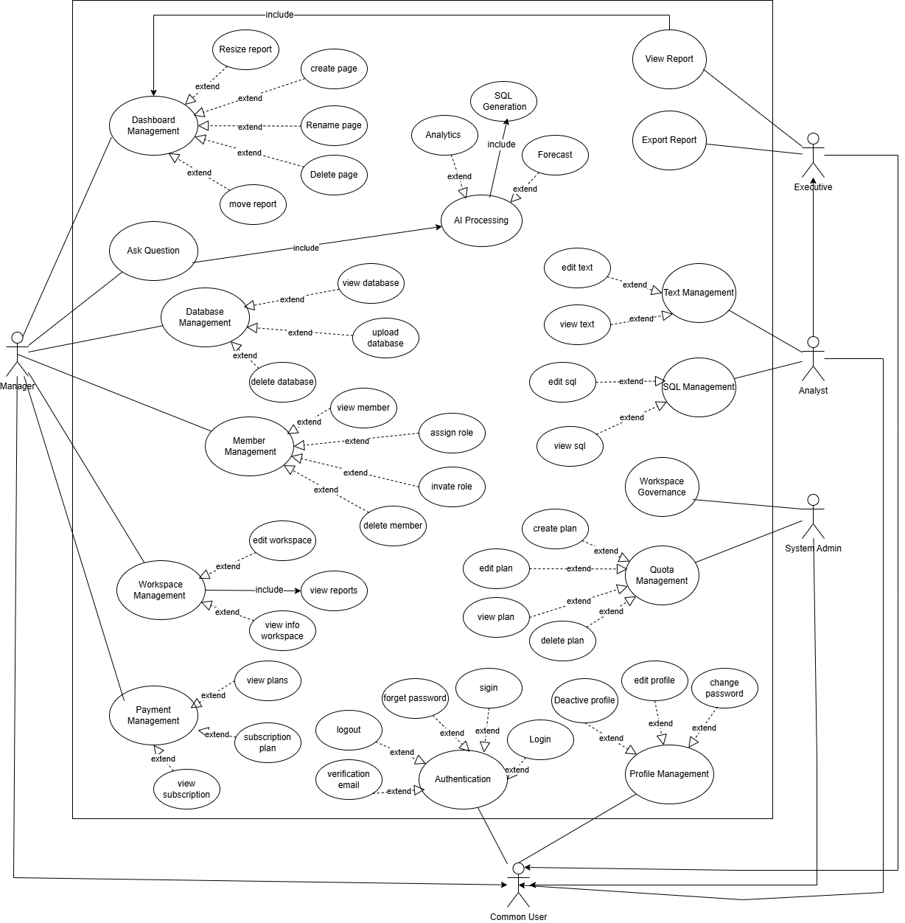
Figure 1 : Use case Diagram

5.2 System features (use case specifications - Sequence Diagrams):

- Sign Up
Field | Description
Requirement ID | R-01
Requirement Name | Sign Up
Actors | Manager – Analyst – Executive
Preconditions | 1- The email address must not already exist in the system  2- The user must have a valid email address
Main Flow | 1. The user opens the Sign-Up page.  2. The system displays the registration form.  3. The user enters the required information: name, email, and password and role  4. The system validates the input data (email format, password strength, required fields, etc.).  5. The system checks whether the email address already exists in the system.  6. The system creates a new user account.  7. If the user is a Manager, the system automatically creates a Workspace linked to their account.  8. The system sends a verification email to the user.  9. The system displays a confirmation message:"Your account has been created. Please check your email to complete the verification process."
Alternative Flows | A1 - Email Already Exists  1. The user clicks the “Create Account” button.  2. The system detects that the email address is already registered.  3. The system displays an error message:"This email address is already in use."  A2 - Invalid Password  1. The user submits the registration form.  2. The system identifies that the password does not meet security requirements.  3. The system displays an error message:"The password does not meet the required criteria."
Postconditions | 1. A new account is successfully created (Manager, Analyst, or Executive).  2. If the user is a Manager, a Workspace is automatically created.  3. A verification email is sent to the user
Table 6 : Use Case Specification for “Sign Up

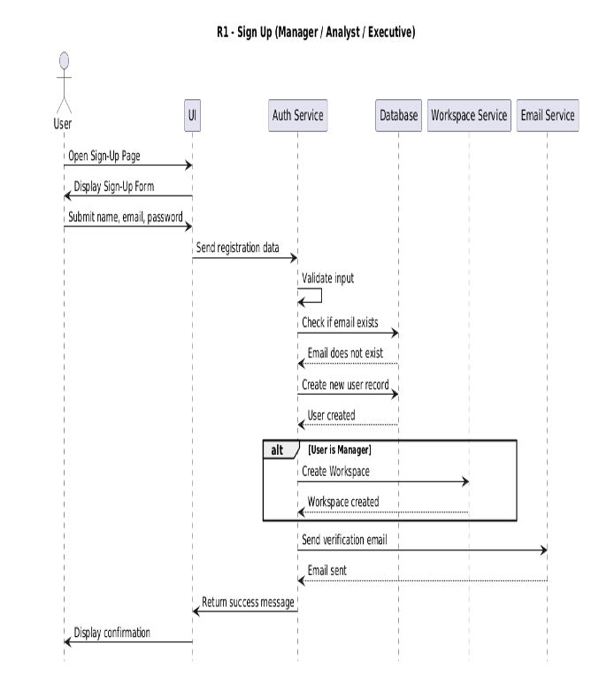
Figure 2 : Sequence Diagram for "Sign Up"

- Email verification

Field | Description
Requirement ID | R-02
Requirement Name | Email verification
Actors | Manager – Analyst – Executive
Preconditions | 1. User has completed Sign Up  2. User account is in Unverified state
Main Flow | 1. User checks their email inbox  2. User opens the verification email  3. User clicks the verification link  4. System receives the verification request  5. System validates the verification token  6. System activates the user account  7. System displays: “Your account has been successfully verified. You can now log in.”
Alternative Flows | A1 - Expired Token  1. User clicks the link  2. System detects the token is expired  3. System displays: “Verification link expired.”  4. System offers “Resend verification email.”  A2 - Already Verified  1. User clicks the link  2. System detects the account is already activated  3. System displays: “Your account is already verified.”
Postconditions | 1. User account is activated  2. User can log in to the system  3. Account status updated to Activated in the database
Table 7 : Use Case Specification for “Email Verification"

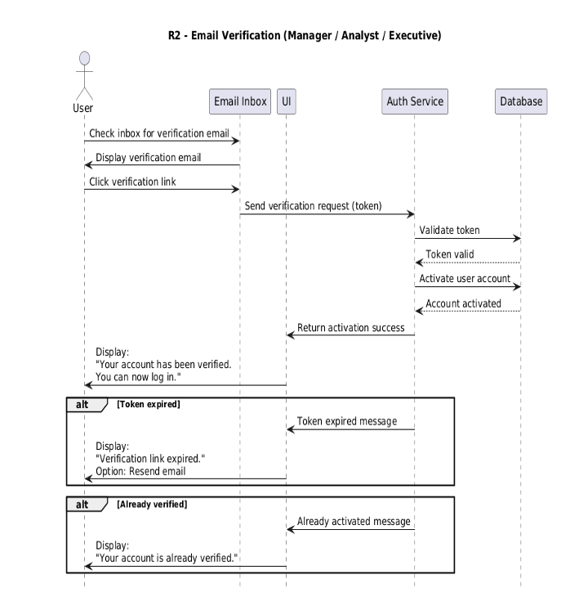
Figure 3 : Sequence Diagram for "Email Verification"

- Login

Field | Description
Requirement ID | R-03
Requirement Name | Login
Actors | Admin - Manager – Analyst – Executive
Preconditions | 1. The user must already have a registered account in the system User  2. The user's account must be verified via email
Main Flow | 1. The user opens the Login page  2. The system displays the login form  3. The user enters their email and password  4. The user clicks the “Login” button  5. The system validates the provided credentials  6. The system checks for a matching account in the database  7. The system verifies that the account is activated and not suspended  8. If the credentials are correct, the system creates a login session (Session or JWT Token)  9. The system redirects the user to the appropriate landing page based on their role:  • Manager : Workspace Dashboard  • Analyst / Executive : Shared Dashboard  10. The system displays a success message or directly redirects the user to their dashboard
Alternative Flows | A1 - Invalid Credentials  1. The user enters an incorrect email or password  2. The system displays:“Invalid login credentials.”  A2 - Account Not Verified  1. The user attempts to log in before email verification  2. The system displays:“Please verify your email before logging in.”  A3 - Account Suspended  1. The system checks the user’s status  2. The system detects that the account is suspended by the Manager  3. The system displays:“Your account is suspended. You cannot log in.”
Postconditions | 4. User is successfully authenticated  5. A session (or JWT Token) is generated  6. User is redirected to the correct landing page according to their role
Table 8 : Use Case Specification for “Login"

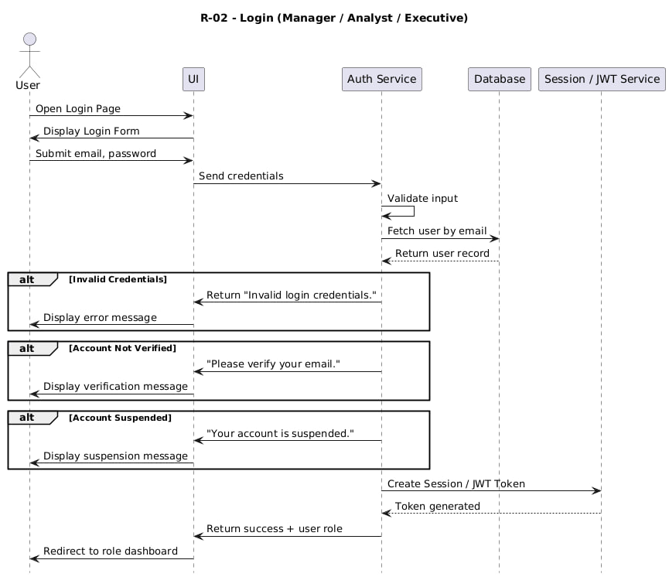
Figure 4 : Sequence Diagram for "Log in"

- Logout
Field | Description
Requirement ID | R-04
Requirement Name | Logout
Actors | Admin - Manager – Analyst – Executive
Preconditions | 1. The user must be currently logged in  2. A valid session or authentication token must exist
Main Flow | 1. The user clicks the “Logout” button  2. The system receives the logout request  3. The system invalidates the active session or authentication token  4. The system clears any session-related data stored in memory or cache  5. The system redirects the user to the login page or public home page  6. The system displays a confirmation message: a. “You have been logged out successfully.”
Alternative Flows | A1 - Session Already Expired  1. The user attempts to log out  2. The system detects that the session has already expired  3. The system redirects the user to the login page without showing an error message
Postconditions | 1. The current user session is invalidated  2. The user is no longer authenticated  3. No protected actions can be performed until the user logs in again
Table 9 : Use Case Specification for “Logout"

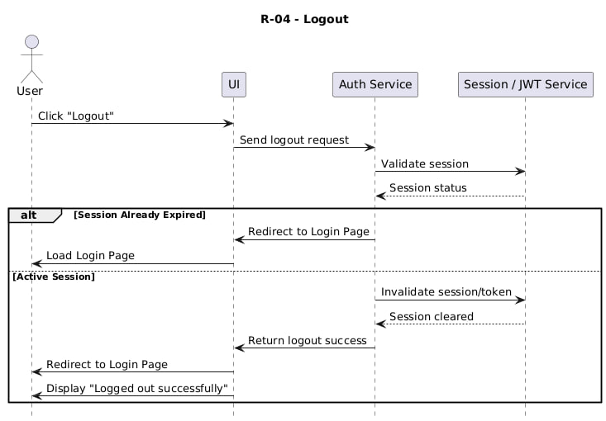
Figure 5 : Sequence Diagram for "Logout"

- Forget password

Field | Description
Requirement ID | R-05
Requirement Name | Forget Password
Actors | Admin - Manager – Analyst – Executive
Preconditions | 1. The user must have a registered account.  2. The user must have access to the registered email address.  3. The system email service must be active.
Main Flow | 1. The user clicks the “Forgot Password” option on the login page.  2. The system requests the user’s registered email address.  3. The user enters the email address.  4. The system validates whether the email exists in the platform.  5. The system generates a secure password reset token.  6. The system sends a password reset link to the user’s email address.  7. The user opens the reset link.  8. The system verifies the validity of the reset token.  9. The user enters a new password and confirms it.  10. The system validates the password strength.  11. The system updates the account password securely.  12. The system displays a confirmation message:  a. “Your password has been reset successfully.”
Alternative Flows | A1 - Invalid Email Address  1. The user enters an unregistered email address.  2. The system displays a message indicating that the email is invalid or not registered.  A2 - Expired or Invalid Reset Token  1. The user opens an expired or invalid reset link.  2. The system rejects the request.  3. The system asks the user to request a new reset link.  A3 - Weak Password  1. The user enters a weak password.  2. The system displays password strength requirements.  3. The user is asked to enter a stronger password.
Postconditions | 1. The user password is updated successfully.  2. Previous reset tokens become invalid.  3. The user can log in using the new password.  4. The system maintains account security and audit logging.
Table 10 : Use Case Specification for “Forget Password"

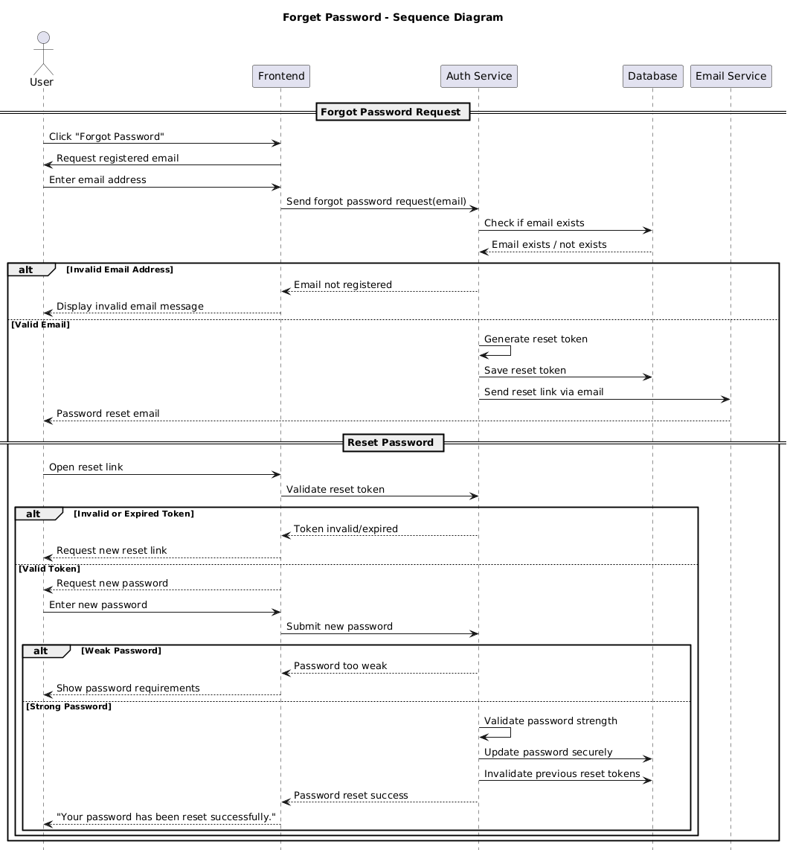
Figure 6 : Sequence Diagram for "Forget Password"

- Edit Profile

Field | Description
Requirement ID | R-06
Requirement Name | Edit profile
Actors | Manager – Analyst – Executive
Preconditions | 1. User is logged in2. Account is active
Main Flow | 1. User opens the Profile page  2. System retrieves and displays profile info  3. System shows editable fields (name, photo, phone…)  4. User updates fields and clicks Save  5. System validates updated data  6. System updates the database record  7. System shows success message
Alternative Flows | A1 - Invalid Data  1. User clicks Save  2. System detects invalid fields  3. System displays: “Invalid profile information.”
Postconditions | 1. The current user session is invalidated  2. The user is no longer authenticated  3. No protected actions can be performed until the user logs in again
Table 11 : Use Case Specification for “Edit Profile"

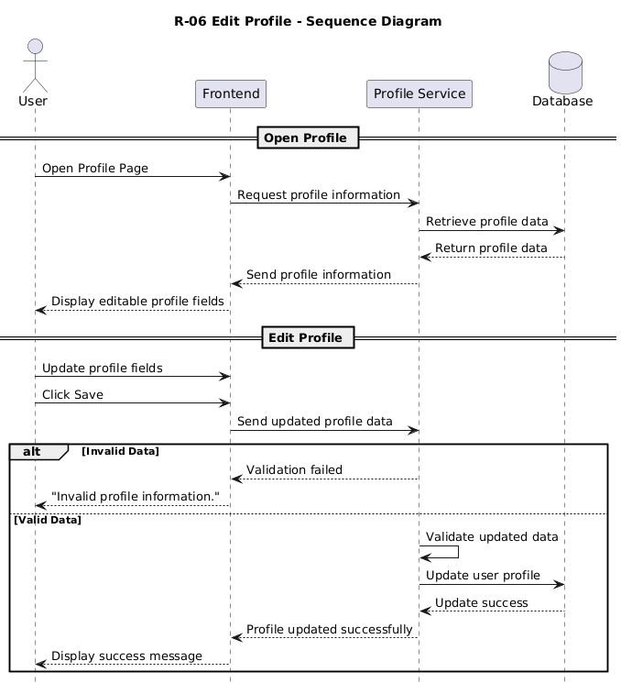
Figure 7 : Sequence Diagram for "Manage Profile"

- Deactivate My Profile

Field | Description
Requirement ID | R-07
Requirement Name | Deactivate My Profile
Actors | Manager – Analyst – Executive
Preconditions | 1. User is logged in
Main Flow | 1. User opens Account Settings  2. System displays account management options including "Deactivate Account"  3. User selects "Deactivate Account"  4. System shows a confirmation warning  5. User confirms the request  6. System verifies the user's identity  7. System sets account status to "Deactivated"  8. System terminates active sessions  9. System shows a success message
Alternative Flows | A1 - User Cancellation  1. User clicks "Deactivate Account"  2. System shows confirmation  3. User selects "Cancel"  4. System returns to settings unchanged
Postconditions | 1. Account is deactivated  2. User cannot log in unless reactivation is supported  3. All sessions are terminated
Table 12 : Use Case Specification for “Deactivate My Profile"

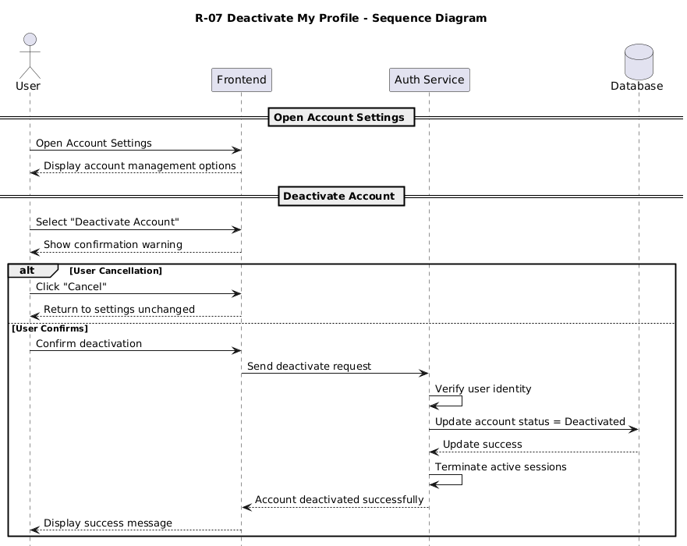
Figure 8 : Sequence Diagram for "Deactivate My Profile"

- Change password

Field | Description
Requirement ID | R-08
Requirement Name | Change password
Actors | Admin - Manager – Analyst – Executive
Preconditions | 1. The user must be logged into the system.  2. A valid authenticated session must exist.  3. The user must know the current account password.
Main Flow | 1. The user navigates to the account settings page.  2. The user selects the “Change Password” option.  3. The system requests the current password.  4. The user enters the current password.  5. The system requests a new password and password confirmation.  6. The user enters and confirms the new password.  7. The system validates the current password.  8. The system verifies the strength and validity of the new password according to security policies.  9. The system securely updates the password.  10. The system displays a confirmation message:  a. “Password changed successfully.”
Alternative Flows
  A1 - Incorrect Current Password
  1. The user enters an incorrect current password.
  2. The system rejects the request.
  3. The system displays an error message indicating that the current password is invalid.
  A2 - Password Confirmation Mismatch
  1. The user enters a different password confirmation.
  2. The system displays a message indicating that the passwords do not match.
  A3 - Weak Password
  1. The user enters a weak password.
  2. The system displays password security requirements.
  3. The user is asked to enter a stronger password.
Postconditions | 1. The user password is updated successfully.  2. The old password becomes invalid.  3. The system maintains an audit log for the password change operation.  4. The user can log in using the new password afterward.
Table 13 : Use Case Specification for “Change Password"
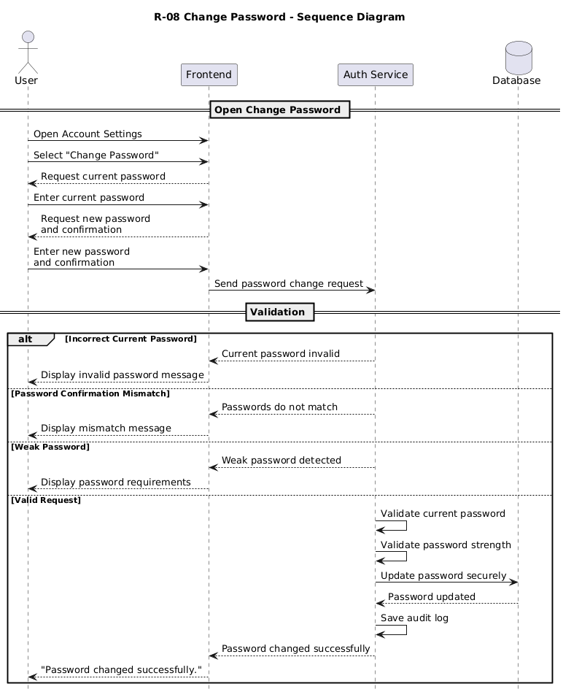
Figure 9 : Sequence Diagram for "Change password"

- Edit Workspace Info

Field | Description
Requirement ID | R-09
Requirement Name | Edit Workspace Info
Actors | Manager
Preconditions | 1. manager is logged in
Main Flow | 1. Manager opens Workspace Settings  2. System displays current workspace info  3. Manager clicks “Edit Workspace Info”  4. System shows editable fields  5. Manager updates fields and clicks Save  6. System validates updated data  7. System updates the database  8. System displays success message
Alternative Flows | A1 - Invalid Data  1. Manager clicks Save  2. System detects invalid data  3. System shows: “Invalid input data.”
Postconditions | 1. Workspace info updated  2. Updated values displayed in manager UI
Table 14 : Use Case Specification for "Edit Workspace Info "

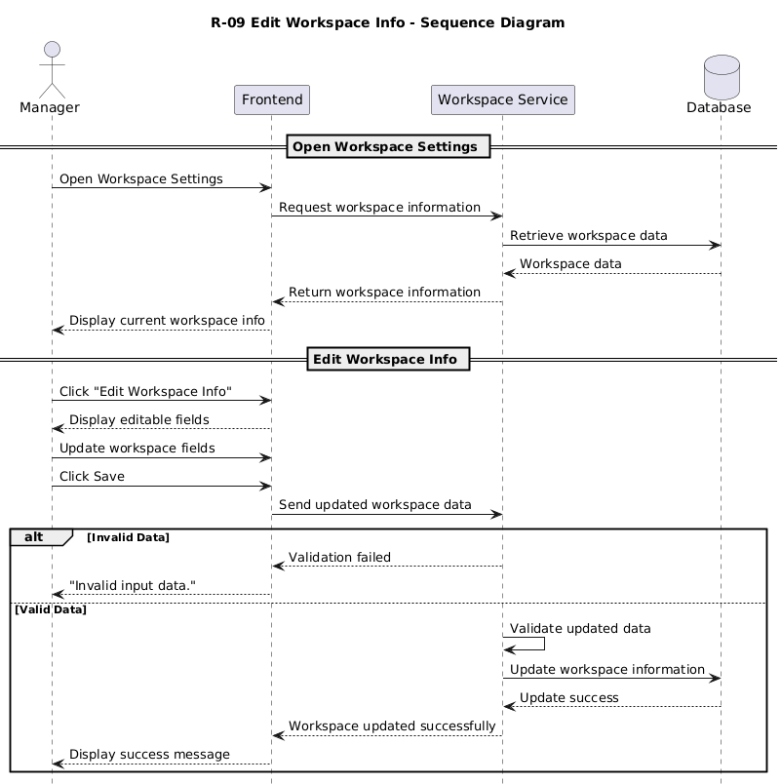
Figure 10 : Sequence Diagram for " Edit Workspace Info"

- View Workspace Members List

Field | Description
Requirement ID | R-10
Requirement Name | View Workspace Members List
Actors | Manager – Analyst – Executive
Preconditions | 1. user is logged in  2. User is a member of the current workspace
Main Flow | 1. User opens Workspace Members page  2. System verifies permission to view members  3. User stays on the same page  4. System retrieves workspace members from the database  5. System displays the list (name, email, role, status)
Alternative Flows
Postconditions | 1. Members list successfully retrieved  2. User can view workspace members
Table 15 : Use Case Specification for “View Workspace Member list"

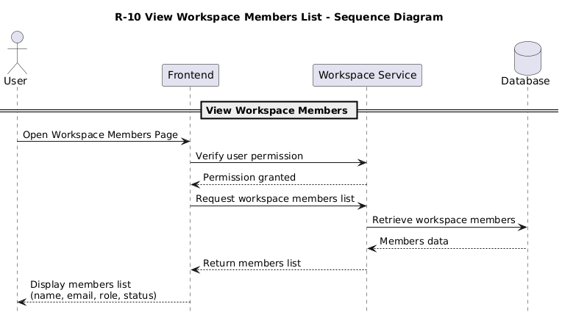
Figure 11 : Sequence Diagram for " View Workspace members list"

- Invite Members

Field | Description
Requirement ID | R-11
Requirement Name | Invite Members
Actors | Manager
Preconditions | 1. manager is logged in  2. New member’s email is valid
Main Flow | 1. Manager opens Members Management page  2. System shows “Invite Member” option  3. Manager clicks “Invite Member”  4. System displays invitation form  5. Manager enters email and selects role  6. System validates email and role  7. System creates invitation record  8. System sends invitation email  9. System shows success message
Alternative Flows | A1 - Invalid Email:  1. Manager enters invalid email.  2. System rejects it.  3. System shows: “Invalid email address.”  A2 - Already Invited  1. Manager enters previously invited email  2. System detects existing invitation  3. System shows: “Invitation already sent.”  A3 - User Already Exists  1. Manager enters email of existing user  2. System detects existing account  3. System shows: “User already exists.”
Postconditions | 1. New invitation is created  2. Invitation email is sent
Table 16 : Use Case Specification for “Invite Member"

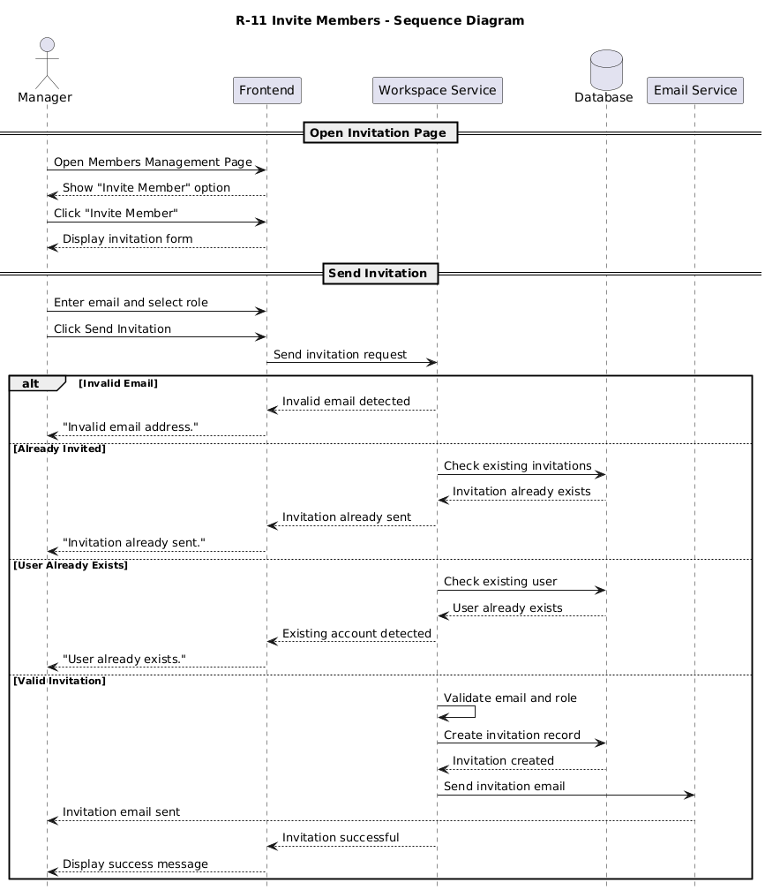
Figure 12 : Sequence Diagram for " invite members"

- Assign Roles

Field | Description
Requirement ID | R-12
Requirement Name | Assign Roles
Actors | Manager
Preconditions | 1. manager is logged in  2. Member exists in the workspace
Main Flow | 1. Manager opens Members Management page  2. System displays members and roles  3. Manager selects a member  4. System shows available actions including Change Role  5. Manager selects new role  6. System validates the role  7. System updates the role in the database  8. System shows success message
Alternative Flows | A1 - Member Not Found  1. Manager selects a member  2. System detects the member does not exist  3. System shows: “Member not found.”
Postconditions | 1. Role is updated in the database  2. New role appears immediately in the UI
Table 17 : Use Case Specification for “Assign Roles"

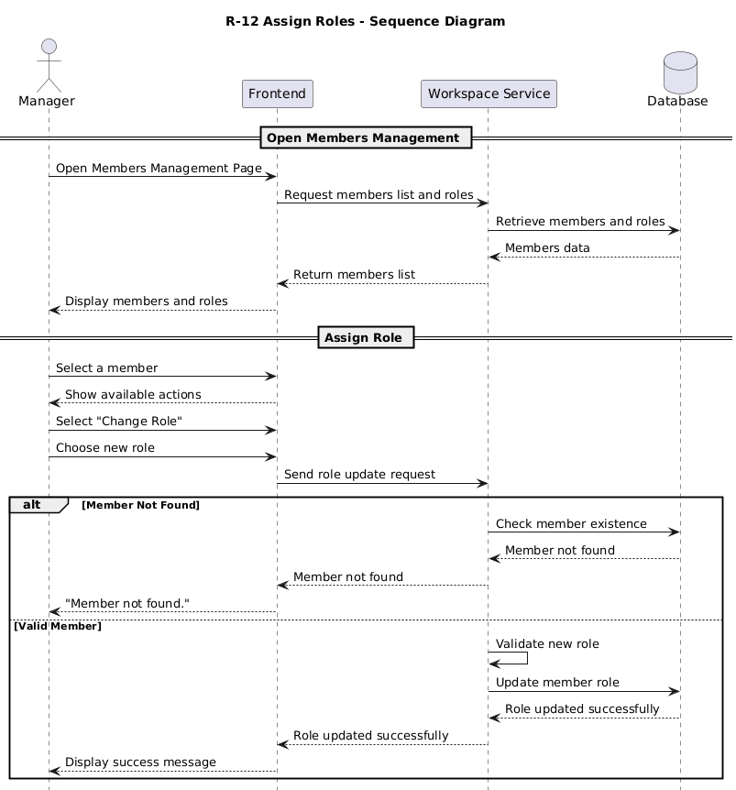
Figure 13 : Sequence Diagram for " Assign Roles"

- Remove Members
Field | Description
Requirement ID | R-13
Requirement Name | Remove Members
Actors | Manager
Preconditions | 1. manager is logged in  2. Member exists in the workspace
Main Flow | 1. Manager opens Members Management page  2. System displays members with a Remove option  3. Manager selects a member and clicks “Remove”  4. System shows confirmation dialog  5. Manager confirms removal  6. System verifies permissions  7. System removes the member  8. System terminates active sessions  9. System shows success message
Alternative Flows | A1 - Cancel Removal  1. System displays confirmation dialog  2. Manager clicks “Cancel”  3. System returns to Members Management with no changes
Postconditions | 1. Member is removed  2. Member loses workspace access
Table 18 : Use Case Specification for “Remove Members"

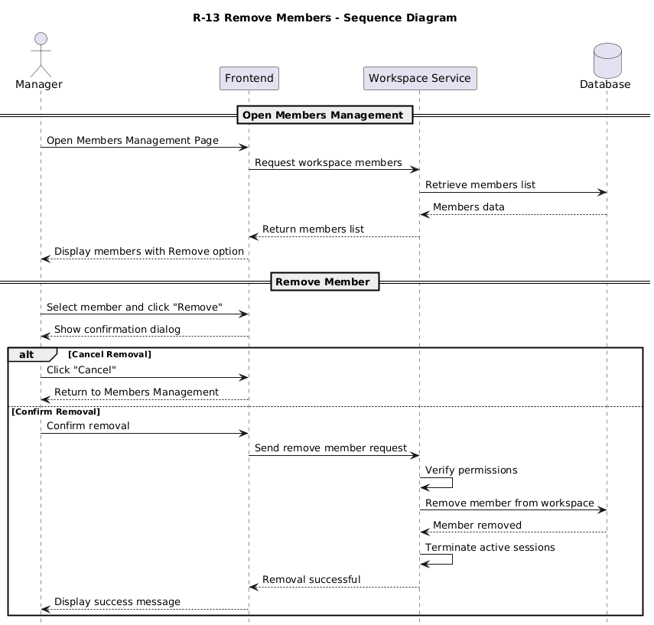
Figure 14 : Sequence Diagram for "Remove Member"

- Suspend Member

Field | Description
Requirement ID | R-14
Requirement Name | Suspend Member
Actors | Manager
Preconditions | 1. manager is logged in  2. Member exists in the workspace
Main Flow | 1. Manager opens Members Management page  2. System shows members with status (Active/Suspended)  3. Manager selects a member and views details  4. System shows “Suspend Member” option  5. Manager clicks “Suspend Member”  6. System shows confirmation with impact explanation  7. Manager confirms  8. System updates member status to Suspended  9. System invalidates member's session  10. System shows success message
Alternative Flows | A1 - Member Already Suspended  1. Manager selects the member  2. System detects status : Suspended  3. System shows: “Member is already suspended.”
Postconditions | 1. Member is suspended  2. Member cannot log in to the workspace  3. Active sessions are terminated
Table 19 : Use Case Specification for “Suspend Member"
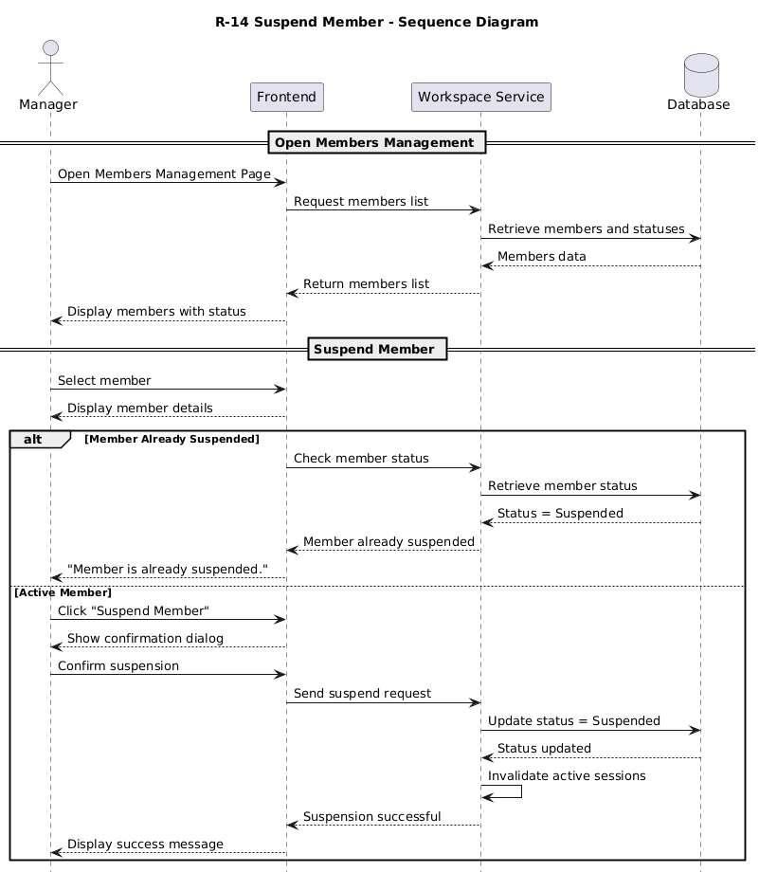
Figure 15 : Sequence Diagram for "Suspend Member"

- Accept Invitation

Field | Description
Requirement ID | R-15
Requirement Name | Accept Invitation
Actors | Analyst – Executive
Preconditions | 1. User has been invited by the manager  2. User received the invitation email  3. Invitation token is valid and unused
Main Flow | 1. User opens invitation email  2. System shows “Join Workspace” link  3. User clicks the link  4. System validates token  5. System checks invitation validity and usage  6. System displays one of two options:  • No account : Registration form  • Existing account : Join button  7. User:  • New user : Register & Join  • Existing user : Join Now  8. System creates or links account  9. System assigns the role  10. System marks invitation as Used  11. System displays success message
Alternative Flows | A1 - Invalid Link  4. User clicks the link  5. System checks invitation token  6. Token is invalid  7. System displays: “Invalid invitation link.  ”A2 - Invitation Expired  1. User clicks the link  2. System detects expired invitation  3. System displays: “Invitation expired.”  A3 - Invitation Already Used  1. User opens the link  2. System detects invitation status : Used  3. System displays: “This invitation was already used.”
Postconditions | 1. User is added to the workspace  2. Invitation is marked as Used  3. User has the assigned role
Table 20 : Use Case Specification for “Accept Invitation"
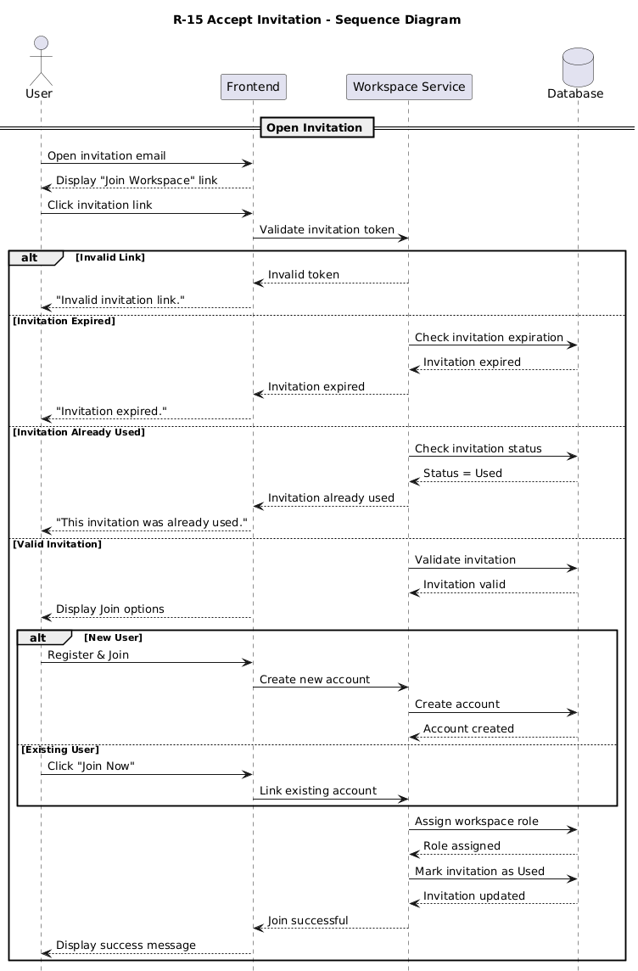
Figure 16 : Sequence Diagram for " Accept inivation"
- Ask Question

Requirement ID | R-16
Requirement Name | Ask Question
Actors | Manager
Preconditions | 1. The user must be authenticated and logged into the system.  2. The user must have access to a workspace with connected datasets or analytical databases.  3. Voice input requires microphone access permission.
Main Flow | 1. The user opens the analytical query interface.  2. The user enters a question using either voice or text input.  3. If voice input is used, the system converts speech into text.  4. The system processes the natural language request.  5. The system analyzes the user intent and determines the query type.  6. The system generates and validates the appropriate SQL query automatically.  7. The system executes the query on the analytical database.  8. The system generates charts, KPIs, tables, or analytical visualizations based on the query result.  9. The system displays the generated analytical output to the user.
Alternative Flows | A1 - Invalid or Unsupported Query  1. The system cannot understand or classify the user request.  2. The system displays an error or clarification message requesting a more specific query.  A2 - Voice Recognition Failure  1. The system fails to convert speech into text correctly.  2. The system requests the user to repeat the voice input or switch to text input.  A3 - Query Execution Failure  1. The generated SQL query fails during execution.  2. The system displays an execution error message.  3. The system logs the error for monitoring and debugging purposes.
Postconditions | 1. The user receives analytical results based on the submitted question.  2. The generated report or visualization is displayed successfully.  3. The query and generated outputs may be stored for dashboard usage or future access.  4. System logs are updated for monitoring and auditing purposes.
Table 21 : Use Case Specification for “As; Quesition"

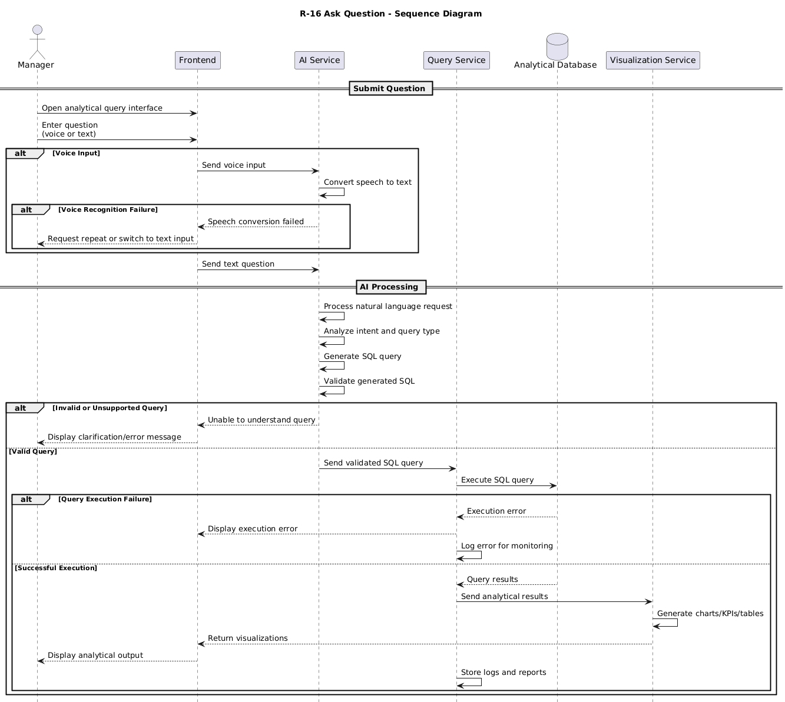
Figure 17 : Sequence Diagram for "Ask Question"

- View Dashboard Report

Requirement ID | R-17
Requirement Name | View Dashboard Reports
Actors | Manager, Analyst, Executive
Preconditions | 1. User is logged in
Main Flow | 1. User logs into the system  2. System identifies user role  3. System redirects user to dashboard page  4. System retrieves available reports from Metabase  5. System displays dashboards and visual reports
Alternative Flows | A1 – No Reports Available  1. System displays empty dashboard message
Postconditions | 1. Dashboard with reports is displayed to the user
Table 22 : Use Case Specification for “View Dashboard report"
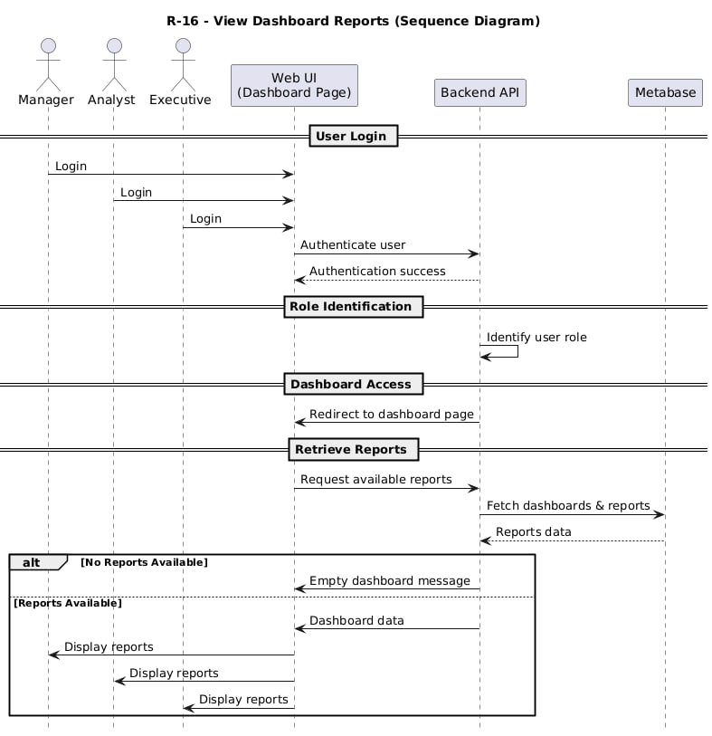
Figure 18 : Sequence Diagram for "View Dashboard Reports"

- View Previous Reports

Requirement ID | R-18
Requirement Name | View Previous Reports
Actors | Manager, Analyst, Executive
Preconditions | 1. Reports exist in the system
Main Flow | 1. User opens Reports section  2. System retrieves report list based on user role  3. System displays list of previous reports  4. User selects a report
Alternative Flows | A1 – Report Not Found  1. System displays error message
Postconditions | 1. Selected report is opened
Table 23 : Use Case Specification for “View Previous Reports"
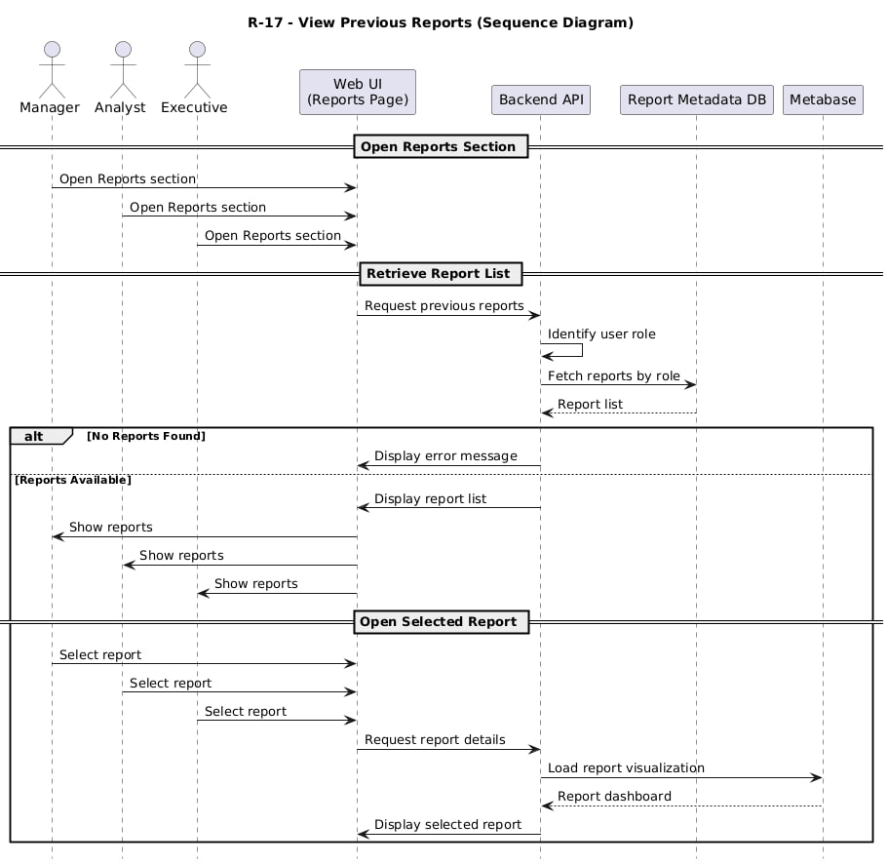
Figure 19 : Sequence Diagram for "View Previous Reports"

- View Report Details

Requirement ID | R-19
Requirement Name | View Report Details
Actors | Manager, Analyst, Executive
Preconditions | 1. Report exists
Main Flow | 1. User opens a specific report  2. System displays report visualization (charts)  3. System displays report metadata (date, source, title)
Alternative Flows | A1 – Visualization Not Available  1. System displays warning message
Postconditions | 1. Report details are visible
Table 24 : Use Case Specification for “View Report Details"
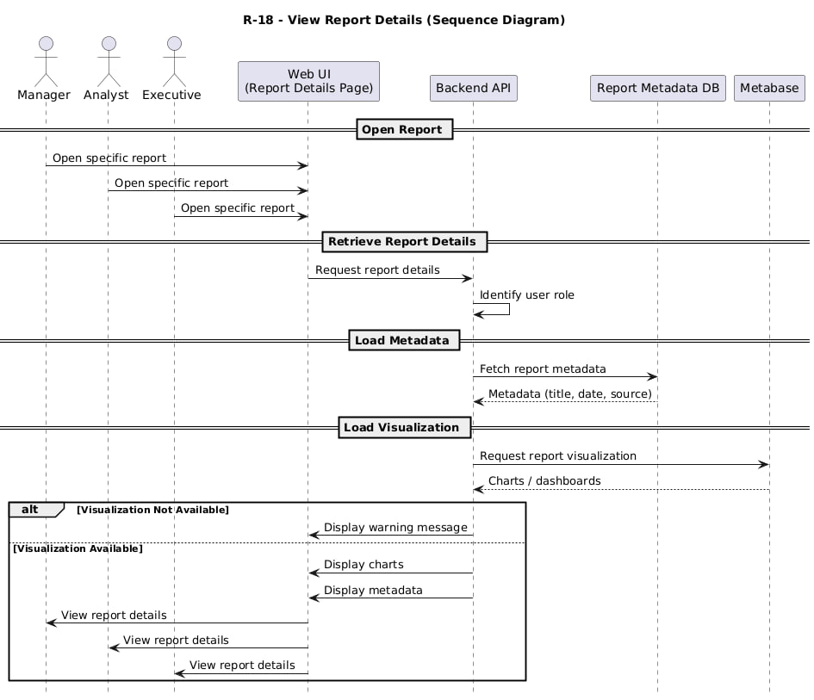
Figure 20 : Sequence Diagram for "View Reports Details"

- Edit SQL Query and Re-execute Rep

Requirement ID | R-20
Requirement Name | Edit SQL Query and Re-execute Report
Actors | Analyst
Preconditions | 1. SQL query exists
Main Flow | 1. Analyst edits SQL query  2. Analyst clicks “Execute”  3. System validates SQL  4. System executes query on ClickHouse  5. System updates result in Metabase  6. System refreshes dashboard
Alternative Flows | A1 – SQL Error  1. System shows error details
Postconditions | 1. Report is updated
Table 25 : Use Case Specification for “Edit SQL Query"
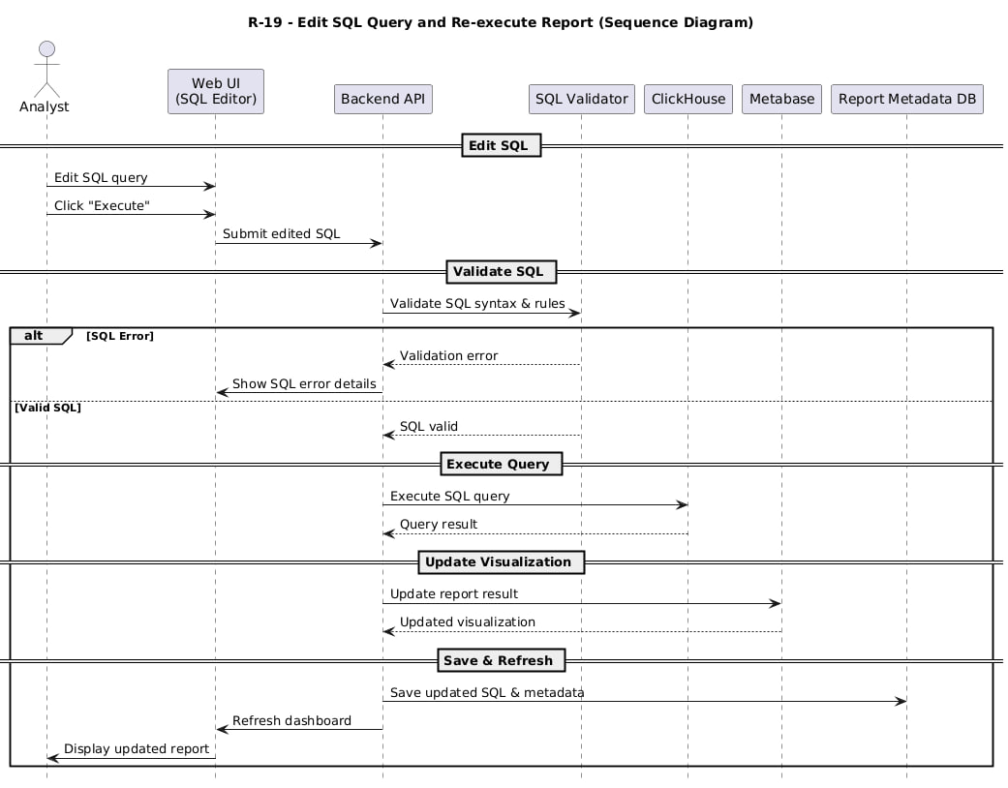
Figure 21 : Sequence Diagram for "Edit SQL"

- Edit Transcription and Regenerate Report

Requirement ID | R-21
Requirement Name | Edit Transcription and Regenerate Report
Actors | Analyst
Preconditions | 1. Transcription exists
Main Flow | 1. Analyst edits transcription text  2. Analyst clicks “Regenerate”  3. System sends updated text to LLM  4. System generates new SQL query  5. System executes query on ClickHouse  6. System updates Metabase visualization
Alternative Flows | A1 – Intent Not Clear  1. System asks for clarification
Postconditions | 1. Updated report is saved
Table 26 : Use Case Specification for “Edit Transcription"
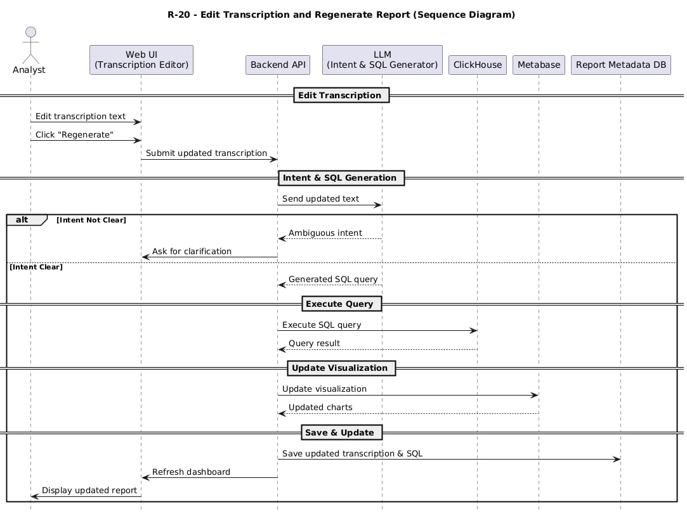
Figure 22: Sequence Diagram for " Edit Transcription"

- Export Report as Image

Requirement ID | R-22
Requirement Name | Export Report as Image
Actors | Manager, Analyst, Executive
Preconditions | 1. Report exists
Main Flow | 1. User selects “Export as Image” option  2. System requests image export from Metabase  3. Metabase generates report image  4. System downloads image file to user device
Alternative Flows | A1 – Export Failed  1. System displays error message
Postconditions | 1. Report image is saved locally
Table 27 : Use Case Specification for “Export Report"

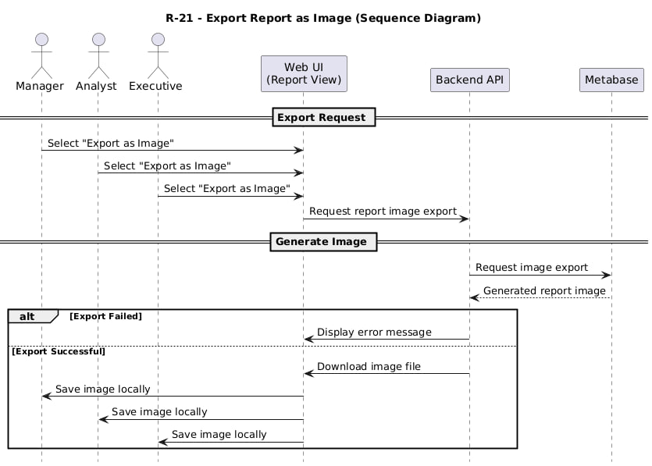
Figure 23 : Sequence Diagram for " Export Report

- Delete Report

Requirement ID | R-23
Requirement Name | Delete Report
Actors | Manager
Preconditions | 1. Report exists
Main Flow | 1. Manager selects report  2. System displays confirmation dialog  3. Manager confirms deletion  4. System deletes report from Metabase and metadata store
Alternative Flows | A1 – Deletion Cancelled  1. System keeps report
Postconditions | 1. Report is deleted
Table 28 : Use Case Specification for “Delete Report"

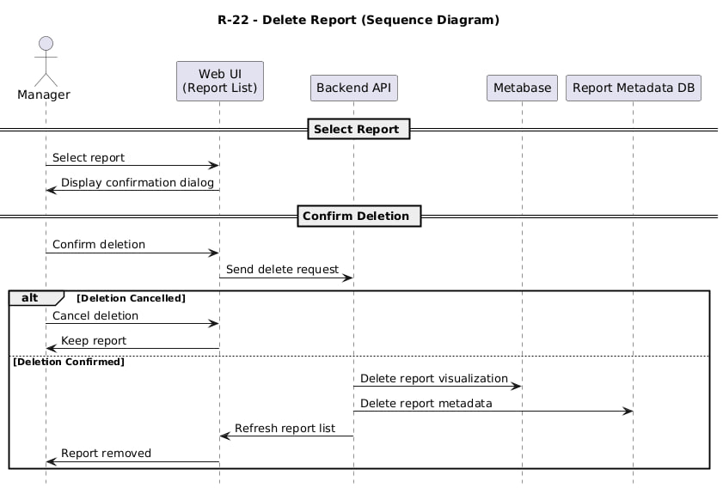
Figure 24: Sequence Diagram for " Delete Report"

- Upload Database and Execute ETL Pipeline

Requirement ID | R-24
Requirement Name | Upload Database and Execute ETL Pipeline
Actors | Manager
Preconditions | 1. Manager is logged in  2. Database file exists
Main Flow | 1. Manager opens Database Management page  2. System displays database upload interface  3. Manager uploads database file  4. System validates file format and schema  5. System starts ETL process  6. System extracts data from uploaded database (Extract)  7. System cleans and transforms data (Transform)  8. System loads processed data into ClickHouse (Load)  9. System verifies data loading success  10. System updates metadata and available datasets  11. System displays successful ETL completion message
Alternative Flows | A1 – ETL Failure  1. System detects ETL error  2. System logs error details  3. System displays failure message
Postconditions | 1. Database is loaded into ClickHouse  2. Data is available for reporting  3. ETL status is stored
Table 29 : Use Case Specification for “Upload Database"

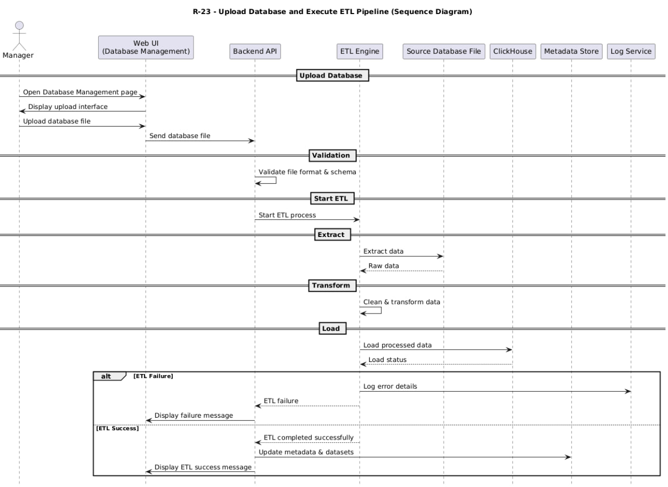
Figure 25 : Sequence Diagram for " Upload datanase"

- Delete Database from ClickHouse

Requirement ID | R-25
Requirement Name | Delete Database from ClickHouse
Actors | Manager
Preconditions | 1. Manager is logged in  2. Database exists in ClickHouse
Main Flow | 1. Manager opens Database Management page  2. System displays list of databases  3. Manager selects a database to delete  4. System displays warning message explaining impact  5. Manager confirms deletion  6. System connects to ClickHouse  7. System executes database deletion command  8. System verifies deletion success  9. System removes related metadata and reports  10. System displays success message
Alternative Flows | A1 – Deletion Failed  1. System detects deletion error  2. System displays error message
Postconditions | 1. Database is removed from ClickHouse  2. Related reports become unavailable  3. Metadata is updated
Table 30 : Use Case Specification for “Delete Database"

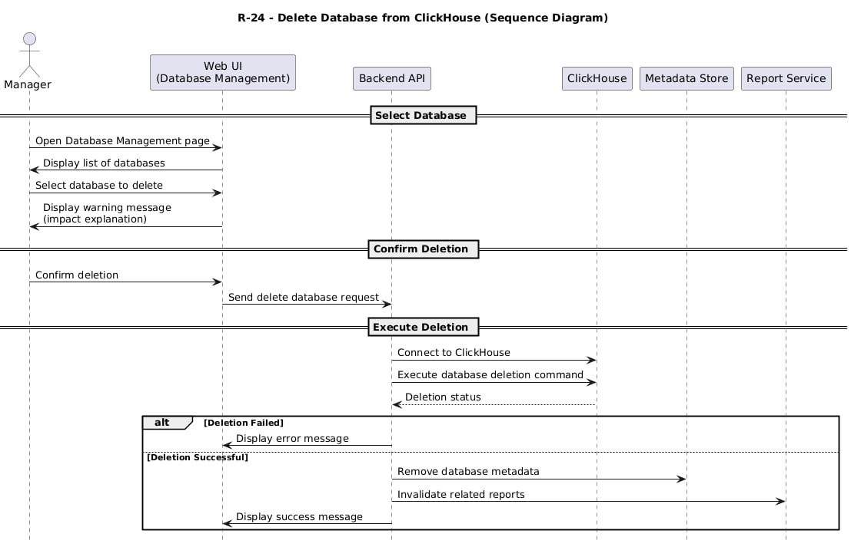
Figure 26 : Sequence Diagram for "Delete Database"

- Create Page

Requirement ID | R-26
Requirement Name | - Create Page
Actors | Manager
Preconditions | 1. The Manager must be logged into the system.  2. The Manager must have access to a workspace.  3. The workspace dashboard module must be available.
Main Flow | 1. The Manager opens the dashboard management interface.  2. The Manager clicks the “Create Page” button.  3. The system requests the page name.  4. The Manager enters the page name.  5. The system validates the page information.  6. The system creates the new dashboard page.  7. The new page appears in the workspace dashboard navigation.
Alternative Flows
  A1 - Empty Page Name
  1. The Manager submits an empty page name.
  2. The system displays a validation message requesting a valid page name.
  A2 - Duplicate Page Name
  1. The Manager enters a page name that already exists.
  2. The system requests a unique page name.
Postconditions
  1. A new dashboard page is created successfully.
  2. The page becomes available inside the workspace.
  3. The system updates dashboard navigation automatically.
Table 31 : Use Case Specification for “Create Page"

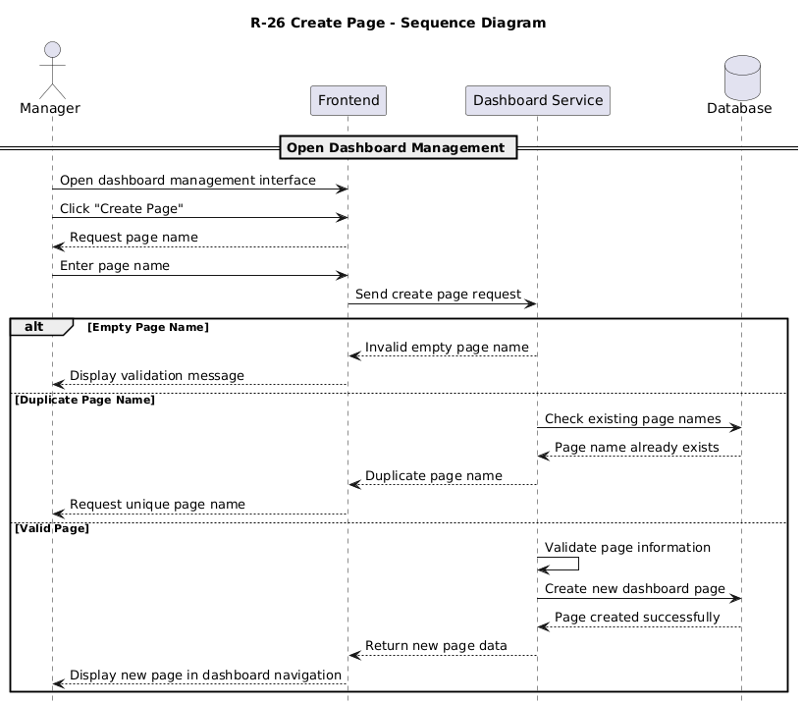
Figure 27 : Sequence Diagram for "Create Page"

- Rename Page

Requirement ID | R-27
Requirement Name | - Create Page
Actors | Manager
Preconditions | 1. The Manager must be logged into the system.  2. The Manager must have access to a workspace.  3. The workspace dashboard module must be available.
Main Flow | 1. The Manager opens the dashboard management interface.  2. The Manager clicks the “Create Page” button.  3. The system requests the page name.  4. The Manager enters the page name.  5. The system validates the page information.  6. The system creates the new dashboard page.  7. The new page appears in the workspace dashboard navigation.
Alternative Flows
  A1 - Empty Page Name
  1. The Manager submits an empty page name.
  2. The system displays a validation message requesting a valid page name.
  A2 - Duplicate Page Name
  1. The Manager enters a page name that already exists.
  2. The system requests a unique page name.
Postconditions
  1. A new dashboard page is created successfully.
  2. The page becomes available inside the workspace.
  3. The system updates dashboard navigation automatically.
Table 32 : Use Case Specification for “Rename Page"

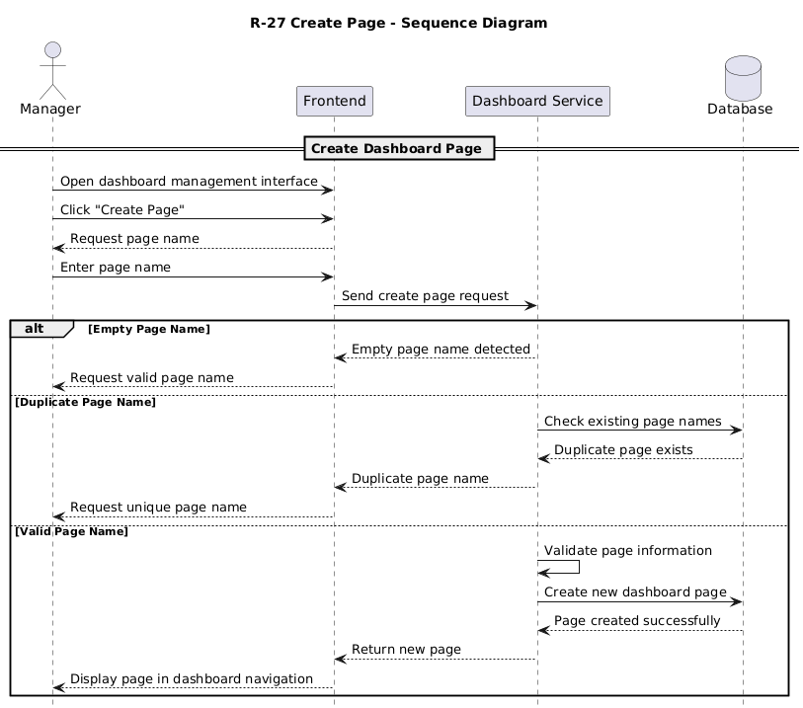
Figure 28 : Sequence Diagram for "Rename Page"

- Delete Page

Requirement ID | R-28
Requirement Name | - Delete Page
Actors | Manager
Preconditions | 1. The Manager must be logged in.  2. The selected dashboard page must exist.
Main Flow | 1. The Manager selects a dashboard page.  2. The Manager clicks the “Delete Page” option.  3. The system requests confirmation.  4. The Manager confirms the deletion.  5. The system removes the dashboard page.  6. The dashboard navigation is updated automatically.
Alternative Flows
  A1 - Deletion Cancelled
  1. The Manager cancels the deletion request.
  2. The system keeps the dashboard page unchanged.
Postconditions
  1. The selected dashboard page is deleted successfully.
  2. The page no longer appears in the workspace dashboard.
Table 33 : Use Case Specification for “Delete Page"
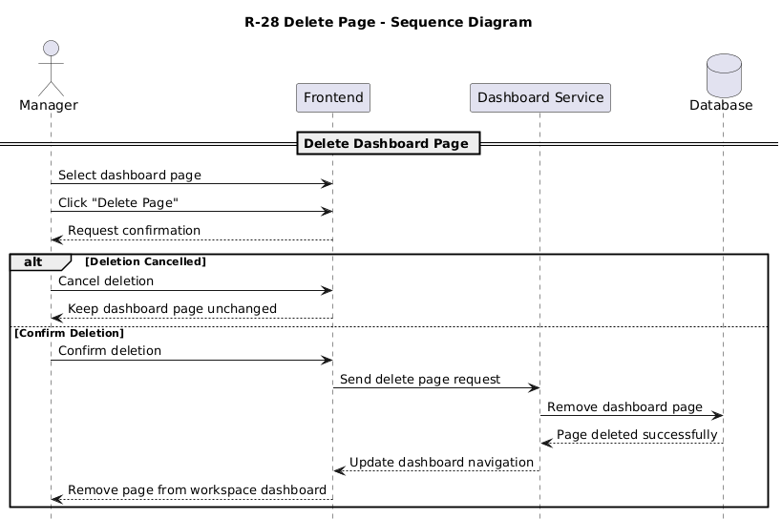
Figure 29 : Sequence Diagram for "Delete Page"

- Move Report

Requirement ID | R-29
Requirement Name | - Move Report
Actors | Manager
Preconditions | 1. The Manager must be logged in.  2. The report must already exist.  3. At least one dashboard page must exist.
Main Flow | 1. The Manager selects a report.  2. The Manager drags the report or selects the “Move Report” option.  3. The system displays available dashboard pages.  4. The Manager selects the target page.  5. The system updates the report location.  6. The report appears on the selected dashboard page.
Alternative Flows
  A1 - Invalid Target Page
  1. The selected page does not exist.
  2. The system rejects the operation and displays an error message.
Postconditions
  1. The report is moved successfully.
  2. The dashboard layout is updated automatically.
  3. The report becomes visible on the target page.
Table 34 : Use Case Specification for “Move Report"

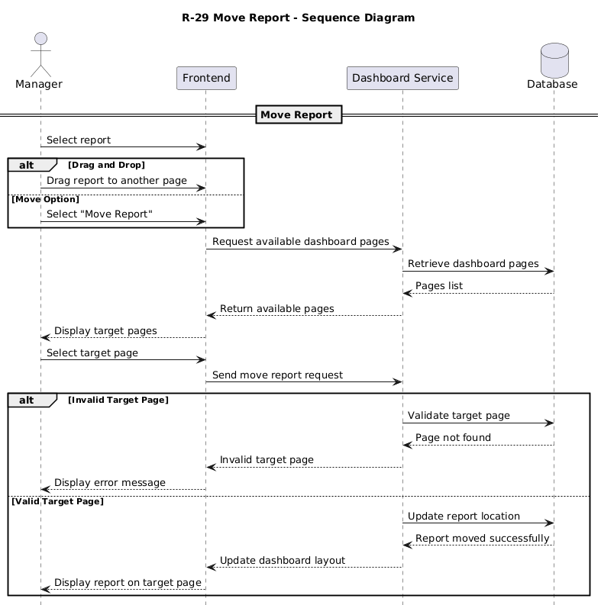
Figure 30 : Sequence Diagram for "Move Report"

- Resize Report

Requirement ID | R-30
Requirement Name | - Resize Report
Actors | Manager
Preconditions
  1. The Manager must be logged into the system.
  2. The report must already exist within a dashboard page.
  3. The dashboard editing mode must be enabled.
Main Flow
  1. The Manager opens a dashboard page.
  2. The Manager selects a report.
  3. The Manager resizes the report using mouse interactions or width and height controls.
  4. The system updates the report dimensions dynamically.
  5. The dashboard layout adjusts automatically.
  6. The updated report size is displayed immediately.
Alternative Flows
  A1 - Invalid Report Size
  1. The Manager attempts to resize the report below or above allowed limits.
  2. The system rejects the invalid size.
  3. The system displays a validation message.
  A2 - Resize Operation Cancelled
  1. The Manager cancels the resize operation.
  2. The report retains its previous dimensions.
Postconditions
  1. The report dimensions are updated successfully.
  2. The dashboard layout is refreshed automatically.
  3. The updated report size is stored within the dashboard configuration.
Table 35 : Use Case Specification for “Resize Report"

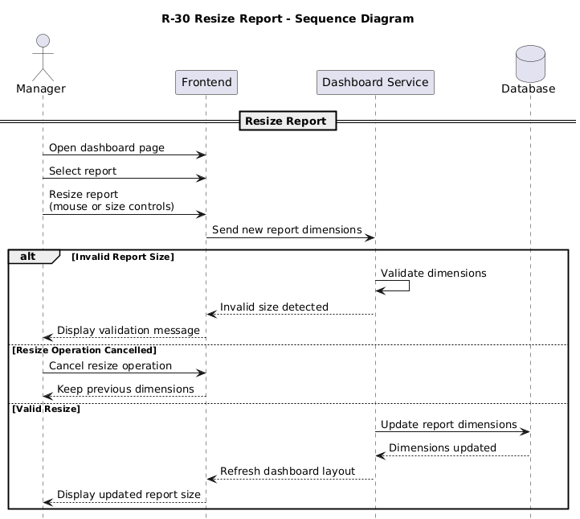
Figure 31 : Sequence Diagram for "Resize Report"

- Create plan

Requirement ID | R-31
Requirement Name | - Create plan
Actors | Admin
Preconditions
  1. The Admin must be logged into the system.
  2. The Admin must have platform management privileges.
Main Flow
  1. The Admin opens the subscription management interface.
  2. The Admin selects the “Create Plan” option.
  3. The system requests plan details such as name, features, duration, and pricing.
  4. The Admin enters the required information.
  5. The system validates the entered data.
  6. The system creates the new subscription plan.
  7. The new plan appears in the subscription management list.
Alternative Flows
  A1 - Missing Required Information
  1. The Admin leaves required fields empty.
  2. The system displays validation messages requesting complete information.
  A2 - Duplicate Plan Name
  1. The Admin enters a plan name that already exists.
  2. The system requests a unique plan name.
Postconditions
  1. A new subscription plan is created successfully.
  2. The plan becomes available for users and workspaces.
  3. The system updates subscription records automatically.
Table 36 : Use Case Specification for “Create Plan"

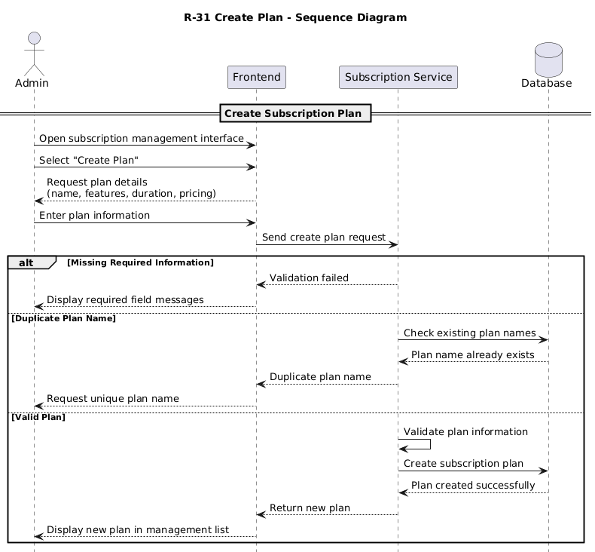
Figure 32 : Sequence Diagram for "Create Plan"

- Edit plan
Requirement ID | R-32
Requirement Name | - Edit plan
Actors | Admin
Preconditions
  1. The Admin must be authenticated.
  2. The target subscription plan must already exist.
Main Flow
  1. The Admin selects a subscription plan.
  2. The Admin chooses the “Edit Plan” option.
  3. The system displays the current plan information.
  4. The Admin updates the required fields.
  5. The system validates the modifications.
  6. The system saves the updated plan information.
  7. The updated plan appears in the subscription list.
Alternative Flows
  A1 - Invalid Data
  1. The Admin enters invalid values.
  2. The system rejects the update and displays validation messages.
Postconditions
  1. The subscription plan information is updated successfully.
  2. Updated settings become active immediately.
Table 37 : Use Case Specification for “Edit Plan"

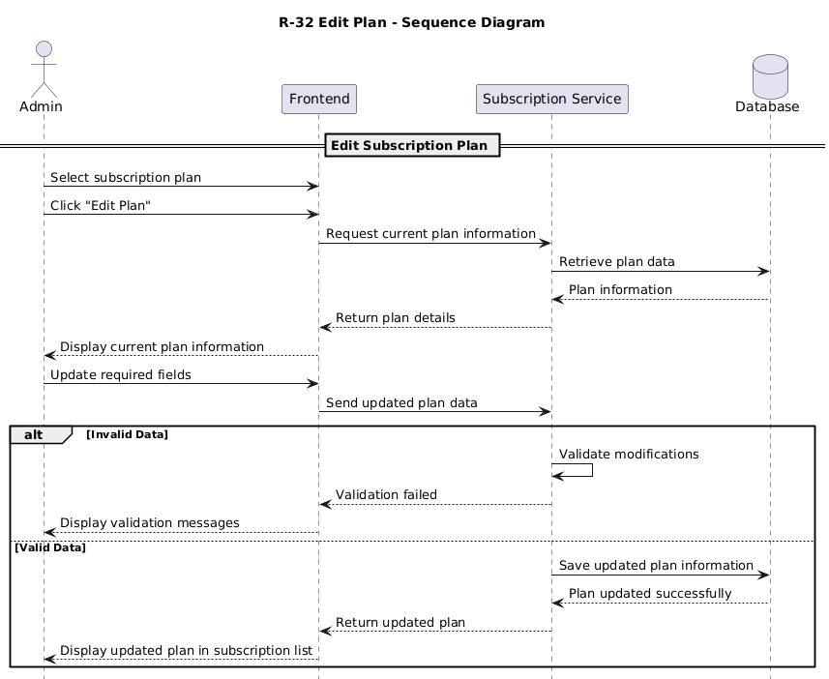
Figure 33 : Sequence Diagram for "Edit Plan"
- View plans

Requirement ID | R-33
Requirement Name | Views plan
Actors | Admin
Preconditions
  1. The Admin must be authenticated.
  2. Subscription management services must be available.
Main Flow
  1. The Admin opens the subscription management page.
  2. The system retrieves all available plans.
  3. The system displays plan information including features, duration, pricing, and status.
  4. The Admin reviews the displayed plans.
Alternative Flows | A1 - No Plans Available  1. The system detects that no plans exist.  2. The system displays an empty-state message.
Postconditions
  1. Subscription plans are displayed successfully.
  2. The Admin can proceed with additional management operations.
Table 38 : Use Case Specification for “Views Plan"
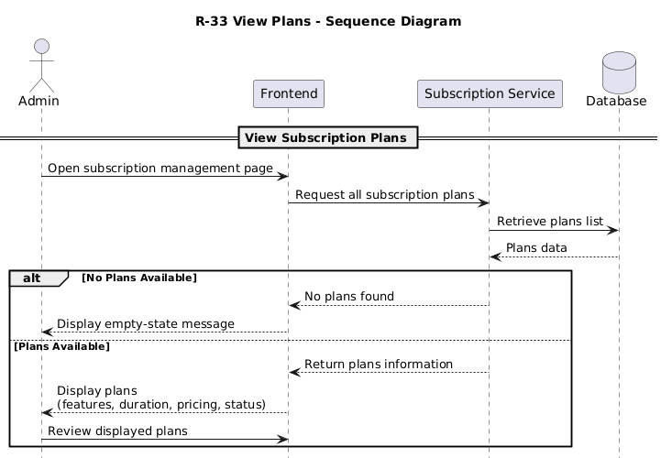
Figure 34 : Sequence Diagram for "Views plan"

- Delete plan

Requirement ID | R-34
Requirement Name | Delete plan
Actors | Admin
Preconditions
  1. The Admin must be logged into the system.
  2. The selected subscription plan must exist.
Main Flow
  1. The Admin selects a subscription plan.
  2. The Admin clicks the “Delete Plan” option.
  3. The system requests deletion confirmation.
  4. The Admin confirms the deletion.
  5. The system removes the subscription plan.
  6. The subscription list is updated automatically.
Alternative Flows | A1 - Deletion Cancelled  1. The Admin cancels the deletion request.  2. The system keeps the plan unchanged.  A2 - Plan Currently In Use  1. The selected plan is assigned to active users or workspaces.  2. The system prevents deletion and displays a warning message.
Postconditions
  1. The subscription plan is deleted successfully.
  2. The deleted plan no longer appears in the system.
  3. Subscription records are updated automatically.
Table 39 : Use Case Specification for “Delete plan"
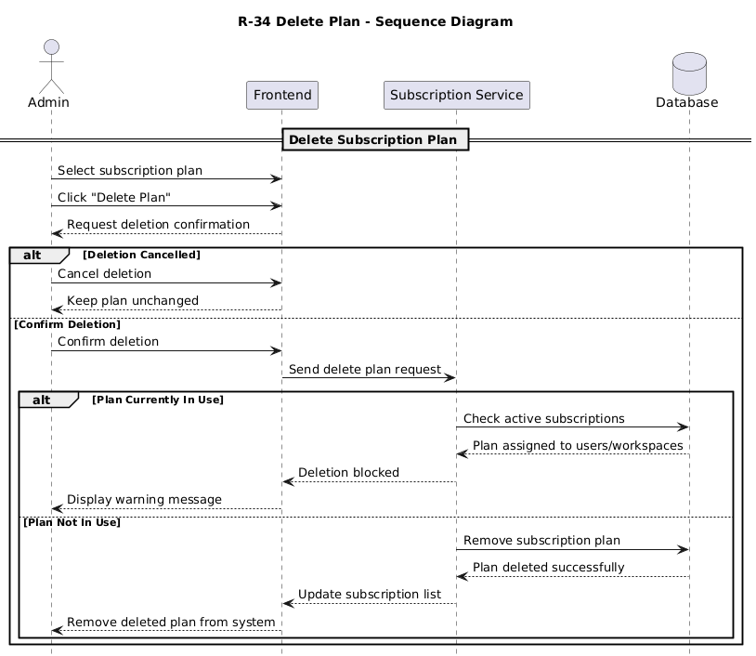
Figure 35 : Sequence Diagram for "Delete Plan"

- View plans for manager

Requirement ID | R-35
Requirement Name | View plans for manager
Actors | Manager
Preconditions
  1. The Manager must be logged into the system.
  2. Subscription services must be available.
Main Flow
  1. The Manager opens the subscription section.
  2. The system retrieves all available subscription plans.
  3. The system displays plan details including pricing, features, duration, and limits.
  4. The Manager reviews the available plans.
Alternative Flows
  A1 - No Available Plans
  1. The system detects that no subscription plans exist.
  2. The system displays a message indicating that no plans are available.
Postconditions
  1. Available subscription plans are displayed successfully.
  2. The Manager can proceed to select or subscribe to a plan.
Table 40 : Use Case Specification for “View plans for manager"
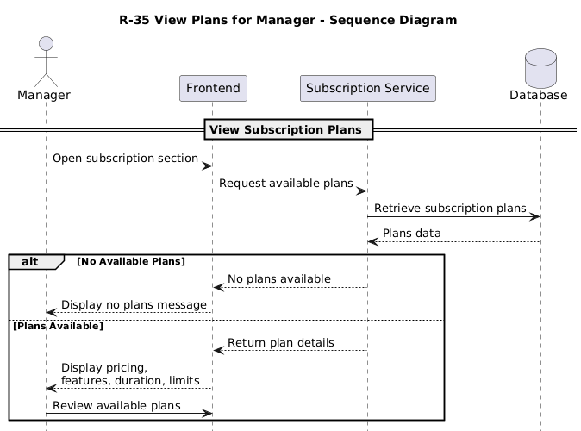
Figure 36 : Sequence Diagram for "View plans for manager"

- Subscription plan

Requirement ID | R-36
Requirement Name | Subscription plan
Actors | Manager
Preconditions
  1. The Manager must be authenticated.
  2. At least one subscription plan must be available.
  3. Payment services must be active.
Main Flow
  1. The Manager selects a subscription plan.
  2. The system displays the selected plan details.
  3. The Manager confirms the subscription request.
  4. The system redirects the Manager to the payment process.
  5. The Manager completes the payment operation.
  6. The system validates the payment transaction.
  7. The system activates the selected subscription plan.
  8. The system displays a confirmation message indicating successful subscription activation.
Alternative Flows
  A1 - Payment Failure
  1. The payment transaction fails.
  2. The system displays a payment error message.
  3. The subscription remains inactive.
  A2 - Subscription Cancelled
  1. The Manager cancels the subscription process.
  2. The system terminates the process without activating the plan.
Postconditions
  1. The selected subscription plan is activated successfully.
  2. The Manager gains access to subscription features.
  3. Subscription records are updated automatically.
Table 41 : Use Case Specification for “Subscription plan"

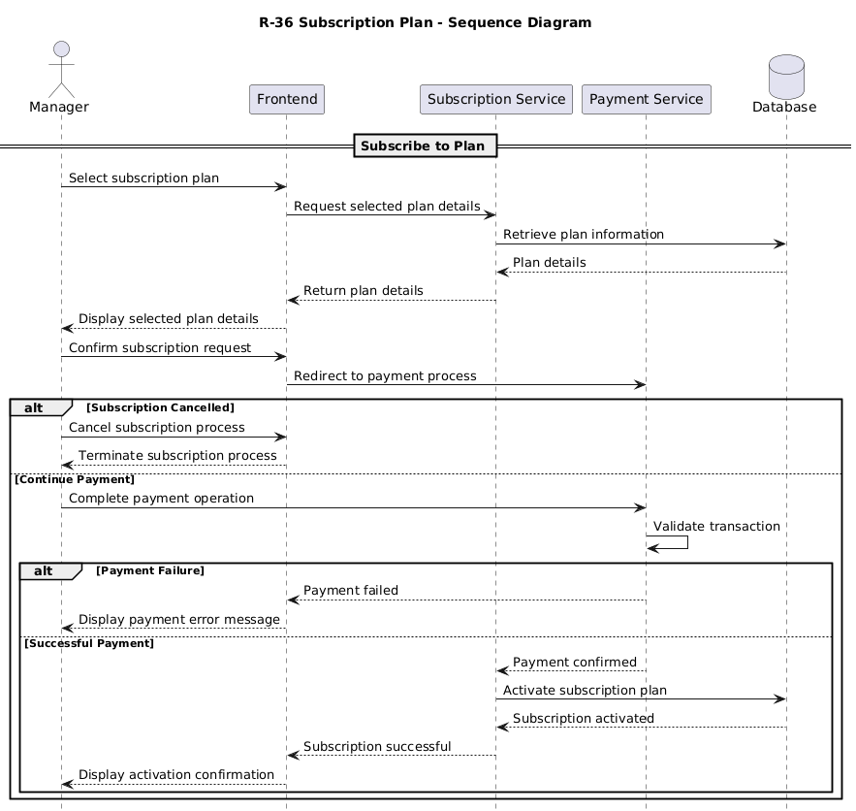
Figure 37 : Sequence Diagram for "Subscription plan"

- View Subscription

Requirement ID | R-37
Requirement Name | View subscription
Actors | Manager
Preconditions
  1. The Manager must be logged into the system.
  2. The Manager must have an active or previous subscription record.
Main Flow
  1. The Manager opens the subscription management section.
  2. The system retrieves the current subscription information.
  3. The system displays subscription details including plan name, status, expiration date, and enabled features.
  4. The Manager reviews the subscription information.
Alternative Flows
  A1 - No Active Subscription
  1. The system detects that no active subscription exists.
  2. The system displays a message encouraging the Manager to subscribe to a plan.
Postconditions
  1. Subscription details are displayed successfully.
  2. The Manager can proceed with subscription-related operations.
Table 42 : Use Case Specification for “View Subscription"
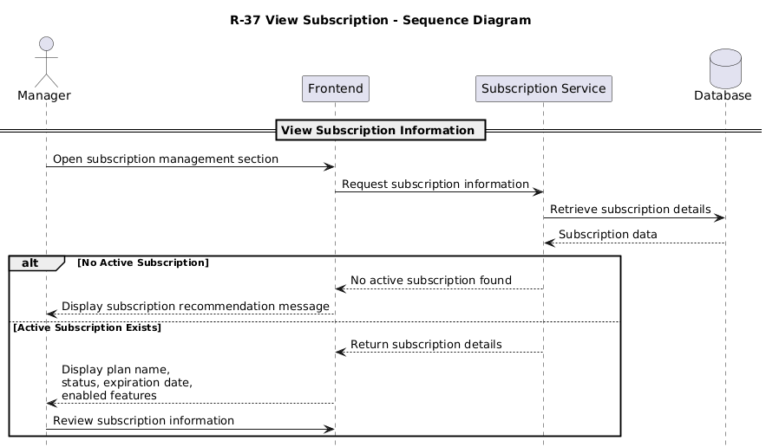
Figure 38 : Sequence Diagram for "View subscription"

6. System architecture

- Class Diagram

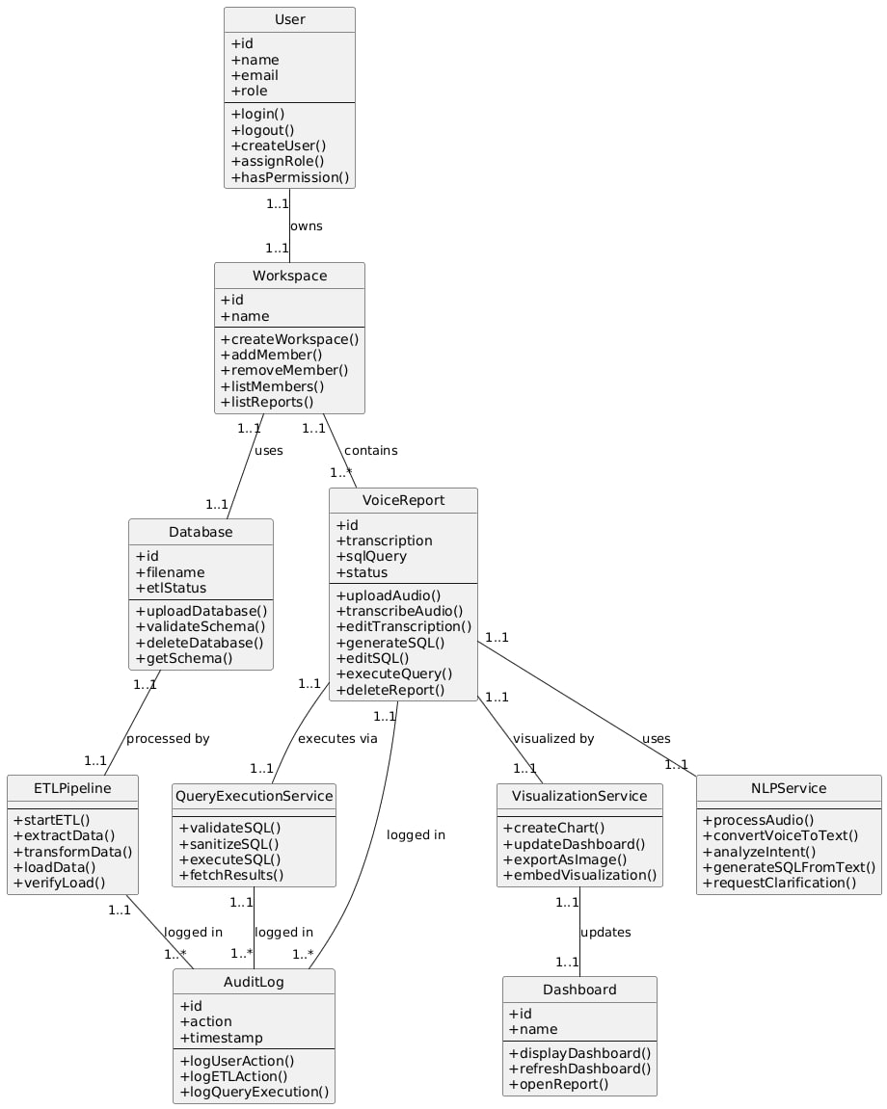
Figure 39 : Class Diagram

- ERD Diagram
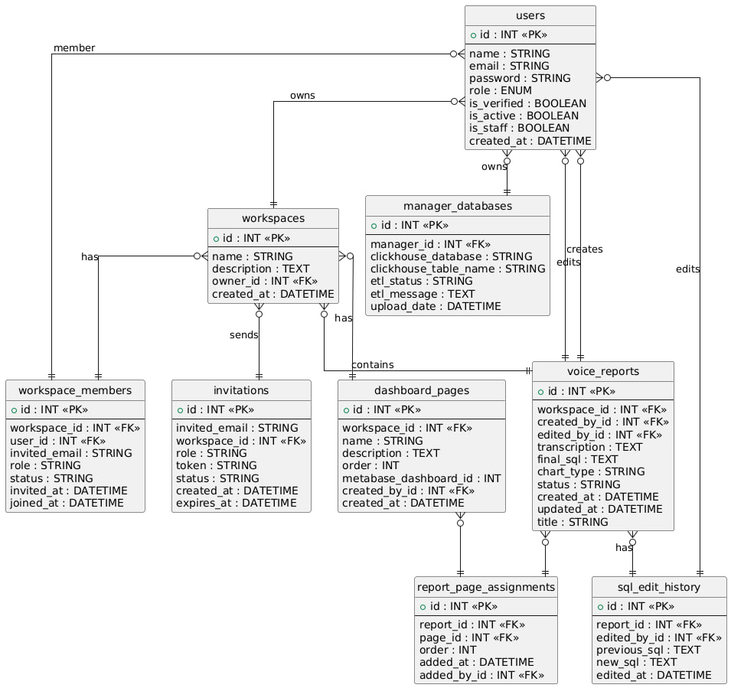
Figure 40 : ERD Diagram

7. Initial Test Cases

- Test cases for User Registration

Test Case ID | Requirement Name | Description | Preconditions | Test Steps | Expected Result | Test Type | Priority
TC-REG-001 | User Registration | Valid user registration with all required fields | No user account exists with provided email | 1. Navigate to signup page  2. Enter valid name (min 3 chars)  3. Enter unique email  4. Enter password (min 8 chars with uppercase/lowercase/number) 5. Select role (Manager/Analyst/Executive) 6. Click Register | User account created successfully; Verification email sent; User redirected to email verification page; Account status is unverified | Positive | High
TC-REG-002 | User Registration | Registration with duplicate email address | User account already exists with provided email | 1. Navigate to signup page  2. Enter name  3. Enter existing email  4. Enter password  5. Select role  6. Click Register | Registration fails; Error message displayed: “Email already exists”; User remains on signup page; No duplicate account created | Negative | High
TC-REG-003 | User Registration | Registration with invalid email format | No user account exists | 1. Navigate to signup page  2. Enter valid name  3. Enter invalid email (missing @ or domain)  4. Enter password  5. Select role  6. Click Register | Registration fails; Error message: “Invalid email format”; Email field highlighted with validation error | Negative | High
TC-REG-004 | User Registration | Registration with weak password | No user account exists | 1. Navigate to signup page  2. Enter valid name  3. Enter unique email  4. Enter weak password (less than 8 chars or missing uppercase/number)  5. Select role  6. Click Register | Registration fails; Error message: “Password must be at least 8 characters with uppercase, lowercase, and number”; Password field highlighted | Negative | High
TC-REG-005 | User Registration | Manager auto-creates workspace on signup | No user account exists | 1. Navigate to signup page  2. Enter valid name  3. Enter unique email  4. Enter valid password  5. Select role as Manager  6. Click Register  7. Verify email | User account created successfully; Workspace automatically created; User assigned as workspace owner; Workspace name defaults to “{UserName}'s Workspace”; User can access workspace after verification | Positive | High
Table 43 : Test cases for User Registration
- Test Cases for User Login

Test Case ID | Requirement Name | Description | Preconditions | Test Steps | Expected Result | Test Type | Priority
TC-PASS-001 | Password Reset | Request password reset with valid registered email | User account exists and is verified | 1. Navigate to Forgot Password page  2. Enter registered email  3. Click Reset Password | Password reset email sent successfully; Confirmation message displayed | Positive | High
TC-PASS-002 | Password Reset | Request password reset with non-existent email | No account exists with provided email | 1. Navigate to Forgot Password page  2. Enter non-existent email  3. Click Reset Password | Request rejected; Error message: “Email not found”; No email sent | Negative | High
TC-PASS-003 | Password Reset | Reset password using valid token | Valid reset token received via email | 1. Open reset password link from email  2. Enter new valid password  3. Confirm password 4. Submit | Password updated successfully; User redirected to login page; Old password invalidated | Positive | High
TC-PASS-004 | Password Reset | Reset password using expired or invalid token | Token is expired or invalid | 1. Open reset link with expired/invalid token  2. Attempt to set new password | Reset fails; Error message: “Invalid or expired token”; User prompted to request new reset link | Negative | High
TC-PASS-005 | Password Reset | Reset password with weak new password | Valid reset token exists | 1. Open reset password link  2. Enter weak password  3. Submit | Reset fails; Password validation error shown; Password not updated | Negative | High
Table 44 : Test Cases for User Login

- Test Cases for Email Verification

Test Case ID | Requirement Name | Description | Preconditions | Test Steps | Expected Result | Test  Type | Priority
TC-EMAIL-001 | Email Verification | Valid email verification with correct token | User registered but not verified; Valid verification token sent | 1. Receive verification email  2. Click verification link with token  3. System verifies token | Email verification successful; User is_verified = True; User can now login; Confirmation message displayed | Positive | High
TC-EMAIL-002 | Email Verification | Email verification with expired token | Verification token has expired (>24 hours) | 1. Receive verification email  2. Wait more than 24 hours  3. Click verification link | Verification fails; Error message: “Verification link expired”; User redirected to request new verification; Account remains unverified | Negative | High
TC-EMAIL-003 | Email Verification | Email verification with invalid token | Verification token is malformed or tampered | 1. Receive verification email  2. Modify token in URL  3. Click modified link | Verification fails; Error message: “Invalid verification link”; User redirected to signup/login; No verification occurs | Negative | High
TC-EMAIL-004 | Email Verification | Email verification with already verified account | User account is already verified | 1. User already verified  2. Click verification link again | Verification succeeds; Message displayed: “Your account is already verified”; No duplicate verification performed | Positive | High
TC-EMAIL-005 | Email Verification | Email verification updates WorkspaceMember status | Invited user verifies email | 1. Invited user receives verification email  2. Click verification link 3. Email verified | Email verified; WorkspaceMember status changes from pending_acceptance to active; joined_at timestamp set; User gains workspace access | Positive | High
Table 45 : Test Cases for Email Verification

- Test Cases for Authentication and Token Management

Test Case ID | Requirement Name | Description | Preconditions | Test Steps | Expected Result | Test Type | Priority
TC-LOG  OUT-001 | User Logout | Successful user logout | User is logged in with valid access and refresh tokens | 1. User clicks Logout  2. System sends logout request with refresh token | Logout successful; Refresh token blacklisted; User session terminated; User redirected to login page | Positive | High
TC-LOGOUT-002 | User Logout | Logout with already expired access token | Access token expired; Refresh token still valid | 1. Access token expires  2. User clicks Logout | Logout succeeds; Refresh token blacklisted; No error displayed; User redirected to login | Positive | Medium
TC-LOGOUT-003 | User Logout | Logout with invalid refresh token | Refresh token is invalid or tampered | 1. User attempts logout with invalid refresh token | Logout fails; Error message: “Invalid token”; No token blacklisted; User prompted to re-login | Negative | High
TC-LOGOUT-004 | User Logout | Logout from multiple active sessions | User logged in on multiple devices | 1. User logs out from one device | Logout affects only current session; Other sessions remain active unless global logout is enabled | Positive | Medium
TC-LOGOUT-005 | User Logout | Logout clears client-side session data | User is logged in | 1. User clicks Logout | Access token removed from client storage; Refresh token removed; No authenticated data remains on client | Positive | High
Table 46 : Test Cases for Authentication and Token Management

- Test Cases for User Management by Admin

Test Case ID | Requirement Name | Description | Preconditions | Test Steps | Expected Result | Test Type | Priority
TC-ADMIN-001 | User Management by Admin | Admin creates a new user account | Admin is logged in and has required permissions | 1. Login as Admin  2. Navigate to User Management  3. Click “Create User”  4. Enter user details (name, email, role)  5. Click Save | User account created successfully; Invitation/verification email sent; User appears in user list with correct role | Positive | High
TC-ADMIN-002 | User Management by Admin | Admin edits existing user details | User account exists | 1. Login as Admin  2. Navigate to User Management  3. Select an existing user  4. Modify user details (name/role) 5. Click Save | User details updated successfully; Changes reflected immediately; Update logged in audit trail | Positive | High
TC-ADMIN-003 | User Management by Admin | Admin deactivates a user account | User account exists and is active | 1. Login as Admin  2. Navigate to User Management  3. Select user  4. Click Deactivate | User account deactivated; User cannot login; Status updated to inactive; Action logged in audit log | Positive | High
TC-ADMIN-004 | User Management by Admin | Deactivated user attempts login | User account is deactivated | 1. Navigate to login page  2. Enter deactivated user credentials | Login fails; Error message: “Your account has been deactivated”; No tokens issued | Negative | High
TC-ADMIN-005 | User Management by Admin | Admin deletes a user account | User account exists; Admin has delete permission | 1. Login as Admin  2. Navigate to User Management  3. Select user  4. Click Delete  5. Confirm deletion | User account deleted successfully; User removed from system; Related sessions invalidated; Action recorded in audit log | Positive | High
Table 47 : Test Cases for User Management by Admin

- Test Cases for Audit Logs and Activity Tracking
Test Case ID | Requirement Name | Description | Preconditions | Test Steps | Expected Result | Test Type | Priority
TC-AUDIT-001 | Audit Logs & Activity Tracking | Log user login activity | User account exists and is verified | 1. Login with valid credentials | Login action recorded in audit log; Log includes user_id, action=LOGIN, timestamp, IP address | Positive | High
TC-AUDIT-002 | Audit Logs & Activity Tracking | Log failed login attempt | User account exists | 1. Navigate to login page  2. Enter valid email  3. Enter incorrect password  4. Click Login | Failed login attempt recorded; Action=FAILED_LOGIN; Timestamp and IP stored | Positive | High
TC-AUDIT-003 | Audit Logs & Activity Tracking | Log user invitation action | Manager invites a new user | 1. Login as Manager  2. Send invitation to new user | Invitation action logged; Log includes inviter_id, invitee_email, role, workspace_id | Positive | High
TC-AUDIT-004 | Audit Logs & Activity Tracking | Log workspace update action | Manager updates workspace settings | 1. Login as Manager  2. Update workspace name or description | Workspace update recorded in audit log; Old and new values stored; Timestamp recorded | Positive | High
TC-AUDIT-005 | Audit Logs & Activity Tracking | Admin views audit logs | Admin is logged in with permission | 1. Login as Admin  2. Navigate to Audit Logs page | Audit logs displayed successfully; Logs are sortable and filterable by date, user, and action | Positive | High
TC-AUDIT-006 | Audit Logs & Activity Tracking | Unauthorized user cannot access audit logs | User is Analyst or Executive | 1. Login as Analyst/Executive  2. Attempt to access Audit Logs | Access denied; Error message: “Insufficient permissions”; No logs displayed | Negative | High
Table 48 : Test Cases for Audit Logs and Activity Tracking

- Test Cases for Accepting Workspace Invitations

Test Case ID | Requirement Name |  | Description | Preconditions | Test Steps | Expected Result | Test Type | Priority
TC-ACCEPT-001 | Accept Workspace Invitation | Existing user accepts invitation |  | User has existing account; Valid invitation token received | 1. Receive invitation email  2. Click acceptance link with token  3. System validates token  4. User logs in | Invitation accepted; WorkspaceMember status changes to active; User added to workspace; Role assigned; User can access workspace after login | Positive | High
TC-ACCEPT-002 | Accept Workspace Invitation | New user accepts invitation and registers |  | User does not have account; Valid invitation token received | 1. Receive invitation email  2. Click acceptance link with token  3. System redirects to signup  4. User registers with provided email and role | Invitation accepted; User account created; WorkspaceMember created with status=active; User can access workspace; Email and role pre-filled from invitation | Positive | High
TC-ACCEPT-003 | Accept Workspace Invitation | Invitation acceptance with expired token |  | Invitation token has expired (>48 hours) | 1. Receive invitation email  2. Wait more than 48 hours  3. Click acceptance link | Acceptance fails; Error message: “Invitation link expired”; User redirected to request new invitation; No workspace access granted | Negative | High
TC-ACCEPT-004 | Accept Workspace Invitation | Invitation acceptance with invalid token |  | Invitation token is malformed or tampered | 1. Receive invitation email  2. Modify token in URL 3. Click modified link | Acceptance fails; Error message: “Invalid invitation link”; User redirected; No workspace access granted | Negative | High
TC-ACCEPT-005 | Accept Workspace Invitation | Cannot accept already accepted invitation |  | Invitation status is already accepted | 1. Accept invitation  2. Attempt to accept same invitation again | Acceptance fails; Error message: “Invitation already accepted”; User remains in workspace; No duplicate membership created | Negative | High
Table 49 : Test Cases for Accepting Workspace Invitations

- Test Cases for Permission and Authorization Control

Test Case ID | Requirement Name | Description | Preconditions | Test Steps | Expected Result | Test Type | Priority
TC-PERM-001 | Permission & Authorization Control | Manager can view all workspace members | Manager is verified and workspace has members | 1. Login as Manager  2. Navigate to Members page  3. View member list | All members displayed (accepted, pending, invited); Manager sees all statuses; Member details include name, email, role, status; List is complete and accurate | Positive | High
TC-PERM-002 | Permission & Authorization Control | Analyst can only view active members | Analyst is verified member of workspace | 1. Login as Analyst  2. Navigate to Members page  3. View member list | Only active members displayed; Pending and invited members hidden; No member management actions available; Read-only access | Positive | High
TC-PERM-003 | Permission & Authorization Control | Manager can assign roles to members | Manager is verified; Member exists in workspace | 1. Login as Manager  2. Navigate to Members  3. Select member  4. Click “Change Role”  5. Select new role (Analyst/Executive)  6. Click Save | Role updated successfully; Role updated in User and WorkspaceMember; Changes reflected immediately; Audit log recorded; Member notified | Positive | High
TC-PERM-004 | Permission & Authorization Control | Analyst cannot assign roles | User is Analyst | 1. Login as Analyst  2. Navigate to Members  3. Attempt to change another member’s role | Access denied; Role change option hidden or disabled; Error message: “Only managers can assign roles”; No changes applied | Negative | High
TC-PERM-005 | Permission & Authorization Control | Manager cannot demote self | Manager is the only manager in workspace | 1. Login as Manager  2. Navigate to Members  3. Select own profile  4. Attempt to change own role to Analyst | Role change blocked; Error message: “Cannot change your own role”; Manager role remains unchanged; Workspace must always have at least one manager | Negative | High
Table 50 : Test Cases for Permission and Authorization Control

- Test Cases for Role & Permission Enforcement (Advanced Scenarios)

Test Case ID | Requirement Name | Description | Preconditions | Test Steps | Expected Result | Test Type | Priority
TC-PERM-006 | Role & Permission Enforcement | Executive has read-only access to workspace data | Executive is verified member of workspace | 1. Login as Executive  2. Navigate to Members page  3. Attempt to edit member details | Members list visible; No edit/delete actions available; Read-only access enforced | Positive | High
TC-PERM-007 | Role & Permission Enforcement | Analyst cannot invite new members | Analyst is verified member of workspace | 1. Login as Analyst 2. Navigate to Members  3. Attempt to invite new member | Access denied; Invite button hidden or disabled; Error message displayed | Negative | High
TC-PERM-008 | Role & Permission Enforcement | Executive cannot invite new members | Executive is verified member of workspace | 1. Login as Executive  2. Navigate to Members  3. Attempt to invite new member | Access denied; Invite functionality unavailable; No invitation sent | Negative | High
TC-PERM-009 | Role & Permission Enforcement | Manager can remove workspace members | Manager is verified; Target member exists | 1. Login as Manager  2. Navigate to Members  3. Select member  4. Click Remove | Member removed successfully; WorkspaceMember marked as removed; User loses workspace access; Action logged | Positive | High
TC-PERM-010 | Role & Permission Enforcement | Analyst cannot remove workspace members | Analyst is verified member | 1. Login as Analyst 2. Navigate to Members  3. Attempt to remove a member | Access denied; Remove option hidden; Error message displayed; No changes applied | Negative | High
Table 51 : Test Cases for Role & Permission Enforcement (Advanced Scenarios)

- Test Cases for Member Suspension Management

Test Case ID | Requirement Name | Description | Preconditions | Test Steps | Expected Result | Test Type | Priority
TC-SUSPEND-001 | Suspend & Unsuspend Member | Manager suspends active member | Manager is verified; Member is active | 1. Login as Manager  2. Navigate to Members  3. Select member  4. Click “Suspend” | Member suspended; is_active = False; Member cannot login; Member cannot access workspace; Status shows “suspended” | Positive | High
TC-SUSPEND-002 | Suspend & Unsuspend Member | Suspended member cannot login | Member is suspended (is_active = False) | 1. Attempt to login with suspended member credentials 2. Enter correct password  3. Click Login | Login fails; Error message: “Your account has been suspended”; No tokens issued; Member cannot access system | Negative | High
TC-SUSPEND-003 | Suspend & Unsuspend Member | Manager unsuspends suspended member | Member is suspended | 1. Login as Manager 2. Navigate to Members  3. Select suspended member  4. Click “Unsuspend” | Member unsuspended; is_active = True; Member can login again; Workspace access restored; Status shows “active” | Positive | High
TC-SUSPEND-004 | Suspend & Unsuspend Member | Analyst cannot suspend members | User is Analyst | 1. Login as Analyst  2. Navigate to Members  3. Attempt to suspend another member | Access denied; Suspend button hidden or disabled; Error message: “Only managers can suspend members”; No suspension occurs | Negative | High
TC-SUSPEND-005 | Suspend & Unsuspend Member | Manager cannot suspend self | Manager is the only manager in workspace | 1. Login as Manager 2. Navigate to Members  3. Select own profile 4. Click “Suspend” | Suspension blocked; Error message: “You cannot suspend yourself”; Manager remains active; Workspace retains at least one active manager | Negative | High
Table 52 : Test Cases for Member Suspension Management

- Test Cases for Data Processing (ETL Pipeline)

Test Case ID | Requirement Name | Description | Preconditions | Test Steps | Expected Result | Test Type | Priority
TC-ETL-001 | Data Processing (ETL Pipeline) | Successful ETL pipeline execution on uploaded file | Valid CSV file uploaded; ETL services running | 1. Upload valid CSV file 2. Trigger ETL process automatically  3. Monitor ETL status | ETL pipeline executes successfully; Data extracted, transformed, and loaded; Status changes to “completed”; Records inserted into database | Positive | High
TC-ETL-002 | Data Processing (ETL Pipeline) | ETL fails due to invalid data values | CSV uploaded with invalid data (e.g., non-numeric in numeric column) | 1. Upload CSV with invalid values  2. Trigger ETL process | ETL fails; Error logged with details; Status set to “failed”; Invalid rows reported; No partial load committed | Negative | High
TC-ETL-003 | Data Processing (ETL Pipeline) | ETL retry after fixing data errors | Previous ETL attempt failed | 1. Fix CSV file  2. Re-upload corrected file  3. Re-run ETL | ETL completes successfully; Status updated to “completed”; Corrected data loaded; Previous failed attempt archived | Positive | High
TC-ETL-004 | Data Processing (ETL Pipeline) | ETL handles empty CSV file | CSV file contains headers only, no data rows | 1. Upload empty CSV file  2. Trigger ETL process | ETL completes with warnings; No records loaded; Warning message displayed; System remains stable | Negative | Medium
TC-ETL-005 | Data Processing (ETL Pipeline) | Unauthorized user cannot trigger ETL | User is Analyst or Executive | 1. Login as Analyst/Executive  2. Attempt to trigger ETL on uploaded file | Access denied; Error message: “Only managers can process data”; ETL not started | Negative | High
Table 53 : Test Cases for Data Processing (ETL Pipeline)

- Test Cases for ETL Pipeline Execution (Detailed Stages)

Test Case ID | Requirement Name | Description | Preconditions | Test Steps | Expected Result | Test Type | Priority
TC-ETL-001 | ETL Pipeline Execution | Successful ETL pipeline execution | Valid CSV file uploaded; All ETL services running | 1. Upload valid CSV file  2. Trigger ETL pipeline  3. Monitor pipeline stages (Detector → Transformer → Loader) | Pipeline completes successfully; Status set to “completed”; Data loaded into ClickHouse; Execution logs stored; User notified | Positive | High
TC-ETL-002 | ETL Pipeline Execution | ETL pipeline fails at Detector stage | CSV file has unrecognizable schema | 1. Upload CSV with invalid/unknown schema  2. Monitor pipeline  3. Check Detector service logs | Pipeline fails at Detector; Error message: “Schema detection failed”; Status = “failed”; Error details logged; User notified; No data loaded | Negative | High
TC-ETL-003 | ETL Pipeline Execution | ETL pipeline fails at Transformer stage | Data transformation rules fail | 1. Upload CSV with data that fails transformation 2. Monitor pipeline  3. Check Transformer service logs | Pipeline fails at Transformer; Error message: “Data transformation failed”; Status = “failed”; Specific transformation error logged; Data not loaded; User can retry | Negative | High
TC-ETL-004 | ETL Pipeline Execution | ETL pipeline fails at Loader stage | ClickHouse connection unavailable | 1. Upload valid CSV  2. Stop ClickHouse service  3. Monitor pipeline  4. Check Loader service logs | Pipeline fails at Loader; Error message: “ClickHouse connection failed”; Status = “failed”; Retry mechanism triggered; Data queued for retry; User notified | Negative | High
TC-ETL-005 | ETL Pipeline Execution | ETL pipeline with large dataset (10M+ rows) | Valid CSV with 10M+ rows uploaded | 1. Upload large CSV file  2. Monitor pipeline execution  3. Check memory usage 4. Verify data in ClickHouse | Pipeline completes successfully; All rows loaded; Execution time logged (expected 5–15 min); No memory leaks; Data integrity verified | Positive | High
Table 54 : Test Cases for ETL Pipeline Execution (Detailed Stages)
- Test Cases for ClickHouse Load & Data Integrity

Test Case ID | Requirement Name | Description | Preconditions | Test Steps | Expected Result | Test Type | Priority
TC-CH-001 | ClickHouse Load & Data Integrity | Successful data load into ClickHouse table | ETL completed successfully; Target table exists | 1. Complete ETL pipeline  2. Loader inserts data into ClickHouse  3. Query target table | Data loaded successfully; Row count matches transformed data; No errors during insert; Load metrics recorded | Positive | High
TC-CH-002 | ClickHouse Load & Data Integrity | Data type mismatch during ClickHouse load | Transformed data has incompatible data types | 1. Complete transformation  2. Attempt to load data into ClickHouse | Load fails; Error message: “Data type mismatch”; Loader stops operation; Error logged; No partial load committed | Negative | High
TC-CH-003 | ClickHouse Load & Data Integrity | Partial failure handling during batch insert | Network interruption during load | 1. Start data load  2. Interrupt network  3. Resume connection | Load rolled back or resumed based on strategy; No duplicate rows; Data consistency preserved; Retry logged | Negative | High
TC-CH-004 | ClickHouse Load & Data Integrity | Verify primary key or unique constraint enforcement | Table has defined unique key | 1. Load data with duplicate keys  2. Query table | Duplicate rows rejected or handled according to config; Constraint violations logged; Data integrity maintained | Positive | High
TC-CH-005 | ClickHouse Load & Data Integrity | Large-scale data load performance | Large transformed dataset ready | 1. Load large dataset into ClickHouse  2. Measure load time and resource usage | Load completes within acceptable time; CPU and memory usage within thresholds; No timeouts; Performance metrics logged | Positive | High
Table 55 : Test Cases for ClickHouse Load & Data Integrity
- Test Cases for Metadata Management & Data Lineage
Test Case ID | Requirement Name | Description | Preconditions | Test Steps | Expected Result | Test Type | Priority
TC-META-001 | Metadata Management & Data Lineage | Store metadata for uploaded data source | CSV file uploaded successfully | 1. Upload CSV file 2. Complete upload process  3. Check metadata service | Metadata stored successfully; Includes source_name, file_id, uploader, upload_time, file_size, schema version | Positive | High
TC-META-002 | Metadata Management & Data Lineage | Track schema evolution across versions | Multiple versions of same data source exist | 1. Upload initial CSV (v1)  2. Upload updated CSV with schema change (v2)  3. View metadata history | Schema versions tracked correctly; Version numbers incremented; Changes recorded; Previous versions preserved | Positive | High
TC-META-003 | Metadata Management & Data Lineage | Maintain end-to-end data lineage | ETL pipeline completed | 1. Upload CSV  2. Run ETL pipeline  3. Inspect lineage graph | Lineage recorded from source → detector → transformer → loader → ClickHouse; Each stage timestamped; Traceability ensured | Positive | High
TC-META-004 | Metadata Management & Data Lineage | Metadata consistency after ETL failure | ETL pipeline fails at any stage | 1. Upload CSV  2. Trigger ETL  3. Force pipeline failure | Metadata reflects failed status; Failure stage recorded; No inconsistent or orphan metadata entries | Negative | High
TC-META-005 | Metadata Management & Data Lineage | Unauthorized user cannot view metadata | User is Analyst or Executive | 1. Login as Analyst/Executive 2. Attempt to access metadata page | Access denied; Error message: “Insufficient permissions”; Metadata not exposed | Negative | High
Table 56 : Test Cases for Metadata Management & Data Lineage

- Test Cases for System Performance & Scalability

Test Case ID | Requirement Name | Description | Preconditions | Test Steps | Expected Result | Test Type | Priority
TC-PERF-001 | System Performance & Scalability | System handles high number of concurrent uploads | System deployed; Multiple users available | 1. Simulate 50+ users uploading CSV files concurrently  2. Monitor system performance  3. Check upload completion | All uploads processed successfully; No system crash; Acceptable response times; Queueing handled correctly; No data loss | Positive | High
TC-PERF-002 | System Performance & Scalability | ETL pipeline performance under heavy load | Large datasets uploaded concurrently | 1. Upload multiple large CSV files  2. Trigger ETL pipelines in parallel  3. Monitor CPU, memory, and processing time | ETL pipelines complete within acceptable SLA; Resource usage within limits; No memory leaks; ETL queues balanced | Positive | High
TC-PERF-003 | System Performance & Scalability | Query performance with concurrent BI queries | ClickHouse contains large datasets | 1. Execute multiple aggregation queries concurrently  2. Monitor query latency | Queries return correct results; Average latency within acceptable threshold; No query failures; System remains responsive | Positive | High
TC-PERF-004 | System Performance & Scalability | System scalability with horizontal scaling | Additional worker nodes available | 1. Add new ETL worker node  2. Trigger multiple pipelines  3. Compare throughput before and after scaling | Throughput increases after scaling; Load distributed evenly; No configuration issues; System scales horizontally | Positive | Medium
TC-PERF-005 | System Performance & Scalability | Stress test beyond system capacity | Load exceeds designed limits | 1. Simulate extreme load beyond capacity 2. Monitor system behavior | System degrades gracefully; Requests throttled or queued; No data corruption; Clear error messages returned; System recovers after load reduced | Negative | High
Table 57 : Test Cases for System Performance & Scalability
- Test Cases for Voice-to-SQL Processing & Intent Detection

Test Case ID | Requirement Name | Description | Preconditions | Test Steps | Expected Result | Test Type | Priority
TC-VSQL-001 | Voice-to-SQL Processing & Intent Detection | Correct intent classification for analytical question | Transcribed text available | 1. Upload audio asking analytical question  2. Transcription completed  3. NLP module analyzes intent | Intent correctly classified as analytical; SQL generation triggered; Intent confidence score recorded | Positive | High
TC-VSQL-002 | Voice-to-SQL Processing & Intent Detection | Correct intent classification for conversational question | Transcribed text available | 1. Upload audio asking conversational question  2. Transcription completed  3. NLP module analyzes intent | Intent classified as conversational; No SQL generated; Textual response prepared; Status updated accordingly | Positive | High
TC-VSQL-003 | Voice-to-SQL Processing & Intent Detection | SQL generation for valid analytical query | Intent classified as analytical; Schema metadata available | 1. Transcribe audio  2. Detect intent  3. Generate SQL query | SQL generated successfully; Query syntactically valid; Uses correct table and columns; SQL stored with report | Positive | High
TC-VSQL-004 | Voice-to-SQL Processing & Intent Detection | SQL generation failure due to ambiguous intent | Transcribed text ambiguous | 1. Upload ambiguous analytical question 2. Attempt SQL generation | SQL generation skipped; Error message: “Ambiguous query”; User prompted for clarification; No execution performed | Negative | High
TC-VSQL-005 | Voice-to-SQL Processing & Intent Detection | SQL validation before execution | SQL generated from voice query | 1. Generate SQL  2. Run SQL validator | SQL validated successfully; Injection-safe; Compatible with ClickHouse; Execution allowed | Positive | High
Table 58 : Test Cases for Voice-to-SQL Processing & Intent Detection

- Test Cases for Chart Generation & Visualization

Test Case ID | Requirement Name | Description | Preconditions | Test Steps | Expected Result | Test Type | Priority
TC-CHART-001 | Chart Generation & Visualization | Automatic chart type recommendation | SQL query executed successfully; Result set available | 1. Execute SQL query  2. Navigate to Visualization tab | System recommends appropriate chart type (bar/line/pie) based on result schema; Recommendation confidence shown; User can accept or change | Positive | High
TC-CHART-002 | Chart Generation & Visualization | Generate bar chart for categorical aggregation | SQL result contains category + metric | 1. Execute aggregation query 2. Select Bar Chart | Bar chart generated correctly; Axes labeled; Data matches query results; Chart renders without errors | Positive | High
TC-CHART-003 | Chart Generation & Visualization | Generate line chart for time-series data | SQL result contains date/time + metric | 1. Execute time-based query  2. Select Line Chart | Line chart rendered correctly; Time axis ordered; No missing points; Chart interactive (hover/zoom) | Positive | High
TC-CHART-004 | Chart Generation & Visualization | Handle incompatible chart selection | SQL result incompatible with selected chart | 1. Execute query 2. Select incompatible chart type | Chart generation blocked; Error message: “Selected chart type is not compatible with data”; User prompted to choose another type | Negative | High
TC-CHART-005 | Chart Generation & Visualization | Chart performance with large result set | Query returns large dataset | 1. Execute query with large result  2. Generate chart | Chart renders within acceptable time; Data sampling or pagination applied; UI remains responsive; No browser crash | Positive | Medium
Table 59 : Test Cases for Chart Generation & Visualization
- Test Cases for Dashboard Creation & Management

Test Case ID | Requirement Name | Description | Preconditions | Test Steps | Expected Result | Test Type | Priority
TC-DASH-001 | Dashboard Creation & Management | Create dashboard from executed report | Report executed successfully; Results available | 1. Login as Manager  2. Open executed report  3. Click “Add to Dashboard”  4. Enter dashboard name  5. Save | Dashboard created successfully; Chart added to dashboard; Dashboard visible in dashboard list; Ownership assigned to creator | Positive | High
TC-DASH-002 | Dashboard Creation & Management | Add multiple charts to same dashboard | Dashboard exists; Multiple reports executed | 1. Login as Manager  2. Open another executed report  3. Add chart to existing dashboard | Chart added successfully; Layout auto-adjusted; All charts render correctly | Positive | High
TC-DASH-003 | Dashboard Creation & Management | Edit dashboard layout | Dashboard exists with charts | 1. Login as Manager  2. Open dashboard 3. Rearrange or resize charts  4. Save layout | Layout updated successfully; New layout persisted; Charts render correctly after reload | Positive | Medium
TC-DASH-004 | Dashboard Creation & Management | Analyst cannot modify dashboard | User is Analyst | 1. Login as Analyst  2. Open dashboard  3. Attempt to add/remove charts or edit layout | Access denied; Edit controls hidden or disabled; Error message displayed; Dashboard unchanged | Negative | High
TC-DASH-005 | Dashboard Creation & Management | Delete dashboard | Dashboard exists; User is Manager | 1. Login as Manager  2. Open dashboard  3. Click “Delete Dashboard”  4. Confirm deletion | Dashboard deleted successfully; Removed from list; Charts not deleted from reports; Action logged | Positive | High
Table 60 : Test Cases for Dashboard Creation & Management

- Test Cases for Dashboard Sharing & Access Control

Test Case ID | Requirement Name | Description | Preconditions | Test Steps | Expected Result | Test Type | Priority
TC-SHARE-001 | Dashboard Sharing & Access Control | Manager shares dashboard with workspace members | Dashboard exists; User is Manager | 1. Login as Manager  2. Open dashboard  3. Click “Share”  4. Select workspace members  5. Set access level (view-only)  6. Save | Dashboard shared successfully; Selected members can view dashboard; Share permissions stored; Members notified | Positive | High
TC-SHARE-002 | Dashboard Sharing & Access Control | Analyst can view shared dashboard | Dashboard shared with Analyst | 1. Login as Analyst  2. Navigate to Dashboards | Shared dashboard visible; Dashboard loads correctly; Charts rendered; View-only access enforced | Positive | High
TC-SHARE-003 | Dashboard Sharing & Access Control | Analyst cannot edit shared dashboard | Dashboard shared as view-only | 1. Login as Analyst  2. Open shared dashboard  3. Attempt to edit layout or charts | Edit controls hidden or disabled; Error message displayed; Dashboard remains unchanged | Negative | High
TC-SHARE-004 | Dashboard Sharing & Access Control | Unauthorized user cannot access dashboard | User not member of workspace | 1. Attempt to access dashboard URL directly | Access denied; Error message: “Unauthorized access”; No dashboard data exposed; Attempt logged | Security | High
TC-SHARE-005 | Dashboard Sharing & Access Control | Revoke dashboard sharing | Dashboard shared previously | 1. Login as Manager 2. Open dashboard sharing settings  3. Remove member access | Access revoked successfully; Member no longer sees dashboard; Revocation logged; No cached access remains | Positive | High

- Test Cases for Notification & Messaging Management

Test Case ID | Requirement Name | Description | Preconditions | Test Steps | Expected Result | Test Type | Priority
TC-NOTIF-001 | Notification & Messaging Management | Receive notification on workspace invitation | User invited to workspace | 1. Invite user to workspace  2. User logs in  3. Check notifications panel | Notification received successfully; Notification shows inviter name, workspace name, timestamp; Status marked as unread | Positive | High
TC-NOTIF-002 | Notification & Messaging Management | Mark notification as read | User has unread notification | 1. Login  2. Open notifications panel  3. Click notification | Notification marked as read; Visual indicator updated; Read timestamp stored | Positive | Medium
TC-NOTIF-003 | Notification & Messaging Management | Notification generated on role change | Manager changes member role | 1. Login as Manager  2. Change role of member | Notification sent to affected member; Notification includes old role and new role; Action logged | Positive | High
TC-NOTIF-004 | Notification & Messaging Management | Notification generated on report execution completion | Report execution finishes | 1. Execute report  2. Wait for completion | Notification sent to report owner; Includes execution status and duration; Link to report provided | Positive | Medium
TC-NOTIF-005 | Notification & Messaging Management | Unauthorized user cannot send notifications | User is Analyst or Executive | 1. Login as Analyst/Executive  2. Attempt to send system notification | Access denied; Error message displayed; No notification sent | Negative | High

- Test Cases for Account Deletion & Data Retention Policy

Test Case ID | Requirement Name | Description | Preconditions | Test Steps | Expected Result | Test Type | Priority
TC-DEL-001 | Account Deletion & Data Retention | Admin permanently deletes user account | Account is deactivated; User exists | 1. Login as Admin  2. Navigate to User Management  3. Select deactivated user  4. Click “Delete Account”  5. Confirm deletion | Account deleted permanently; User record removed; Login impossible; Deletion logged; No orphan references | Positive | High
TC-DEL-002 | Account Deletion & Data Retention | Deleted user cannot authenticate | User account deleted | 1. Attempt login with deleted user credentials | Login fails; Error message: “Account does not exist”; No tokens issued; Authentication blocked | Negative | High
TC-DEL-003 | Account Deletion & Data Retention | User data retention after account deletion | User has historical reports and audit logs | 1. Delete user account  2. Check reports, audit logs, and ETL history | Reports and audit logs preserved according to retention policy; User ID anonymized; Data integrity maintained | Positive | High
TC-DEL-004 | Account Deletion & Data Retention | Prevent deletion of last active workspace manager | User is last active manager in workspace | 1. Login as Admin  2. Attempt to delete last manager account | Deletion blocked; Error message: “Workspace must have at least one active manager”; Account preserved | Negative | High
TC-DEL-005 | Account Deletion & Data Retention | Unauthorized user cannot delete account | User is Analyst or Executive | 1. Login as Analyst/Executive  2. Attempt to access account deletion endpoint | Access denied; Error message displayed; No deletion performed; Attempt logged | Security | High
Table 61 : Test Cases for Account Deletion & Data Retention Policy

Chapter 5

System Design

5.1 Introduction

The purpose of this section is to provide a comprehensive description of the full system architecture of the BI Voice Agent platform The platform is designed to convert voice input into SQL queries, execute analytical operations on the data using ClickHouse , and present the results through interactive dashboards
• This section outlines the core system components, architectural layers, microservices, external integrations, and the end-to-end data flow across the entire system

5.2 High-Level System Design

The platform is built using a Microservices architecture, divided into several functional domains. It includes a front-end interface, an API gateway, independent service servers, an ETL pipeline powered by Kafka, multiple data storage layers, and external analytics tools such as Metabase

- Microservices

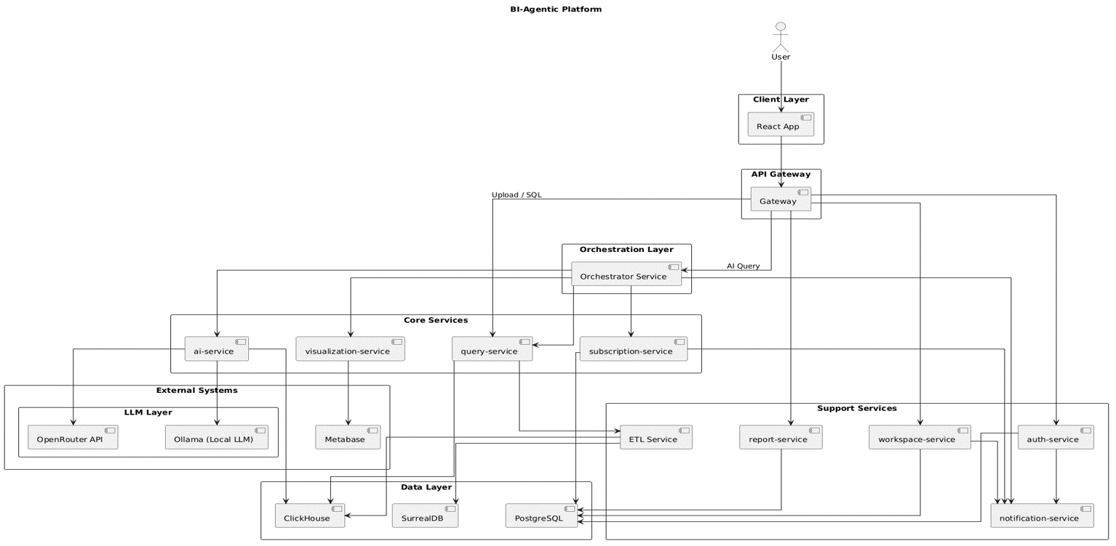
Figure 41 : System Architecture

5.3 Architecture Layers

Client Layer
This layer includes the Web User Interface (Web UI).
Users interact with the system through this interface by performing actions such as:
- logging in,
- uploading databases,
- submitting voice or text queries,
- viewing analytical results,
- managing dashboards and reports.
The client layer is implemented using React.js and communicates with the backend services through the API Gateway.

API Gateway Layer
This layer acts as the main entry point for all client requests.
It is responsible for:
- routing requests to the appropriate microservices,
- handling authentication and authorization,
- validating incoming requests,
- applying security policies,
- and managing communication between the frontend and backend services.
The API Gateway centralizes access to the system and simplifies service communication.

Orchestration Layer
This layer coordinates the execution flow between multiple services.
The Orchestrator Service manages complex analytical workflows by:
- receiving analytical requests,
- communicating with AI services,
- coordinating SQL generation and execution,
- and managing visualization generation.
It ensures that all services work together correctly to complete analytical tasks.

Core Services Layer
This layer contains the main business and AI logic of the platform.
It includes:
- AI processing,
- SQL generation,
- data querying,
- visualization generation,
- and subscription management.
These services are responsible for executing the core analytical functionalities of the BI-Agentic Platform.

AI Service
The AI Service is responsible for intelligent analytical processing.
Its responsibilities include:
- converting voice to text,
- natural language understanding,
- intent classification,
- SQL query generation,
- predictive analytics,
- and AI-based reasoning.
The service integrates with both local and external large language models (LLMs).

Query Service
This service handles SQL query validation and execution.
It:
- validates generated SQL queries,
- securely executes queries on analytical databases,
- retrieves query results,
- and returns structured analytical data.
This layer isolates direct database access for security and scalability purposes.

Visualization Service
This service generates analytical visualizations based on query results.
It supports:
- charts,
- KPIs,
- dashboards,
- tables,
- and interactive reports.
The service integrates with Metabase for advanced BI visualizations.

Subscription Service
This service manages subscription plans and billing operations.
Its responsibilities include:
- creating and managing subscription plans,
- activating subscriptions,
- handling access limitations,
- and controlling premium features.

Support Services Layer
This layer contains auxiliary services that support the main platform operations.
These services handle:
- authentication,
- workspace management,
- notifications,
- reports,
- and ETL processes.
They improve modularity and maintainability within the system architecture.

Auth Service
The Authentication Service manages user identity and access control.
It handles:
- login and registration,
- password management,
- JWT authentication,
- role-based access control,
- and session validation.

Workspace Service
This service manages workspaces and collaboration features.
Its responsibilities include:
- managing members,
- assigning roles,
- handling invitations,
- and controlling workspace permissions.

Report Service
The Report Service manages analytical reports and dashboards.
It supports:
- report storage,
- dashboard pages,
- layout customization,
- moving and resizing reports,
- and dashboard organization.

Notification Service
This service handles all system notifications.
It is responsible for:
- email notifications,
- invitation messages,
- password reset messages,
- and system alerts.

ETL Service
The ETL (Extract, Transform, Load) Service manages data integration operations.
Its responsibilities include:
- extracting data from external sources,
- transforming and cleaning data,
- and loading processed data into analytical databases.
This service ensures that analytical data remains accurate and updated.

External Systems Layer
This layer includes external platforms and third-party services integrated with the system.
These systems provide:
- large language model access,
- BI visualization support,
- and external AI capabilities.

OpenRouter API
OpenRouter provides access to external large language models (LLMs).
It enables the platform to use advanced AI models for:
- natural language understanding,
- reasoning,
- SQL generation,
- and analytical assistance.

Ollama (Local LLM)
Ollama provides locally hosted large language models.
It allows:
- offline AI processing,
- faster response times,
- improved privacy,
- and reduced dependency on external APIs.

Metabase
Metabase is a Business Intelligence (BI) visualization platform.
It is used to:
- generate charts,
- create dashboards,
- embed analytical reports,
- and display query results visually.

Data Layer
This layer contains all databases used by the platform.
It stores:
- system data,
- analytical datasets,
- AI metadata,
- and workspace information.

ClickHouse
ClickHouse is the analytical database used for high-performance query execution.
It is optimized for:
- large-scale analytics,
- aggregation queries,
- and real-time BI operations.

PostgreSQL
PostgreSQL is the primary relational database of the platform.
It stores:
- user accounts,
- workspaces,
- reports,
- subscriptions,
- and application metadata.

SurrealDB
SurrealDB is a flexible modern database used for dynamic and AI-related data storage.
It supports:
- flexible schemas,
- graph-like relationships,
- and intelligent metadata storage.

5.4 -Design class diagram

5.1.1 - User Authentication

This class diagram illustrates the relationships and responsibilities between the components of the User Authentication module in the system. This module is responsible for managing user accounts and handling authentication-related operations such as registration, login, logout, and email verification. It includes the following primary entities:

- UserRepository:
Handles all database operations related to user management, including creating users, retrieving user data, updating user information, and deactivating user accounts.

- AuthService:
Provides core authentication services and business logic. It uses the UserRepository to perform user-related operations such as user registration, login, logout, and email verification.

- BaseAuthView:
A base class for all authentication-related views. It provides access to the authentication services and ensures a unified structure for authentication endpoints.

SignUpView, LoginView, LogoutView, and EmailVerificationView:
Represent the API endpoints responsible for user registration, login, logout, and email verification, respectively. Each view handles HTTP requests and delegates authentication logic to the service layer.

Relationships
1. Dependency:

AuthService depends on UserRepository for all user data operations.

BaseAuthView depends on AuthService to access authentication functionality.

2. Inheritance:

SignUpView, LoginView, LogoutView, and EmailVerificationView inherit from BaseAuthView, allowing them to reuse common authentication behavior and maintain consistency across the authentication module.

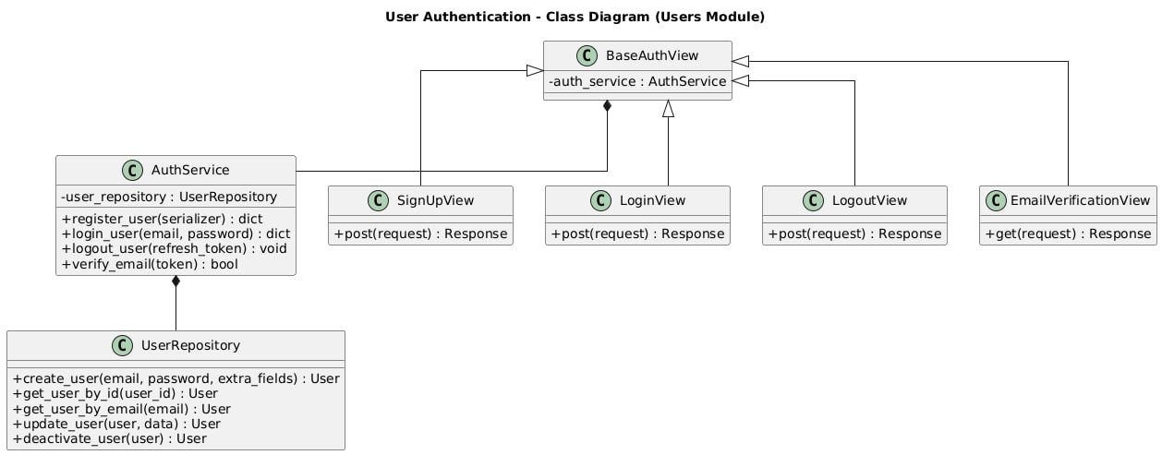
Figure 42 : Class diagram for user auth

5.1.2 - User Management

This class diagram illustrates the relationships and responsibilities between the components of the User Management module in the system. This module is responsible for managing users within a workspace, including creating users, updating their information, managing roles, activating or suspending accounts, and deleting users. It includes the following primary entities:

- UserManagementService:
Handles the core business logic related to user management. It coordinates user-related operations by interacting with both user and workspace member repositories.

- UserRepository:
Handles database operations related to user entities, such as retrieving users, creating new users, updating user data, deactivating users, and deleting user accounts.

- WorkspaceMemberRepository:
Manages workspace membership data, including assigning roles to users within a workspace, updating member status, and removing users from a workspace.

- BaseUserManagementView:
A base class for all user management-related views. It provides access to user management services and ensures a consistent structure for user management endpoints.

UserListView, UserCreateView, UserUpdateView, UserSuspendView, UserActivateView, and UserDeleteView:
Represent API endpoints for listing users, creating new users, updating user information, suspending users, activating suspended users, and deleting users, respectively.

Relationships
1. Dependency:

UserManagementService depends on UserRepository and WorkspaceMemberRepository to perform all user and workspace-related data operations.

BaseUserManagementView depends on UserManagementService to access user management functionality.

2. Inheritance:

UserListView, UserCreateView, UserUpdateView, UserSuspendView, UserActivateView, and UserDeleteView inherit from BaseUserManagementView, allowing them to reuse common logic and maintain consistency across user management endpoints.

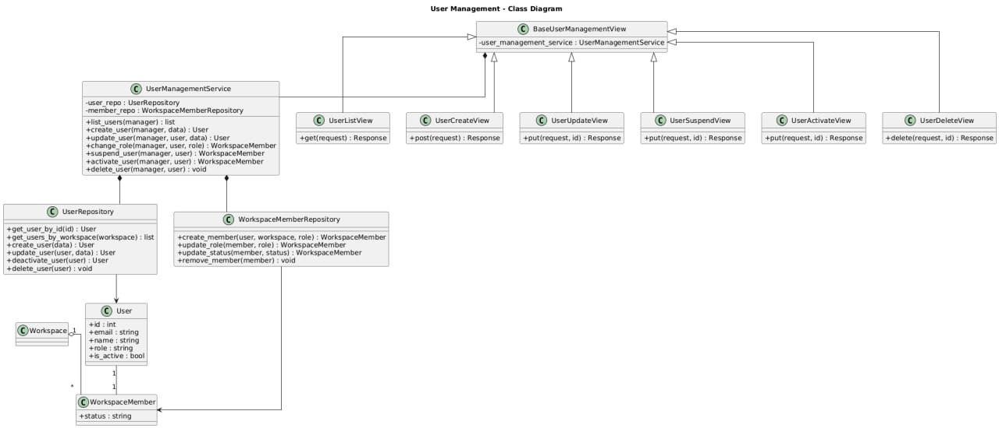
Figure 43 : class diagram for User managements

5.1.3 - Workspace Management

This class diagram illustrates the relationships and responsibilities between the components of the Workspace Management module in the system. This module is responsible for managing workspaces and their members, including updating workspace information, handling member roles, sending invitations, accepting invitations, and controlling member status within a workspace. It includes the following primary entities:

- WorkspaceService:
Handles the core business logic related to workspace management. It coordinates workspace operations and member management by interacting with workspace and invitation repositories.

- WorkspaceRepository:
Handles database operations related to workspaces, such as retrieving workspace information, updating workspace data, managing workspace members, and removing users from a workspace.

- InvitationRepository:
Manages invitation-related data, including creating invitations, retrieving invitations by token, and expiring invitations.

- InvitationService:
Provides invitation-specific business logic, including inviting new members to a workspace and accepting workspace invitations using secure tokens.

- BaseWorkspaceView:
A base class for all workspace-related views. It provides access to workspace services and ensures a unified structure for workspace management endpoints.

WorkspaceUpdateView, WorkspaceMembersView, InvitationView, RoleAssignmentView, MemberManageView, MemberSuspendView, MemberUnsuspendView, and AcceptInvitationView:
Represent API endpoints for updating workspace details, listing workspace members, inviting users, assigning roles, managing members, suspending or unsuspending members, and accepting workspace invitations, respectively.

Relationships
1. Dependency:

WorkspaceService depends on WorkspaceRepository and InvitationRepository to perform workspace and member-related data operations.

InvitationService depends on InvitationRepository to manage invitation lifecycle operations.

BaseWorkspaceView depends on WorkspaceService to access workspace management functionality.

AcceptInvitationView depends on InvitationService to handle invitation acceptance.

2. Inheritance:

WorkspaceUpdateView, WorkspaceMembersView, InvitationView, RoleAssignmentView, MemberManageView, MemberSuspendView, and MemberUnsuspendView inherit from BaseWorkspaceView, ensuring consistent behavior and reuse of shared workspace logic across all workspace management endpoints.

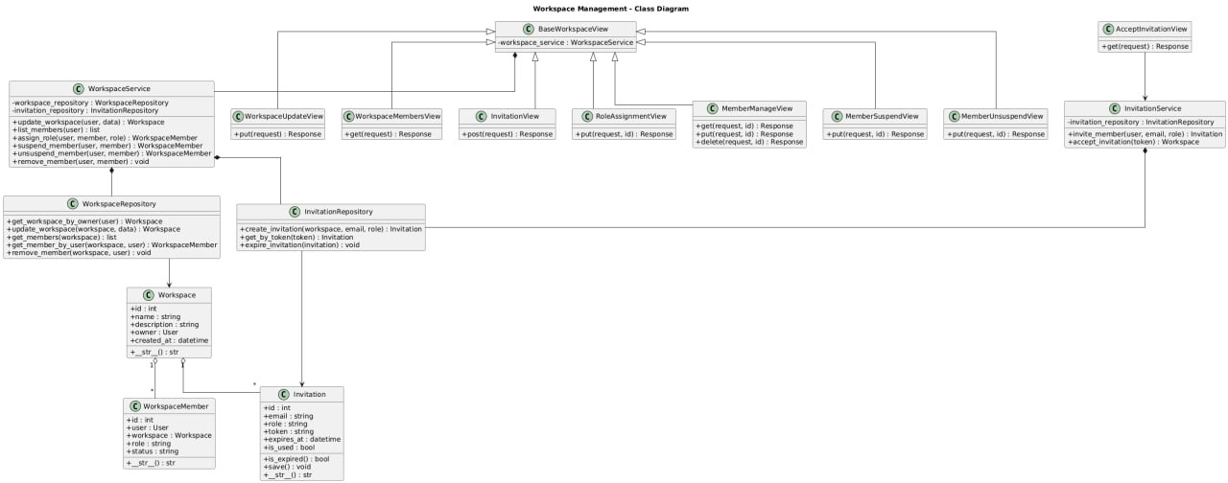
Figure 44 : class diagram for Workspace managements

5.1.4 - Database Management

This class diagram illustrates the relationships and responsibilities between the components of the Database Management module in the system. This module is responsible for handling user-uploaded databases, managing their lifecycle, interacting with the analytical database engine, and providing database preview and status functionalities. It includes the following primary entities:

- DatabaseService:
Handles the core business logic related to database management. It coordinates database upload, replacement, deletion, preview generation, and status checking by interacting with the database repository and the analytical database client.

- DatabaseRepository:
Handles database-related persistence operations, including creating database records, retrieving databases by workspace, updating database status and metadata, and deleting databases.

- ClickHouseClient:
Provides an abstraction layer for interacting with the ClickHouse analytical database engine. It is responsible for executing queries, retrieving table previews, schemas, row counts, and checking table existence.

- DatabaseUtils:
Provides utility functions related to database processing, such as cleaning database data and formatting file sizes for display purposes.

- BaseDatabaseView:
A base class for all database-related views. It provides access to database services and ensures a unified structure for database management endpoints.

DatabaseUploadView, DatabaseDetailView, DatabasePreviewView, DatabaseStatusView, and DatabaseHealthCheckView:
Represent API endpoints for uploading databases, retrieving or deleting database details, previewing database content, checking database status, and performing database health checks, respectively.

Relationships
1. Dependency:

DatabaseService depends on DatabaseRepository to perform database-related persistence operations.

DatabaseService depends on ClickHouseClient to interact with the analytical database engine.

BaseDatabaseView depends on DatabaseService to access database management functionality.

DatabaseService utilizes DatabaseUtils for auxiliary database processing tasks.

2. Inheritance:

DatabaseUploadView, DatabaseDetailView, DatabasePreviewView, DatabaseStatusView, and DatabaseHealthCheckView inherit from BaseDatabaseView, ensuring consistency and reuse of shared logic across all database management endpoints.

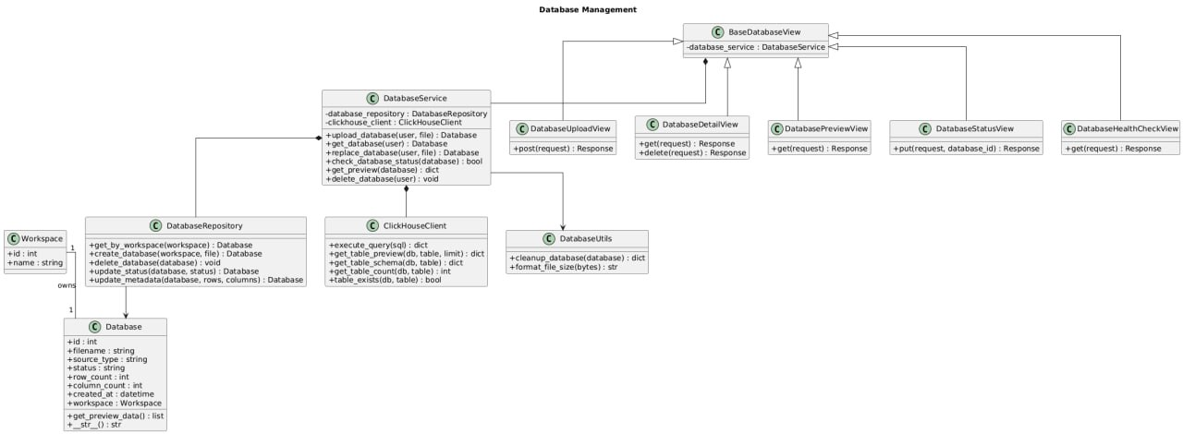
Figure 45 : class diagram for Database Managements

5.1.5 - AI Services

This class diagram illustrates the relationships and responsibilities between the components of the AI Services module in the system. This module is responsible for processing voice-based analytical requests, transforming spoken input into structured queries, and ensuring the correctness and security of generated SQL queries. It includes the following primary entities:

- AIProcessingService:
Handles the core AI processing pipeline. It orchestrates the entire flow of voice request processing, starting from audio transcription and ending with validated SQL query generation. It integrates multiple AI and validation components to ensure accurate and secure query generation.

- WhisperService:
Responsible for transcribing audio input into text using a speech-to-text model.

- QuestionClassifier:
Classifies the transcribed text to identify the type of analytical question being asked.

- IntentService:
Extracts structured analytical intent from the transcribed text, including metrics, dimensions, and filters.

- IntentValidator:
Validates the extracted intent semantically, checks schema compatibility, and ensures SQL executability.

- SQLCompiler:
Compiles validated intent into executable SQL queries while applying appropriate casting and formatting rules.

- SQLGuard:
Performs security validation on generated SQL queries to prevent unsafe or unauthorized query execution.

- VoiceRequestRepository:
Handles persistence operations for voice requests, including storing audio files, transcriptions, intents, generated SQL queries, and request status updates.

- AIServiceView:
Represents the API endpoint responsible for receiving voice-based requests and triggering the AI processing workflow.

Relationships
1. Dependency:

AIProcessingService depends on WhisperService, QuestionClassifier, IntentService, IntentValidator, SQLCompiler, and SQLGuard to execute the AI processing pipeline.

AIProcessingService depends on VoiceRequestRepository to store and update voice request data throughout processing stages.

AIServiceView depends on AIProcessingService to initiate voice request processing.

2. Association and Ownership:

A User with a manager role owns voice requests and is allowed to initiate voice-based analytical queries within a Workspace.

A Workspace contains multiple VoiceRequest entities representing historical voice queries and their results

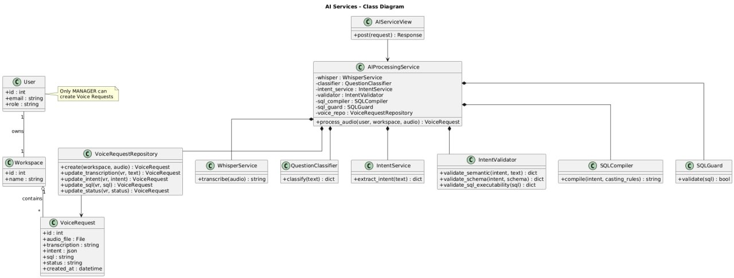
Figure 46 : Class Diagram for AI Services
5.1.6 - Voice Reports

This class diagram illustrates the relationships and responsibilities between the components of the Voice Reports module in the system. This module is responsible for managing voice-based analytical reports, starting from audio upload and processing, passing through query execution and validation, and ending with report visualization and dashboard integration. It includes the following primary entities:

- VoiceReportService:
Handles the core business logic related to voice reports. It coordinates audio upload, AI processing, SQL execution, report management, and integration with dashboards and visualization services.

- VoiceReportRepository:
Handles persistence operations for voice reports, including creating reports, updating transcription, intent, SQL queries, report status, and retrieving reports by workspace.

- AIServiceClient:
Acts as a client interface to the AI Services module, responsible for processing audio input and returning structured analytical results.

- ClickHouseExecutor:
Executes validated SQL queries against the analytical database engine and returns query results.

- SQLGuard:
Ensures the security and validity of SQL queries before execution.

- MetabaseService:
Integrates the system with Metabase to create analytical questions, dashboards, and associate reports with visual dashboards.

- JWTEmbeddingService:
Generates secure embedded URLs for dashboards, allowing controlled access to visual reports.

- SQLEditHistoryRepository:
Stores the history of SQL edits applied to voice reports, enabling traceability and auditability of query modifications.

- BaseVoiceReportView:
A base class for all voice report-related views. It provides access to voice report services and ensures a consistent structure for report-related endpoints.

VoiceUploadView, QueryExecuteView, SQLEditView, ReportListView, ReportDetailView, and WorkspaceDashboardView:
Represent API endpoints for uploading voice input, executing queries, editing SQL queries, listing reports, viewing or deleting report details, and displaying workspace dashboards, respectively.

Relationships
1. Dependency:

VoiceReportService depends on VoiceReportRepository, SQLEditHistoryRepository, AIServiceClient, ClickHouseExecutor, SQLGuard, MetabaseService, and JWTEmbeddingService to perform report processing, execution, validation, and visualization tasks.

BaseVoiceReportView depends on VoiceReportService to access voice report functionality.

2. Association and Ownership:

A User creates and manages voice reports within a Workspace.

A Workspace contains multiple VoiceReport entities representing generated analytical reports.

Each VoiceReport may have multiple SQL edit history records to track modifications over time.

3. Inheritance:

VoiceUploadView, QueryExecuteView, SQLEditView, ReportListView, ReportDetailView, and WorkspaceDashboardView inherit from BaseVoiceReportView, ensuring reuse of common logic and consistency across all voice report endpoints.

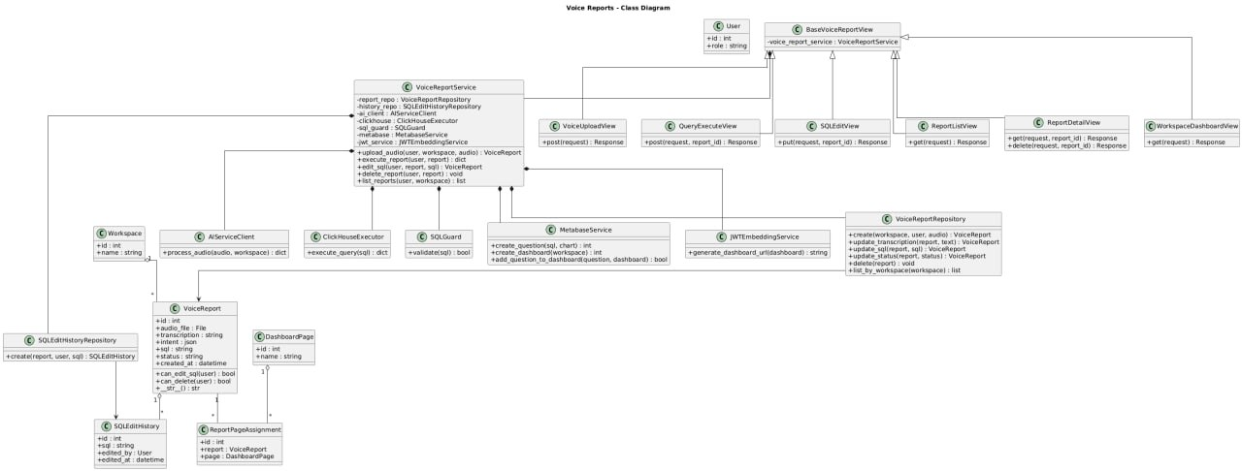
Figure 47 : class diagram for Voice Managements

Chapter 6

Artificial Intelligence

  - Introduction

  - Purpose of the AI Component

The Artificial Intelligence component in the BI Voice Agent system is designed to enable intelligent interaction between users and analytical data through natural language. Its primary purpose is to interpret user voice input, understand the analytical intent behind the request, and translate this intent into structured operations that can be executed on analytical data sources. By doing so, the AI component removes the technical barrier traditionally associated with data querying and allows non-technical users to interact with business intelligence systems in an intuitive and efficient manner

  - Motivation for Using AI in Business Intelligence Systems

Traditional business intelligence systems rely heavily on predefined dashboards and manually written queries, which limits flexibility and slows down the decision-making process. In dynamic environments, decision-makers often need immediate answers to ad-hoc questions that were not anticipated during dashboard design. Integrating artificial intelligence enables the system to dynamically interpret user questions and generate analytical queries on demand. This capability significantly enhances system usability, supports exploratory data analysis, and improves the responsiveness of business intelligence platforms.

  - Scope of the AI

This section focuses on the artificial intelligence and data science aspects of the BI Voice Agent system. It covers the conceptual foundations, processing stages, and integration mechanisms that enable voice-based analytical querying. The section explains how voice input is transformed into text, how user intent is extracted and structured, how analytical queries are generated, and how results are prepared for visualization. Implementation-level details are described conceptually without delving into source code, ensuring clarity and alignment with academic documentation standards.

  - Role of AI in Voice-Based Analytical Systems

2.1 Voice as a Natural Interface for Data Interaction

Voice-based interaction represents one of the most natural forms of communication between humans and machines. In the context of business intelligence systems, using voice as an interface allows users to express analytical needs in the same way they would ask questions during meetings or discussions. Artificial intelligence plays a crucial role in enabling this interaction by converting unstructured spoken language into structured representations that machines can understand and process. This approach reduces cognitive load on users and supports more spontaneous and exploratory data analysis.
2.2 From Spoken Questions to Analytical Intent

A spoken question typically contains ambiguity, implicit assumptions, and contextual references. Artificial intelligence techniques, particularly natural language processing, are required to interpret such questions and extract their analytical meaning. This involves identifying key entities such as metrics, dimensions, filters, and time constraints, and organising them into a structured analytical intent. The ability to accurately infer this intent is essential for generating meaningful and correct analytical queries that reflect the user’s actual information needs.
2.3 Enhancing Accessibility and Decision-Making

By enabling voice-based analytical interaction, artificial intelligence significantly enhances accessibility to data-driven insights. Users who lack technical expertise in databases or query languages can still obtain valuable information through natural conversation. This democratization of data access improves organisational decision-making by allowing a broader range of stakeholders to explore and analyse data directly, without dependency on technical teams. As a result, insights can be generated faster and integrated more effectively into operational and strategic decisions.

  - AI Processing Pipeline for Voice-Based Analytics
3.1 Speech-to-Text Conversion Using Whisper
- The first stage of the AI processing pipeline is responsible for converting the user’s spoken input into textual form. This task is performed using a speech-to-text model based on the Whisper architecture. The model processes the uploaded audio file and produces a high-quality textual transcription that represents the spoken question. This textual output serves as the foundational input for all subsequent processing stages.

- Accurate transcription is critical, as any errors at this stage may propagate through the pipeline and negatively affect intent detection and query generation. Therefore, a robust speech recognition model is essential to ensure reliable interpretation of user requests, particularly in environments where accents, background noise, or domain-specific terminology may be present.

3.2 Determining Whether the Question Requires Analytical Query Execution
- The second stage determines whether the transcribed question requires analytical processing and database query execution. This decision is essential to avoid unnecessary query generation for questions that are conversational, informational, or unrelated to data analysis. The system employs a two-step strategy to make this determination.
- In the first step, the system checks the transcribed text against a predefined set of analytical keywords commonly associated with data analysis, such as aggregation terms, temporal expressions, and metric-related phrases. If such keywords are detected, the question is directly classified as analytical.
- If no analytical keywords are found, the second step is activated. In this step, the question is passed to a language model, which evaluates the semantic structure and intent of the question to determine whether it represents an analytical request. The model classifies the question as either analytical or non-analytical based on its meaning rather than explicit keywords. This hybrid approach combines rule-based efficiency with model-based semantic understanding to achieve reliable classification.

3.3 Intent Generation and Safe Analytical Query Construction
- In the third stage, the system transforms the analytical question into a structured intent representation. The transcribed question is sent, along with the database schema retrieved from the ClickHouse system, to a language model responsible for intent generation. The schema includes available tables, columns, and data types, ensuring that the generated intent is grounded in the actual structure of the database.

- The resulting intent contains all information required to manually construct an analytical query using deterministic writing rules. This includes selected tables, metrics with aggregation functions, grouping dimensions, filters, ordering conditions, and result limits. Instead of generating SQL directly, the system relies on this structured intent as an intermediate representation, allowing for controlled and transparent query construction.
- After intent generation, the system performs strict validation to ensure that the resulting query will be safe and compatible with ClickHouse. This validation verifies that the query is a read-only SELECT statement, conforms to ClickHouse syntax, and does not include any destructive or unsupported operations. Only after passing these checks is the intent considered valid, and the stage is completed. This ensures that generated queries are both semantically correct and operationally safe.

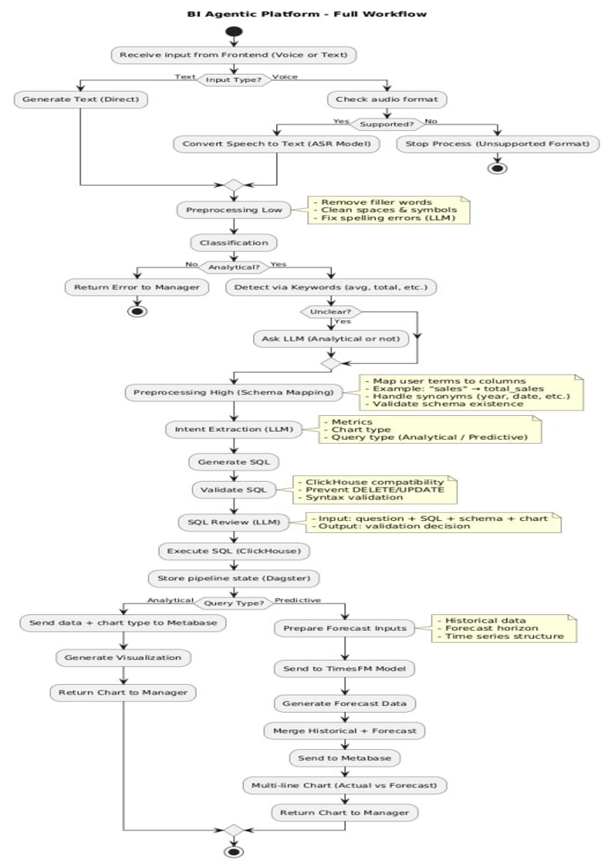
Figure 48 : AI Processing Pipeline

  - AI Models and Their Roles in the BI Voice Agent System

4.1 Speech-to-Text Model (Whisper – Large v3 1.55B)

- Model Overview
The speech-to-text component of the BI Voice Agent system relies on the Whisper large v3 model. This model is responsible for converting raw audio input into accurate textual representations. It serves as the entry point of the AI pipeline, enabling the system to process spoken language as structured text suitable for further analysis. The choice of the large v3 variant reflects the system’s requirement for high transcription accuracy across diverse accents, speaking styles, and acoustic conditions

- Input and Output
The input to the Whisper model consists of an audio file containing the user’s spoken question. The output is a textual transcription that accurately reflects the spoken content. This text is produced in a normalized and machine-readable format, making it suitable for subsequent natural language processing stages. The transcription output does not include any analytical interpretation; it strictly represents the spoken words.

- Internal Functioning
Internally, the Whisper model applies deep learning techniques to analyse audio signals and map them to linguistic units. The model processes acoustic features extracted from the audio and decodes them into text using a sequence-to-sequence architecture. The large v3 variant provides improved robustness and accuracy, particularly in challenging scenarios such as background noise or mixed-language speech, which are common in real-world business environments.

- Role in the System
Within the overall system, the Whisper model acts as a foundational component. All subsequent AI operations depend on the correctness of its output. By providing reliable textual input, the model enables accurate classification of the question and effective intent extraction. The model operates independently of business logic and database context, ensuring a clear separation between speech processing and analytical reasoning.

4.2 Analytical Question Classification Model

- Model Overview
The second artificial intelligence model used in the system is a lightweight large language model deployed locally through the Ollama framework, based on the Gemma 3 architecture with a 1B parameter configuration. This model is dedicated to classifying user questions and determining whether a given transcribed input requires analytical processing and database query execution. Its primary role is decision-making rather than content generation, enabling efficient routing of requests within the AI pipeline.

The choice of a compact model reflects a design trade-off between performance and resource efficiency. By using a smaller model hosted locally, the system can perform fast classification without incurring external API latency or cost, making it suitable for real-time interaction.

- Input and Output
The input to the classification model is the transcribed text produced by the speech-to-text stage. The model analyses this text and produces a binary or categorical output indicating whether the question is analytical or non-analytical. The output does not include any SQL or structured query elements; instead, it provides a routing decision that determines whether the request should proceed to the intent generation stage or be handled as a conversational response.

- Internal Functioning
Internally, the model evaluates the semantic structure of the input text rather than relying solely on explicit keywords. It considers contextual cues, intent-related phrasing, and implicit analytical patterns that may not be captured by rule-based checks. This allows the system to correctly classify questions that lack obvious analytical keywords but still require data-driven responses. The model complements the initial keyword-based detection by providing semantic validation when ambiguity exists.

- Key Characteristics
Key characteristics of this model include low latency, local execution, and deterministic behaviour suitable for classification tasks. Its compact size enables fast inference and predictable performance, which are critical for maintaining a responsive user experience. While the model is not designed for complex reasoning or long text generation, it excels at its designated role of intent classification within the system.

- Role in the System Workflow
Within the system workflow, the classification model acts as a gatekeeper that prevents unnecessary analytical processing. Only questions classified as analytical are forwarded to the intent generation stage, while non-analytical questions are handled separately. This design improves system efficiency, reduces load on downstream models, and ensures that database queries are generated only when truly required.
4.3 Intent Generation and Schema-Aware Language Model
- Model Overview
The third artificial intelligence model used in the system is a large language model accessed through the OpenRouter service, based on the Gemma 3n 4b architecture. This model is responsible for generating structured analytical intent from user questions that have been classified as analytical. Its primary function is to translate natural language queries into a formal representation that ensures compatibility with the underlying analytical database.

Unlike the classification model, which performs lightweight decision-making, this model is used for complex semantic understanding and structured output generation. The use of a remotely hosted model allows the system to leverage stronger reasoning capabilities and broader contextual understanding, which are essential for accurate intent construction in analytical scenarios.

- Input and Output
The input to the intent generation model consists of the analytical question text combined with schema information retrieved from the ClickHouse database. This schema information includes available tables, columns, and data types, providing essential context that constrains the model’s output. The output is a structured intent representation, typically expressed in a machine-readable format, containing all elements required to construct an analytical query.

The generated intent includes selected tables, metrics with aggregation functions, grouping dimensions, filtering conditions, sorting preferences, and result limits. This structured output acts as an intermediate layer between natural language and SQL, enabling controlled and transparent query construction.

- Schema-Aware Reasoning and Hallucination Prevention
A critical feature of this model’s usage is schema-aware reasoning. By explicitly providing database schema information, the system constrains the model to reference only existing tables and columns. This significantly reduces the risk of hallucination, a common issue in large language models where non-existent entities may be generated. Schema awareness ensures that all generated intents are grounded in the actual data structure of the system.

Additionally, the model is instructed to adhere to a predefined intent format, which further limits ambiguity and enforces consistency. Any intent that references invalid schema elements or violates structural constraints is rejected during subsequent validation stages.

- Role in Safe Analytical Query Construction
The intent generated by this model is not executed directly as SQL. Instead, it serves as a controlled blueprint for deterministic query construction. This design choice allows the system to apply strict validation rules before execution, ensuring that the resulting query is safe, read-only, and compatible with ClickHouse. By separating semantic understanding from query execution, the system minimizes the risk of incorrect or unsafe database operations.

This model therefore plays a central role in balancing flexibility and safety: it provides rich semantic interpretation while allowing the system to maintain full control over the final query generation process.

- Integration within the AI Pipeline
Within the AI pipeline, this model represents the final and most semantically intensive stage. It is invoked only after the question has been classified as analytical and prepared for intent extraction. Its output directly influences the structure of the analytical query and the subsequent visualization. As such, the correctness and clarity of the generated intent are essential for the overall reliability of the BI Voice Agent system

4.4 Preprocessing Layer: Low-Level and High-Level Processing
Before analytical intent generation and SQL construction, the BI-Agentic Platform performs a two-stage preprocessing pipeline designed to improve the quality, consistency, and reliability of user queries. This preprocessing layer consists of:
- Low-Level Preprocessing
- High-Level Preprocessing
These stages progressively transform raw user input into a structured and schema-compatible analytical request suitable for downstream AI reasoning and query generation.

a) Low-Level Preprocessing
The low-level preprocessing stage is responsible for basic normalization and linguistic cleanup of the user query. Its primary objective is to prepare raw textual or transcribed input for semantic analysis while preserving the original analytical meaning.
This stage performs several operations including:
- removing unnecessary symbols and formatting,
- normalizing whitespace and punctuation,
- converting text into standardized forms,
- correcting simple transcription inconsistencies,
- and cleaning noisy input generated from speech recognition.
For voice-based interactions, this stage also processes the output generated by the speech-to-text module to improve readability and consistency before further analysis.
Low-level preprocessing is intentionally lightweight and deterministic. It does not attempt to infer business logic or database structure; instead, it focuses on ensuring that the textual input is syntactically clean and semantically stable for subsequent stages.
This stage improves downstream model performance by reducing ambiguity and eliminating input noise that may negatively affect intent classification or SQL generation.

b) High-Level Preprocessing
The high-level preprocessing stage performs semantic normalization and schema-aware preparation of the analytical request. Unlike low-level preprocessing, this stage operates with awareness of the database structure and analytical context.
Its responsibilities include:
- identifying relevant datasets,
- mapping user terminology to actual database columns,
- resolving synonyms and semantic variations,
- normalizing analytical expressions,
- detecting metrics and dimensions,
- and preparing structured information for intent generation.
For example, user expressions such as:
- “sales”,
- “revenue”,
- or “income”
may be mapped to the correct database column depending on the schema configuration.
This stage also detects:
- temporal expressions,
- aggregation requirements,
- comparison operations,
- ranking instructions,
- and filtering conditions.
Additionally, schema validation mechanisms are applied to ensure that referenced tables and columns exist within the ClickHouse analytical database. Any unresolved or unsupported schema references are flagged before query generation.
The output of this stage is a semantically enriched and schema-aligned analytical request that can be safely passed to the intent generation model.

c) Role in AI Pipeline Stability
The preprocessing layer plays a critical role in improving system reliability and reducing semantic ambiguity throughout the AI pipeline.
The low-level stage ensures textual consistency and removes input noise, while the high-level stage establishes semantic alignment between natural language and the analytical database schema.
Together, these stages:
- improve intent classification accuracy,
- reduce hallucination risks,
- increase SQL generation reliability,
- and enforce compatibility with the underlying data model.
By separating preprocessing into two dedicated stages, the system achieves greater modularity and better control over query preparation before AI reasoning and database interaction occur.

d) Integration within the Analytical Workflow
Within the AI workflow, preprocessing occurs immediately after user input acquisition and before intent generation.
The processing order is as follows:
- User submits voice or text query
- Speech-to-text conversion (if required)
- Low-level preprocessing
- High-level preprocessing
- Intent generation
- SQL construction and validation
- Query execution
- Visualization generation
This layered preprocessing architecture ensures that all downstream analytical operations operate on normalized, validated, and semantically meaningful input data.

4.5 Predictive Forecasting Model and Time-Series Analysis

a) Model Overview
The fourth artificial intelligence model used in the system is a predictive forecasting model responsible for generating future analytical insights from historical business data. Unlike the intent generation model, which focuses on understanding analytical requests, this model specializes in time-series prediction and future trend estimation.
The system utilizes the DeepAR forecasting architecture to perform predictive analytics on temporal datasets stored within the analytical database. DeepAR is a probabilistic recurrent neural network model designed specifically for forecasting sequential numerical data. It enables the system to predict future values such as sales, revenue, customer growth, or operational metrics based on historical observations.
This model is activated only when the system detects that the user question contains predictive intent, such as forecasting, future estimation, growth prediction, or trend continuation.

b) Input and Output
The input to the predictive model consists of:
- historical time-series data retrieved from ClickHouse,
- temporal dimensions such as dates or timestamps,
- numerical business metrics,
- and forecasting parameters extracted from the user request.
The forecasting pipeline first organizes the historical data into structured sequential format before passing it to the DeepAR model.
The output of the model includes:
- predicted future values,
- confidence intervals,
- trend estimations,
- and forecast-ready analytical datasets.
These outputs are then forwarded to the visualization layer to generate forecasting charts and predictive dashboards.

c) Predictive Reasoning and Temporal Understanding
A key capability of the predictive model is temporal reasoning. The system analyzes user questions to determine whether the request refers to future-oriented analytical behavior. Questions containing expressions such as:
- “predict”,
- “forecast”,
- “expected sales”,
- “future revenue”,
- or “next month trend”
are classified as predictive queries and routed to the forecasting pipeline.
The model learns temporal dependencies and recurring patterns from historical data, allowing it to generate statistically informed future estimations. By analyzing seasonality, trends, and sequential behavior, the model produces forecasts that reflect realistic business expectations.

d) Role in Safe Predictive Analytics
The forecasting model does not interact directly with the database execution layer. Instead, it operates on validated analytical datasets generated through controlled SQL queries. This design ensures that forecasting operations remain isolated from direct database manipulation and maintain compatibility with the system’s security architecture.
Additionally, forecasting requests are restricted to supported numerical and temporal data structures. Invalid forecasting scenarios, such as non-temporal datasets or unsupported metrics, are rejected before model execution.
The use of probabilistic forecasting also improves reliability by providing confidence ranges rather than deterministic single-value predictions. This allows decision-makers to evaluate uncertainty and risk within predictive analytical results.

e) Integration within the AI Pipeline
Within the AI pipeline, the predictive model represents the forecasting stage of the analytical workflow. After:
- intent classification,
- schema-aware intent generation,
- SQL construction,
- and analytical query execution,
the retrieved historical data is passed into the forecasting module when predictive intent is detected.
The forecasting results are then integrated into the visualization service, where predictive charts and trend visualizations are generated automatically.
This model extends the BI-Agentic Platform from traditional business intelligence toward intelligent decision-support and predictive analytics, enabling users not only to analyze historical data but also to anticipate future business behavior.

  - Summary

This chapter described the artificial intelligence component of the BI Voice Agent system and its role in enabling voice-based analytical interaction. It explained how spoken user input is processed through several AI stages, starting from speech-to-text conversion, followed by question classification, and ending with structured intent generation.

The chapter also presented the three AI models used in the system. The first model converts voice input into text, the second model determines whether the question requires analytical processing, and the third model generates a structured intent that can be safely translated into an analytical query. Together, these models form a clear and efficient AI workflow that allows users to interact with data using natural language.

Chapter 7

Data science Module

- Introduction
  - Purpose of the Data Science Component

The Data Science component in the BI Voice Agent project applies the ETL principle to prepare data for analytical querying. It starts by uploading external databases or files, then extracting, cleaning, and loading the data into the ClickHouse analytical database. Once loaded, this data can be queried later through voice interaction, where spoken questions are converted into SQL queries.

The main purpose of this component is to ensure that the data stored in ClickHouse is clean, structured, and ready for analysis, enabling accurate and reliable voice-based queries.

Relationship Between ETL and Voice-Based Querying

The ETL process prepares data for use by the voice-based querying system. Clean and well-structured data allows the AI component to retrieve correct schema information from ClickHouse and generate valid SQL queries from user voice input. Any issues in data preparation may lead to incorrect or failed queries.

  - Scope of the ETL

This chapter focuses on the practical application of ETL for data preparation. It explains how data is uploaded, extracted, cleaned, and loaded into ClickHouse to support voice-based analytical queries. Predictive modeling and machine learning training are not covered.

- Applied ETL Workflow for Data Preparation

  - Data Source Submission (User Input)
The ETL workflow starts when the user submits a data source to the system. This source can be a file uploaded manually, such as CSV or Excel, or an online database connection. At this stage, the data is still external to the analytical system and has not yet been processed or validated.

  - Connection Registration (connection_topic)
Once the data source is submitted, its connection information is published to a Kafka topic dedicated to connection registration. This step signals the ETL system that a new data source is available and ready for extraction. The published message contains essential metadata describing the source type and access details.

  - Schema Extraction (schema_topic)
After receiving the connection information, the system extracts the schema of the data source. This includes identifying available tables, columns, and data types. The extracted schema is published to a dedicated Kafka topic and serves as a structural description of the data. This schema information is later used to guide data transformation and to support analytical query generation

  - Raw Data Extraction (extracted_rows_topic)
Once the schema is identified, the ETL system begins extracting the raw data rows from the source. Each row is published as a message to a Kafka topic dedicated to raw data. At this stage, the data remains uncleaned and unmodified, preserving its original values for further processing.

  - Data Transformation (Transformer Service)
The transformer service consumes raw data rows and applies data preparation operations. These operations include data cleaning, type casting, and handling null or invalid values. The goal of this stage is to improve data quality and ensure consistency with the extracted schema. Cleaned rows are then forwarded to the next stage of the pipeline.

  - Clean Data Publishing (clean_rows_topic)
After transformation, the cleaned and validated data rows are published to a Kafka topic dedicated to clean data. This topic represents data that is ready to be loaded into the analytical database. Only rows that pass cleaning and validation rules reach this stage.

  - Data Loading into ClickHouse (Loader Service)
The loader service consumes clean data rows and inserts them into the ClickHouse analytical database. Data is loaded into tables that can later be queried efficiently. This step finalizes the ETL process and makes the data available for analytical querying.

  - Metadata and Logging (metadata_topic)
Throughout all ETL stages, execution metadata and logs are published to a dedicated Kafka topic. This metadata includes information about processed rows, errors, and execution status. It provides visibility into the ETL workflow and supports monitoring, auditing, and troubleshooting.

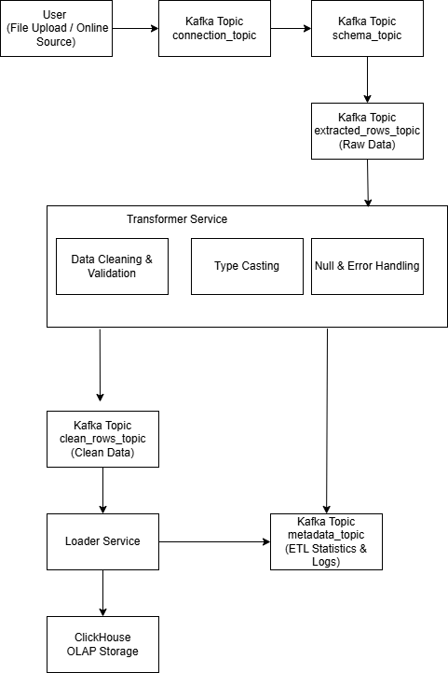
Figure 49 : ETL Pipeline

- Data Readiness for Voice-Based Querying
  - 3.1 Structured Data Availability in ClickHouse
After the ETL workflow completes, the processed data is stored in ClickHouse in a structured and query-ready form. Tables, columns, and data types are clearly defined, allowing the analytical database to efficiently execute aggregation and filtering operations. This structured availability is essential for enabling accurate analytical queries generated from voice input.

  - Schema Accessibility for AI Query Generation
The AI component relies on the availability of database schema information to generate valid SQL queries. Since the ETL pipeline publishes and maintains structured schemas in ClickHouse, the AI module can retrieve up-to-date information about tables and columns before constructing queries. This schema accessibility ensures that voice-generated queries reference existing data structures and avoid invalid or non-existent fields.

  - Impact of Clean Data on Query Accuracy
Clean and validated data directly affects the accuracy of analytical query results. Data cleaning and type consistency performed during the ETL process reduce the risk of incorrect aggregations, failed queries, or misleading outputs. When voice-generated SQL queries are executed on well-prepared data, the results are more reliable and easier to interpret.

  - Enabling Reliable Voice-Based Analytics
By combining structured data storage in ClickHouse with schema-aware AI query generation, the system enables reliable voice-based analytics. The ETL pipeline ensures that data is ready for querying, while the AI component translates user voice input into executable SQL. This integration allows users to interact with data naturally through voice while maintaining analytical correctness.

- Summary

This chapter presented the applied data science workflow used to prepare data for voice-based analytical querying. It described how data is uploaded, extracted, cleaned, and loaded into ClickHouse through an event-driven ETL pipeline. The chapter also explained how prepared data supports schema-aware AI query generation and improves the accuracy of analytical results. Together, these processes ensure that voice-driven queries operate on reliable and well-structured data.

Chapter 8

Practical Implementation

8.1 Introduction

In this chapter, we present the practical implementation of the proposed system, highlighting the technologies, tools, and frameworks used during development. This chapter focuses on how the system was built in practice, covering backend and frontend implementation, database management, artificial intelligence components, and infrastructure tools. In addition, system interfaces are demonstrated, and the chapter concludes with an overview of testing procedures used to verify system functionality across different scenarios.

8.2 Used Tools

8.2.1 Django & Django REST Framework

Django is a high-level Python web framework that enables rapid development and clean, pragmatic design. It provides built-in features such as authentication, ORM, and administrative interfaces, which significantly reduce development complexity.

In this project, Django is used as the main backend framework for implementing the system’s core logic, user management, workspace management, database handling, and voice report services.

Additionally, Django REST Framework (DRF) is used to build RESTful APIs. DRF integrates seamlessly with Django’s models, views, and URL routing, making it ideal for developing scalable and secure APIs. It provides serializers, authentication mechanisms, permission control, and standardized API responses, which are essential for frontend-backend communication.

8.2.2 React

React is a popular JavaScript library for building user interfaces, developed by Facebook. It enables the creation of reusable UI components and efficient rendering through its virtual DOM mechanism.

In this project, React is used to implement the frontend application, providing a dynamic and interactive user interface. React facilitates smooth navigation between pages, real-time UI updates, and modular component-based design. Tools such as React Router are used for client-side routing, while state management is handled using lightweight libraries to maintain authentication and workspace states.

8.2.3 PostgreSQL Database

PostgreSQL is an open-source relational database management system known for its robustness, reliability, and advanced features.

In this system, PostgreSQL is used as the primary relational database, storing core application data such as users, workspaces, voice reports, database metadata, and permissions. The Django ORM is used to interact with PostgreSQL, providing an abstraction layer that simplifies database operations while maintaining data integrity and consistency.

8.2.4 ClickHouse

ClickHouse is a high-performance, column-oriented database designed for analytical workloads and large-scale data processing.

In this project, ClickHouse is used as the analytical database engine. It stores processed data generated by the ETL pipeline and serves as the execution engine for analytical SQL queries generated from voice inputs. ClickHouse is accessed using both HTTP and native protocols, depending on the use case, ensuring efficient query execution and batch data loading.

8.2.5 Visual Studio Code (VS Code)

Visual Studio Code is a lightweight yet powerful source code editor that provides features such as syntax highlighting, IntelliSense, debugging tools, and Git integration.

VS Code is used as the primary development environment for the entire project, including frontend, backend, AI services, and ETL components. Its extensibility and rich plugin ecosystem enhance productivity and code quality.

8.2.6 Bitbucket

Bitbucket is a Git-based source code repository hosting platform that supports version control and collaborative development.

In this project, Bitbucket is used to manage the source code repository, track changes, and maintain development history. It facilitates collaboration between team members and ensures proper versioning of the system throughout the development lifecycle.

8.3 AI Used Technologies and Tools

8.3.1 OpenAI Whisper

OpenAI Whisper is an automatic speech recognition (ASR) model capable of transcribing speech into text with high accuracy.

In this system, Whisper is used as the speech-to-text component, converting voice inputs submitted by users into textual form. The transcribed text serves as the initial input for subsequent natural language processing and intent extraction stages.

8.3.2 Large Language Models (LLMs) via OpenRouter

Large Language Models are used to extract analytical intent and generate structured SQL queries from natural language input.

The system integrates LLMs through the OpenRouter API, enabling flexible model selection and scalable inference. These models are responsible for understanding user questions, identifying metrics and filters, and producing SQL queries suitable for analytical execution.

8.3.3 LangChain and LangGraph

LangChain is a framework designed for building applications powered by large language models. It provides abstractions for prompt management, chaining logic, and model interaction.

LangGraph extends this approach by enabling graph-based workflows for reasoning and decision-making. In this project, LangChain and LangGraph are used to implement the reasoning pipeline, allowing structured processing of user queries, classification of question types, and routing between analytical and conversational flows.

8.3.4 Pydantic

Pydantic is a data validation library that uses Python type annotations to enforce data correctness.

In this system, Pydantic is used to validate intent schemas, ensuring that extracted intents, metrics, dimensions, and filters conform to predefined structures before SQL generation and execution. This validation step improves system reliability and reduces runtime errors.

8.3.5 Ollama and Local Language Models

Ollama is a local inference platform used to run large language models on-premise without relying on external cloud services. In this project, Ollama is utilized to host and execute local language models for intent extraction and SQL generation.

Using local models provides several advantages, including improved data privacy, reduced latency, and full control over model behavior. This approach ensures that sensitive analytical queries and business data are processed locally without being sent to third-party services.

8.4 ETL Pipeline Technologies

To support large-scale data ingestion and processing, the system includes an ETL pipeline built using modern distributed tools.

Apache Kafka is used as a message broker to enable asynchronous communication between ETL services.

Pandas and OpenPyXL are used for data extraction, transformation, and file processing.

SurrealDB is used to store metadata, logs, and audit information related to ETL operations.

ClickHouse serves as the final destination for processed analytical data.

This architecture ensures scalability, fault tolerance, and efficient data processing.

8.4.1 Apache Kafka

Apache Kafka is a distributed event streaming platform used as the backbone of the ETL pipeline. In this system, Kafka enables asynchronous and decoupled communication between ETL services, allowing data to flow efficiently through extraction, transformation, and loading stages.

Kafka topics are used to transfer structured messages between services, ensuring scalability, fault tolerance, and reliable data processing across the ETL pipeline.

    - SurrealDB

SurrealDB is a modern, cloud-native database used for storing ETL metadata, logs, and audit information. In this project, SurrealDB records pipeline execution details, transformation metadata, and processing status.

This separation between analytical data (stored in ClickHouse) and metadata (stored in SurrealDB) improves system organization, traceability, and monitoring capabilities.

8.5 Infrastructure and DevOps Tools

The system uses Docker and Docker Compose to containerize and orchestrate backend services, ETL components, Kafka, ClickHouse, and SurrealDB. Environment variables are managed using .env files to ensure secure and flexible configuration across environments.

This setup simplifies deployment, improves reproducibility, and enables local and distributed development environments.

8.6 Testing

Testing is conducted using pytest and pytest-django, which provide a robust testing framework for Django applications. Test cases are designed to validate API endpoints, authentication flows, database operations, and AI processing logic.

These tests ensure that the system behaves correctly under different scenarios and that core functionalities operate as expected.

  - Data Visualization and Reporting

8.7.1 Metabase

Metabase is an open-source business intelligence and data visualization platform used to present analytical results generated by the system. In this project, Metabase is integrated to create interactive dashboards and visual reports based on SQL queries generated from voice input.

The system programmatically creates questions and dashboards in Metabase and embeds them securely into the application using JWT-based embedding. This integration enables users to view analytical insights in a clear and interactive manner without directly accessing the Metabase interface.

6.3 System interfaces

- Home page

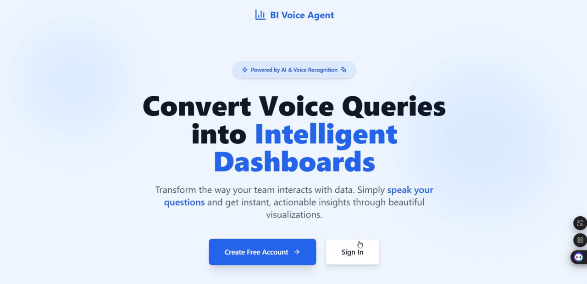
Figure 50 : Home Page Interface

- Log in


Figure 51 : Login interface

- Sign up

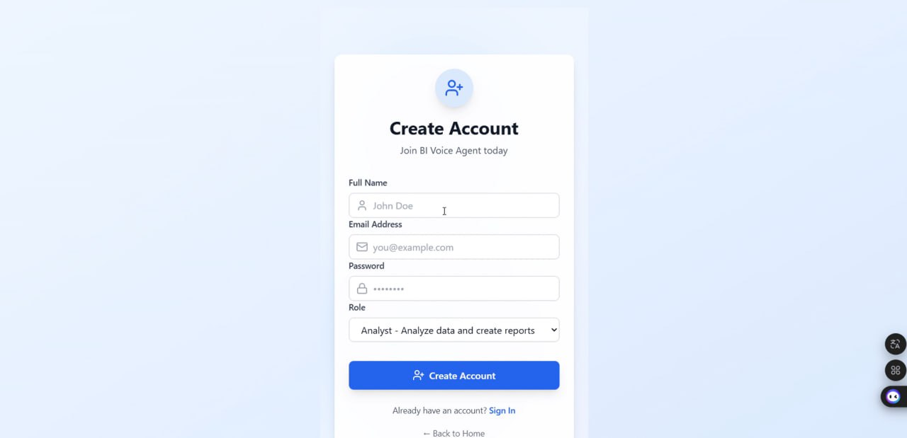
Figure 52 : sign up interface

- Link for verification email

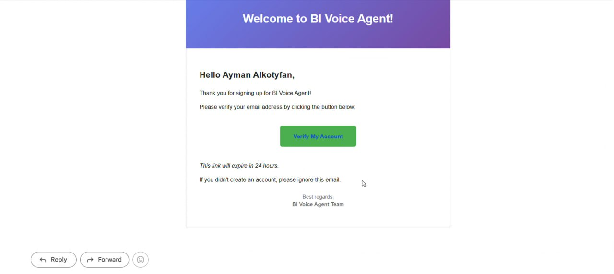
Figure 53 : Email verification in gmail

- Dashboard manager

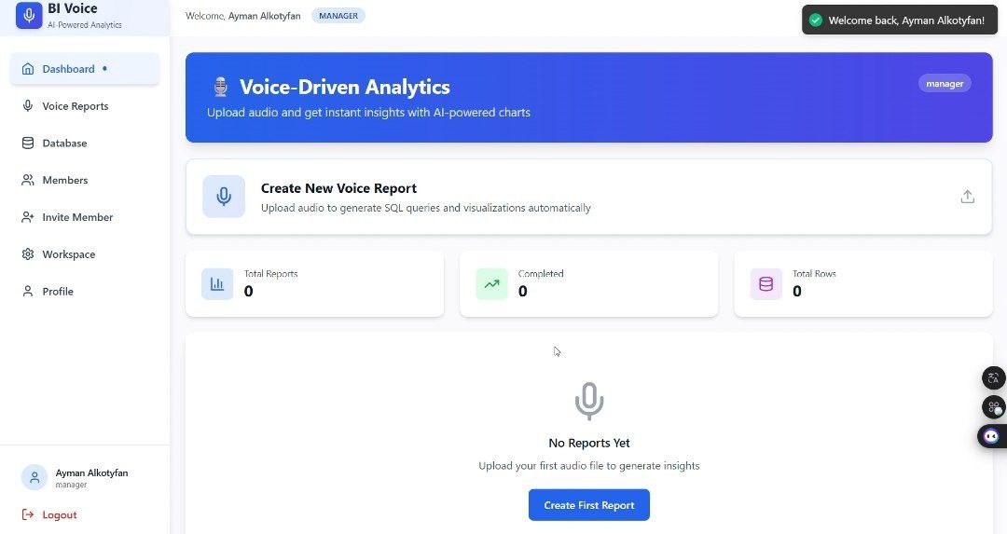
Figure 54 : Dashboard Manager
- Workspace settings

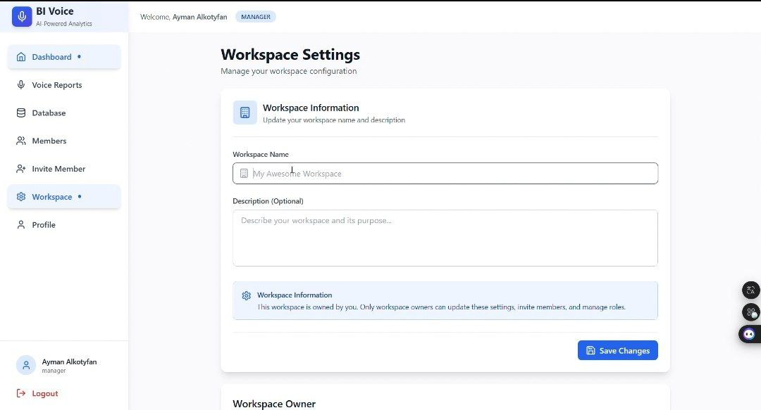
Figure 55 : Workspace Settings

- Profile settings

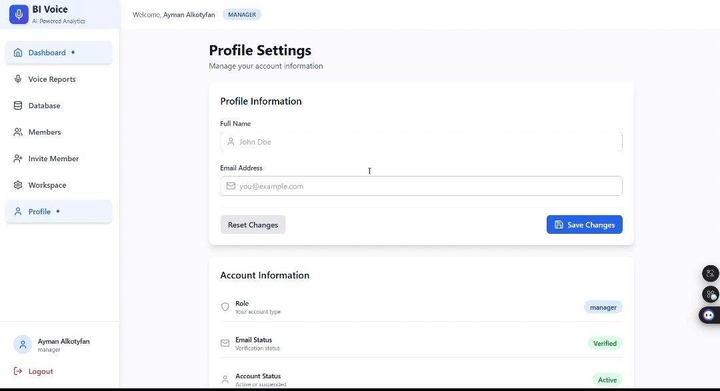
Figure 56 : Profile settings

- Detective account

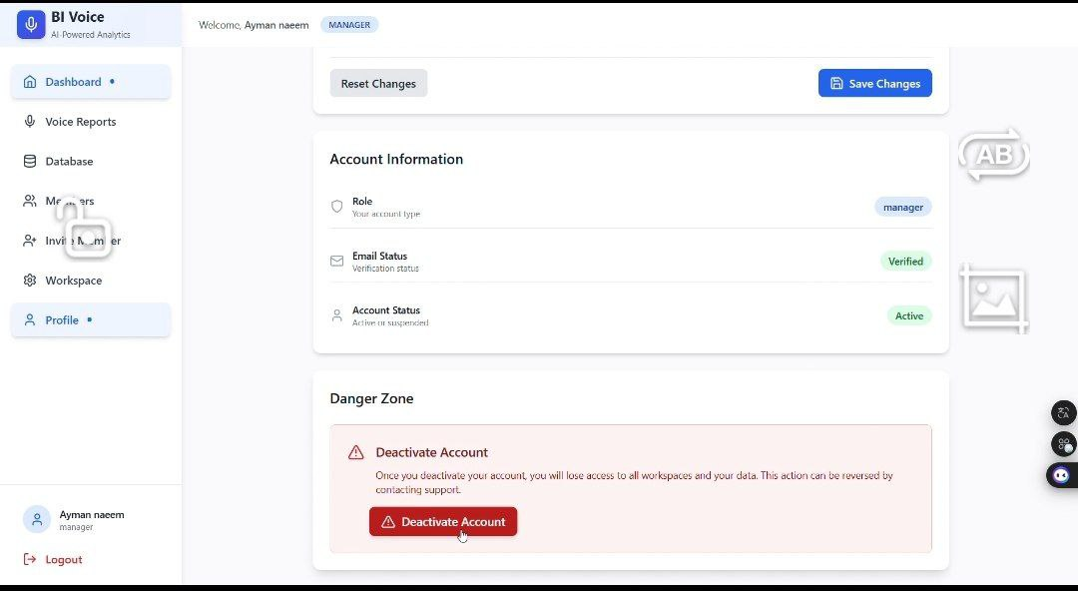
Figure 57 : Detective account interface

- invitation member

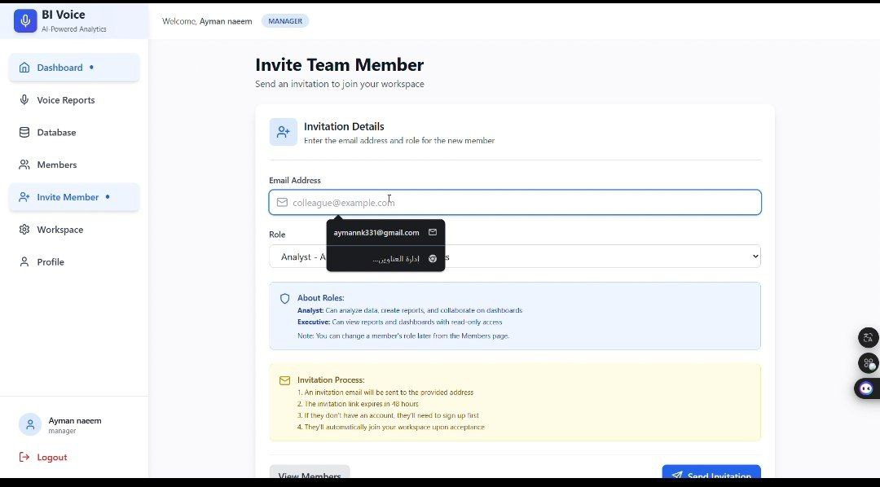
Figure 58 : invitation member interface
- Join workspace in gmail

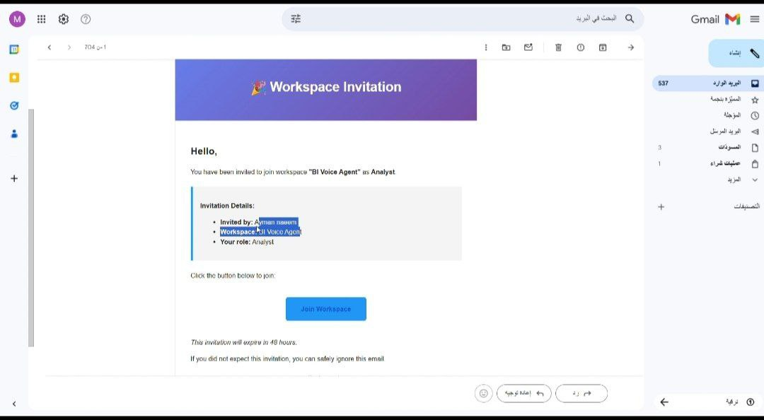
Figure 59 : join workspace in gmail

- Dashboard analysis

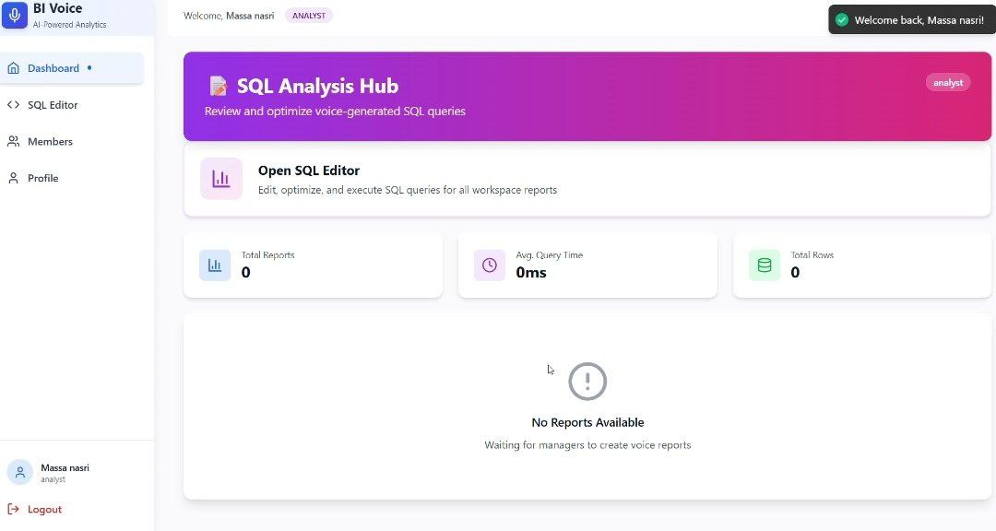
Figure 60 : dashboard Analysis

- Member settings

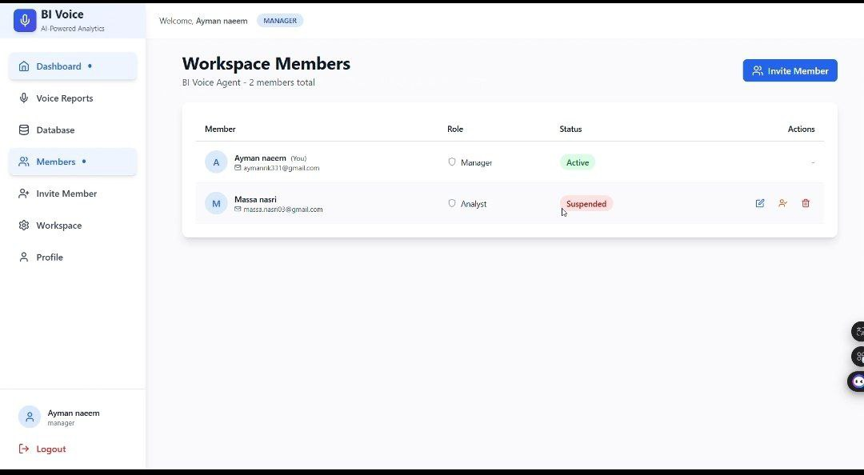
Figure 61 : Member Settings

- Suspend member

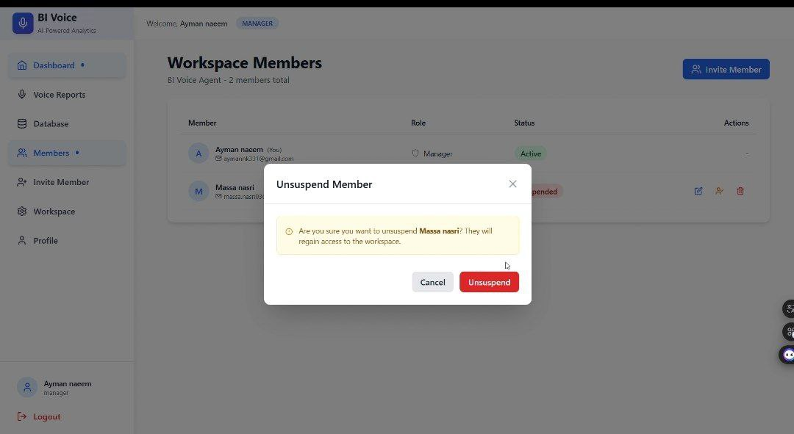
Figure 62 : Suspend Member interface

- Change member role

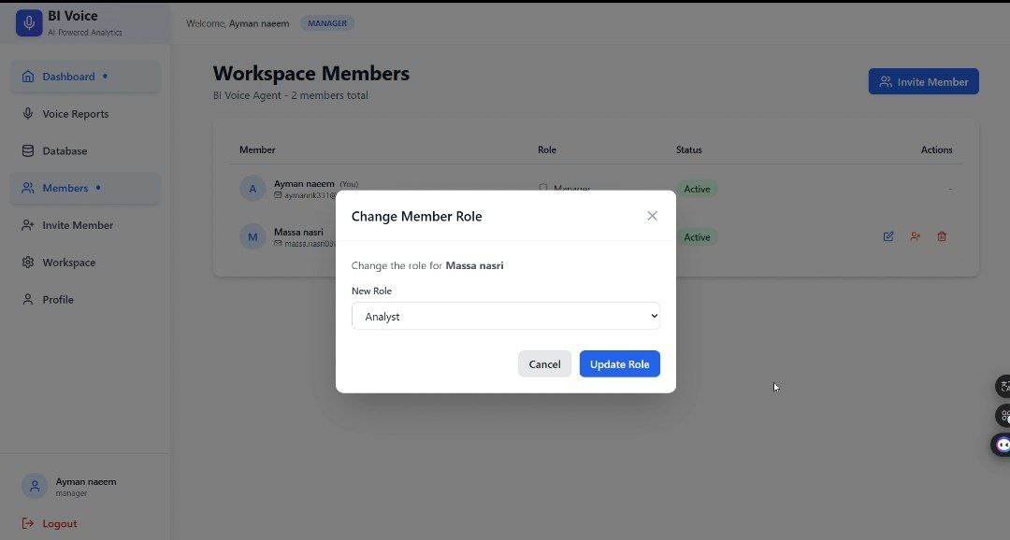
Figure 63 : change member role

- Dashboard Executive

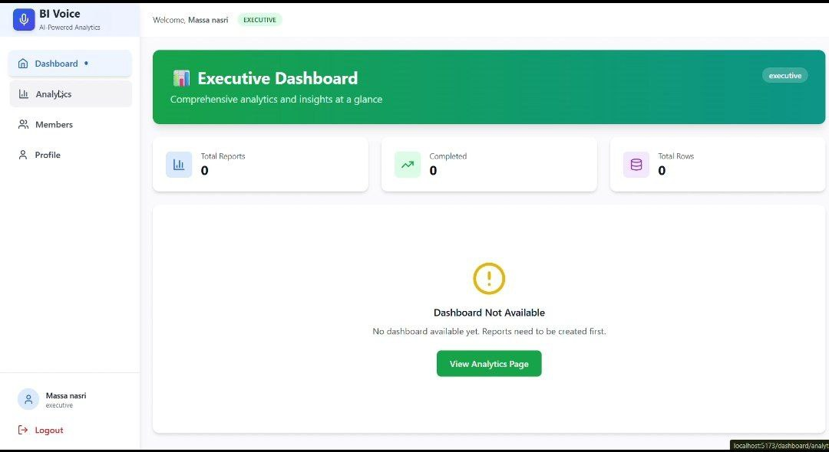
Figure 64 : Dashboard Executive

- Upload database

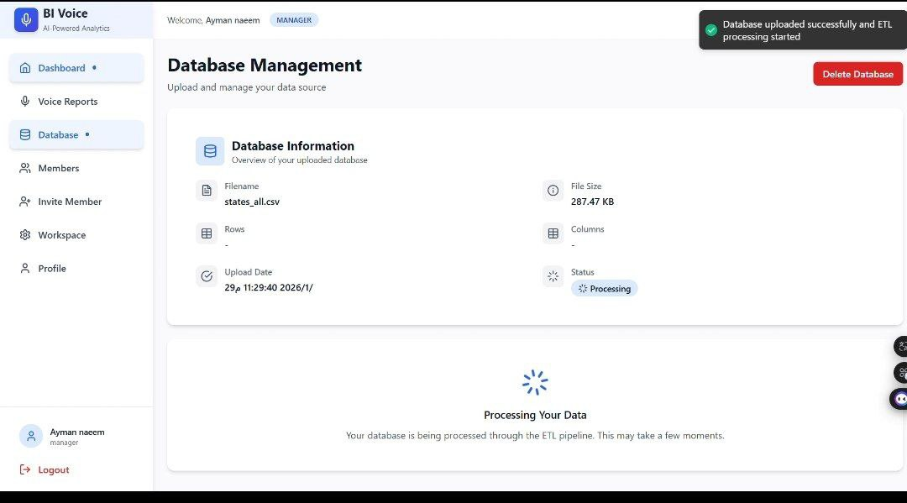
Figure 65 : Upload database

- Upload voice

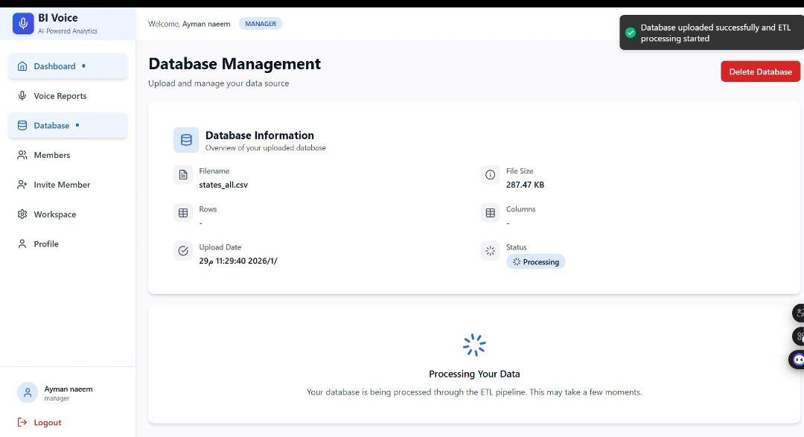
Figure 66 : Upload Voice
- SQL editor

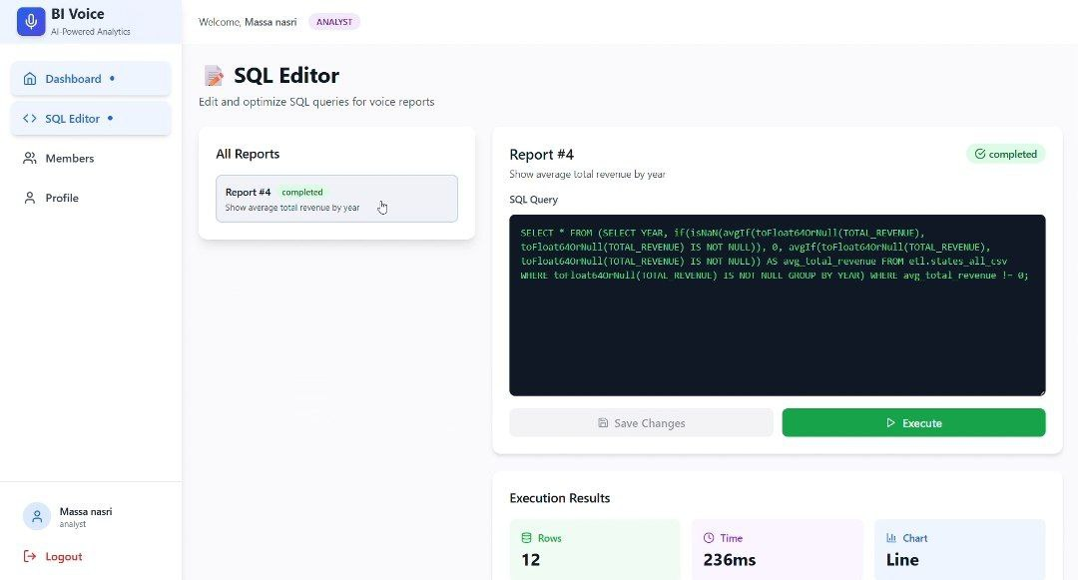
Figure 67 : Edit SQL

6.4 Summary

This chapter presented the practical implementation of the BI Voice Agent system, detailing the technologies and tools used across all layers of the application. The system combines modern web technologies, advanced AI models, distributed data processing, and scalable infrastructure to deliver an intelligent voice-based business intelligence platform.

Chapter 9

Report Overview

9.1 Introduction
This chapter provides an overview of the entire report and explains the purpose and content of each chapter. The main objective of this chapter is to guide the reader through the logical structure of the report and clarify how each chapter contributes to the analysis, design, implementation, and evaluation of the proposed BI Agentic Platform.
The report follows a systematic approach, beginning with the project background and theoretical foundations, progressing through project management, system analysis, system design, artificial intelligence and data science components, and concluding with practical implementation and evaluation. This structure ensures a comprehensive understanding of the platform and its development process.

9.2 Report Structure and Purposes

Chapter 1: Introduction
This chapter introduces the project background, motivation, and problem statement addressed by the BI Agentic Platform. It defines the project objectives and provides a general overview of the proposed solution, highlighting the integration of Agentic Artificial Intelligence, Business Intelligence, analytics, forecasting, and decision-support capabilities. The chapter also presents the overall structure of the report.

Chapter 2: Basic Concepts and Reference Study
This chapter discusses the fundamental concepts related to the project, including Business Intelligence (BI), Agentic AI, Natural Language Processing (NLP), Speech Recognition, Data Warehousing, Predictive Analytics, and Data Visualization. It also reviews related studies and existing systems, providing a comparative analysis and identifying research gaps addressed by the proposed platform.

Chapter 3: Project Management
This chapter focuses on the project management aspects of the BI Agentic Platform. It includes the Project Charter, Scope of Work (SOW), project scheduling, Gantt charts, resource planning, and risk management analysis. This chapter ensures that the project is planned, monitored, and executed in a structured and controlled manner.

Chapter 4: System Analysis
This chapter presents the system analysis phase and the Software Requirements Specification (SRS). It details the functional and non-functional requirements, use case descriptions, actors, test cases, and the Requirement Traceability Matrix (RTM). The chapter provides a complete understanding of the platform requirements and user interactions.

Chapter 5: System Design
This chapter describes the system design of the BI Agentic Platform in detail. It includes the microservices architecture, database design, system components, data flow diagrams, sequence diagrams, deployment architecture, and the interactions between different services. This chapter serves as the technical blueprint for implementing the platform.

Chapter 6: Artificial Intelligence
This chapter focuses on the artificial intelligence components integrated into the platform. It explains the AI pipeline, speech-to-text processing using Whisper, query classification, intent generation, natural language understanding, SQL generation, agentic reasoning workflows, and AI-driven decision-making mechanisms used throughout the system.

Chapter 7: Data Science
This chapter presents the data science and analytics aspects of the platform. It explains data preprocessing, ETL pipelines, data warehousing using ClickHouse, analytical processing, forecasting models, predictive analytics techniques, and the methods used to transform raw data into actionable business insights.

Chapter 8: Practical Implementation
This chapter covers the practical implementation of the platform, including the technologies, frameworks, APIs, and tools used during development. It explains the implementation of system modules, service integration, user interfaces, testing activities, evaluation results, and the final Requirement Traceability Matrix (RTM), demonstrating consistency between requirements and implementation.

9.3 Summary
This chapter provides a clear overview of the report structure and the contribution of each chapter to the development of the BI Agentic Platform. Through this organized approach, the report ensures a logical progression from theoretical foundations and project planning to system analysis, design, artificial intelligence, data science, implementation, and evaluation, resulting in a comprehensive and well-documented intelligent analytics platform.

References

[1] ThoughtSpot.
ThoughtSpot Official Website. Available at: https://www.thoughtspot.com/

[2] Databricks.
Databricks AI/BI Genie. Available at: https://www.databricks.com/product/ai-bi/genie

[3] Microsoft.
Microsoft Power BI – Business Intelligence Tool. Available at:
https://www.microsoft.com/en-us/power-platform/products/power-bi

[4] Vanna AI.
Vanna.AI Official Website. Available at: https://vanna.ai/

[5] Sequel.sh.
Sequel.sh – Natural Language to SQL Platform. Available at: https://sequel.sh/

[1] OpenRouter.
OpenRouter – Unified API for Large Language Models. Available at: https://openrouter.ai/

[2] OpenAI.
ChatGPT: Large Language Model for Natural Language Understanding and Generation. Available at: https://chat.openai.com/

[3] OpenAI.
Whisper: Speech-to-Text Model for Automatic Speech Recognition. Available at:
https://openai.com/research/whisper

[4] ClickHouse.
ClickHouse – Column-Oriented Database Management System. Available at:
https://clickhouse.com/

[5] Metabase.
Metabase – Open Source Business Intelligence and Analytics Platform. Available at:
https://www.metabase.com/

[6] Apache Kafka.
Apache Kafka – Distributed Event Streaming Platform. Available at:
https://kafka.apache.org/

[7] Python.
Python Programming Language – Official Documentation. Available at:
https://www.python.org/

[8] Django.
Django Web Framework – Official Documentation. Available at:
https://www.djangoproject.com/

